**Azure**

Deploying model

Service model

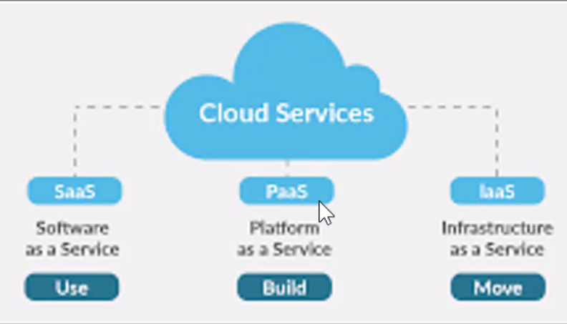

**Software as a service:**No need to worry about anything things will be available and get charged oly for the service ex:google, drive,netflix etc

**Platform as a service:** Data Engineering comes under this, When we want to create application we need to ram storage and hardware and operating system, basically a platform, coding we have to do. Coding is our part and platform will get from cloud, ex :

**Infrastructure as a service:** Normal hardware box will get , and rest everything we need to do.

Deployment Models:  
How we are deploying services.  
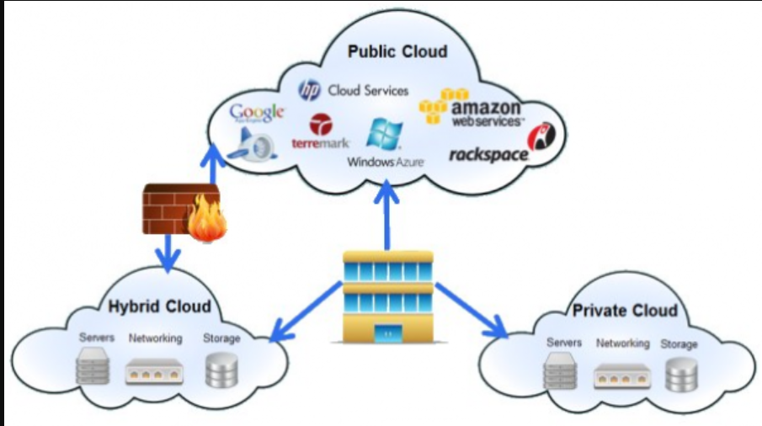



**Private cloud:** Restricted entry  
**Public cloud:** Everyone can enter  
**Hybrid Cloud:** Mix of private and public. Netflix which comes in rent that is private and things which is free that is public.

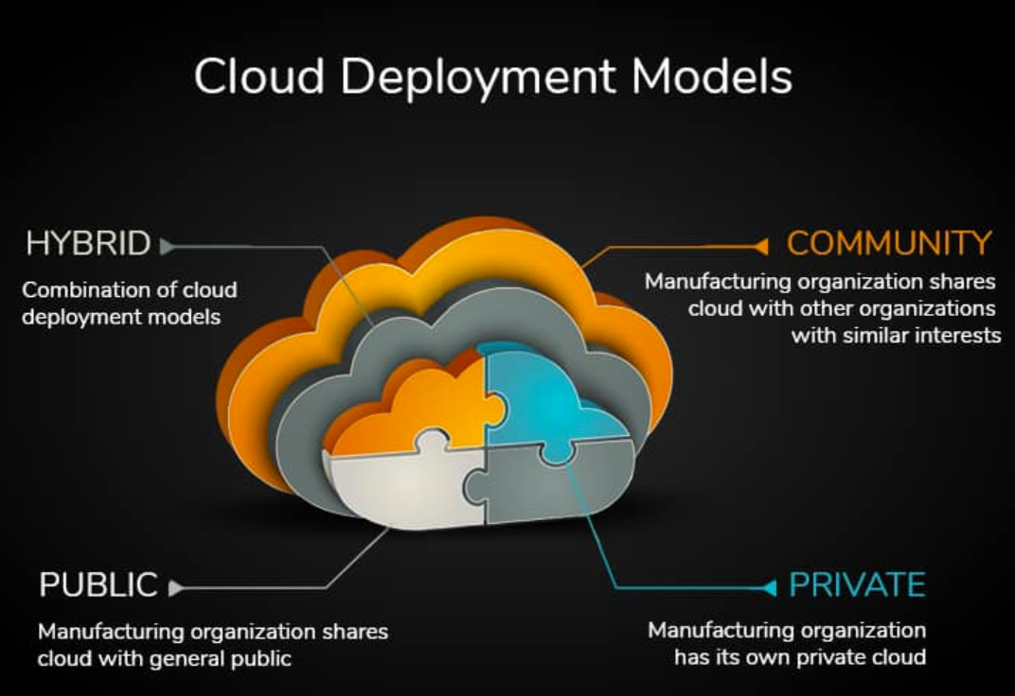

Praticle

**Azure data Storage**

Azure document  
<https://learn.microsoft.com/en-us/azure/storage/common/storage-introduction>

Creating Resource group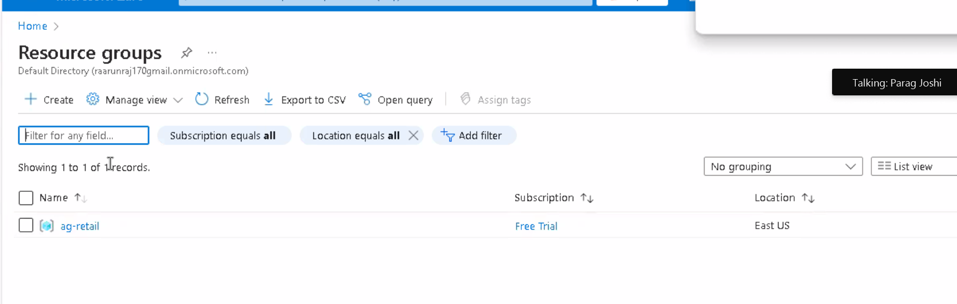

Creating storage group  
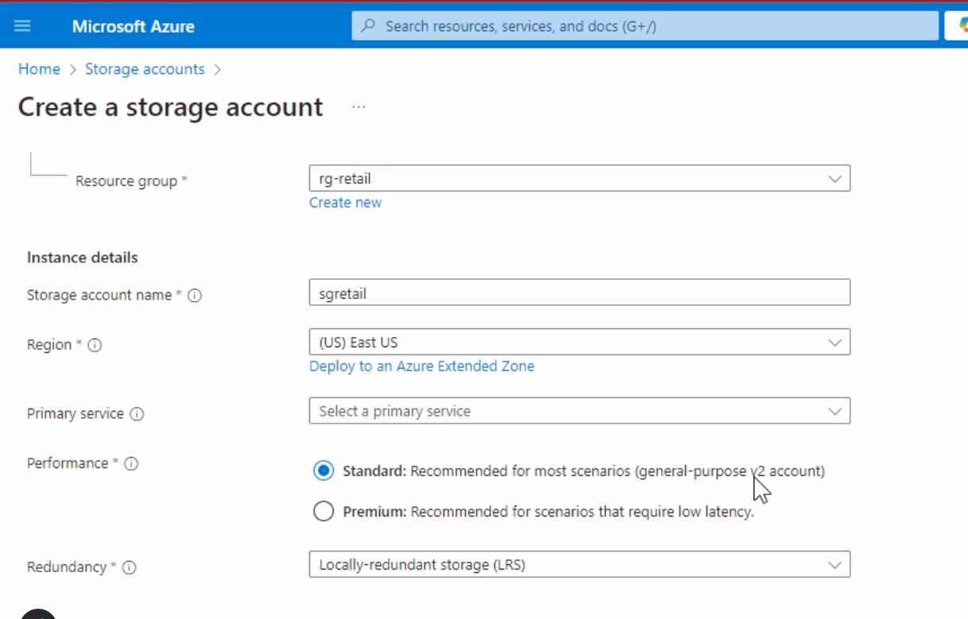  
and click review and create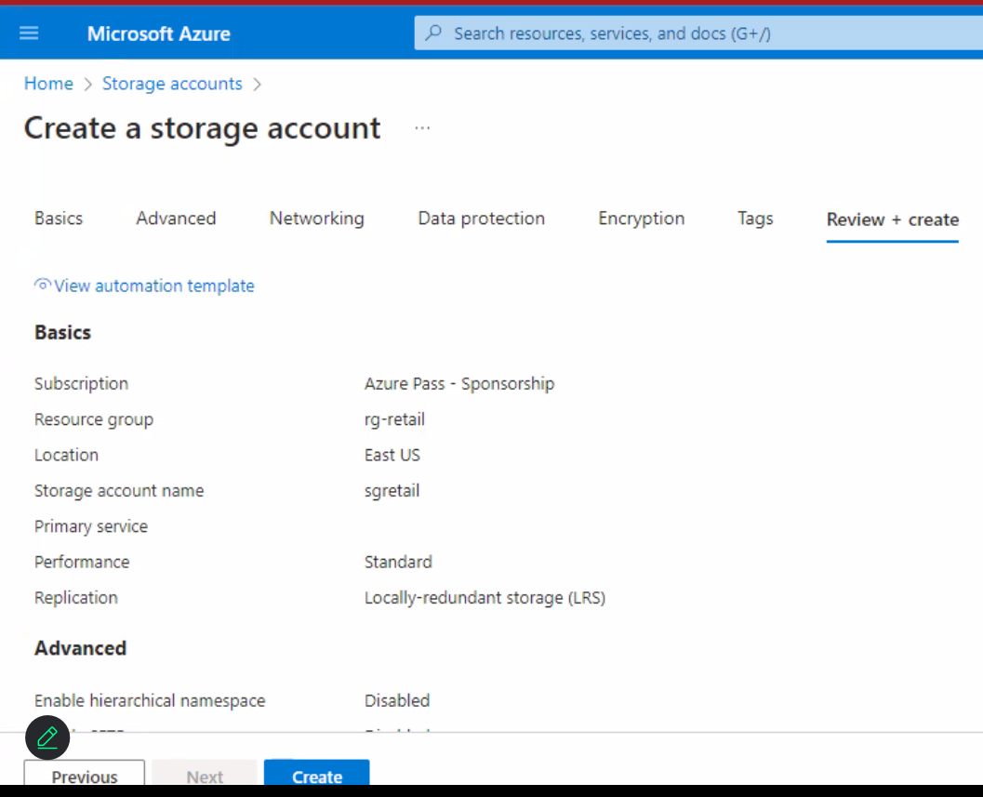

**Types of azure storage:**  
 1.Azure Blob Storage  
 2.Azure File Storage  
 3.Azure Queues Storage – To store large number of messages, 64 kb/queue.  
 4.Azure Table Storage – To know SQL structure and data, storing dataset.  
 5.Azure Disk Storage – It act as virtual hard disk.

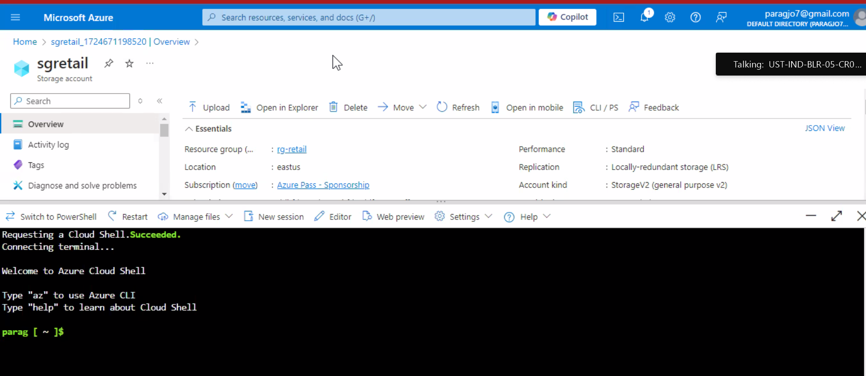  
Click here for the shell 🡪bash 🡪 no storage and don’t check 🡪 click ok  
  
**Commands**



* az – to find the list of commands
* az help storage – to find the details of the storage
* az storage account list – to list the storage

<https://learn.microsoft.com/en-us/cli/azure/install-azure-cli-windows?tabs=azure-cli>

To Install AZURE CLI **lastest MSI of AZURE CLI 64 bit ,** Download install , oper power shell in windows

* az version – it shows the CLI version
* az login --use-device-code – will get the url and in that url give the login ID and verify it do this for the first time
* az login – we can login from second time

<https://github.com/dgadiraju/data> --> download it zip file

🡪need to install storage explorer to upload the folder  
<https://azure.microsoft.com/en-in/products/storage/storage-explorer>

Click on upload and Create container  
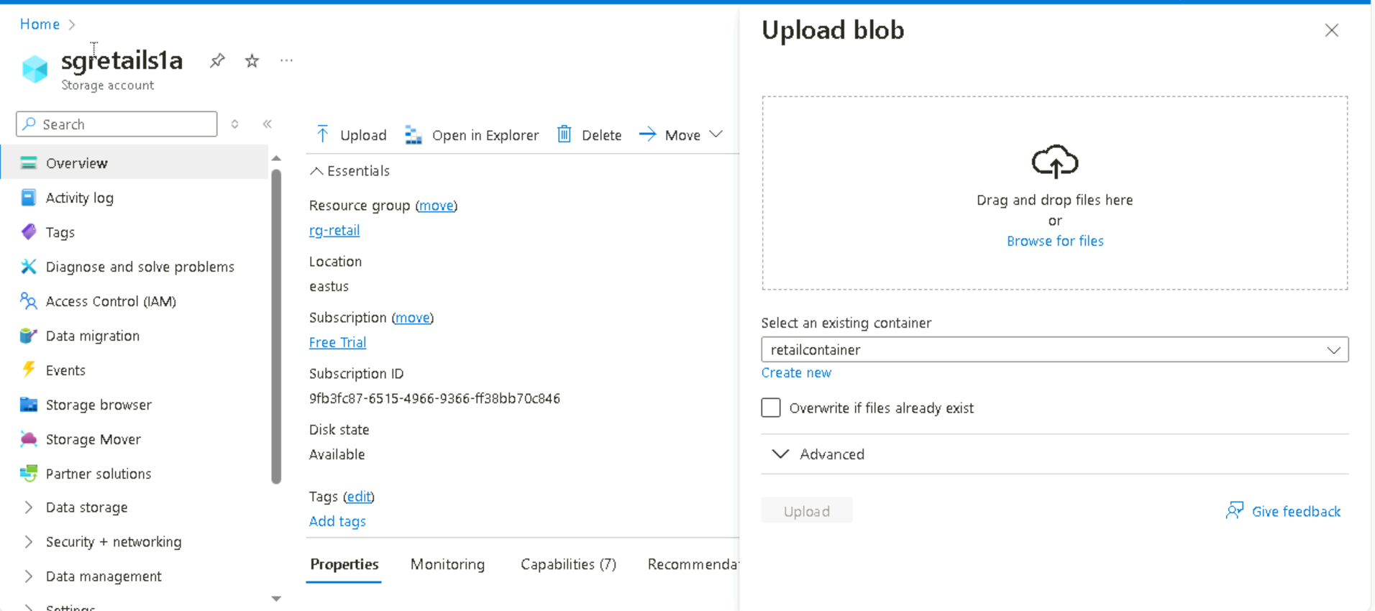  
after downloading upload retail\_db folder into the container from the github  
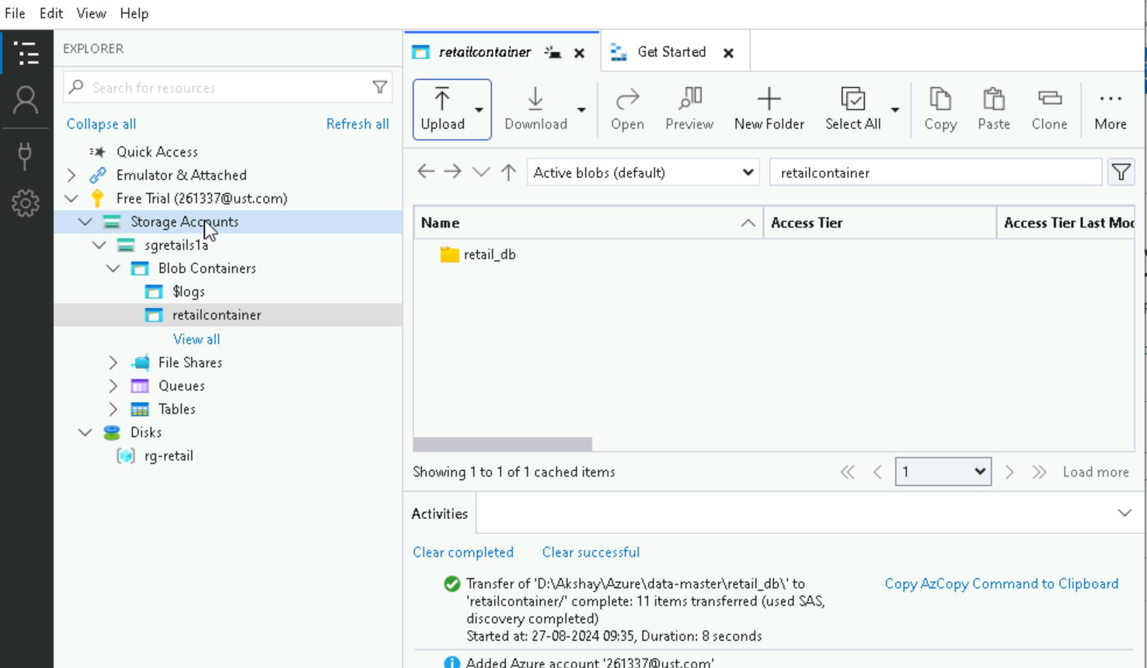

Disable the blob and container soft delete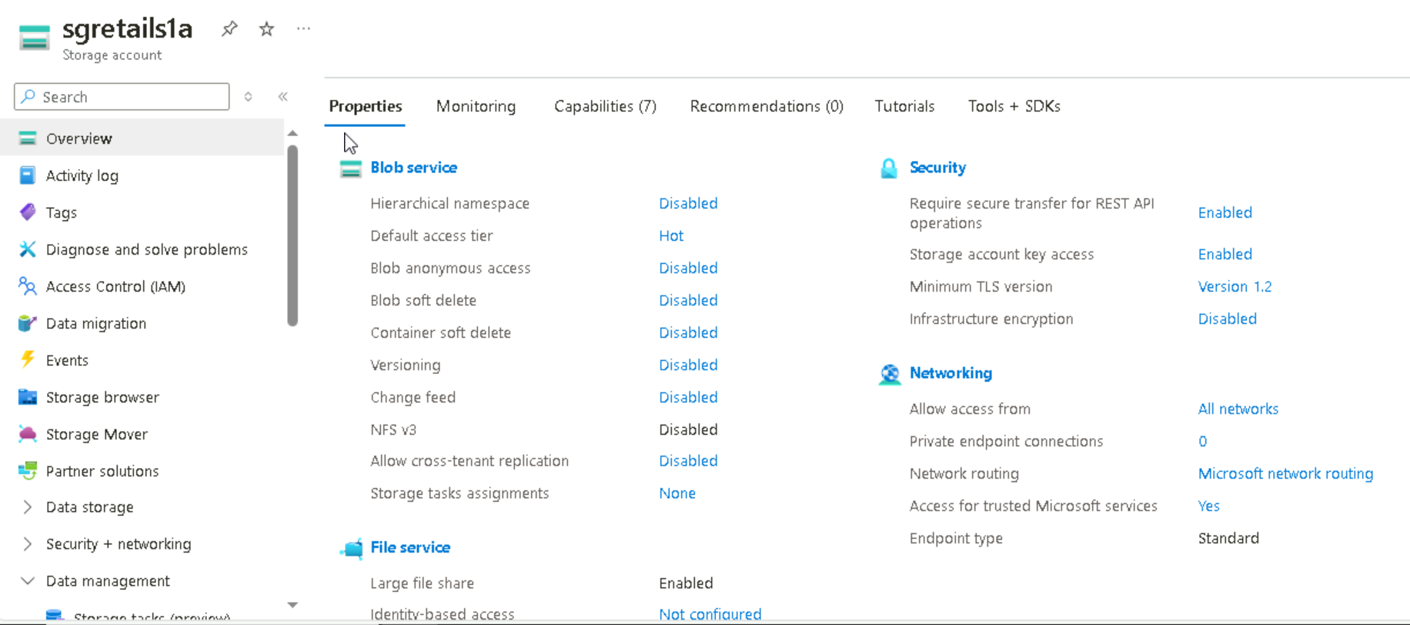



Upgrade account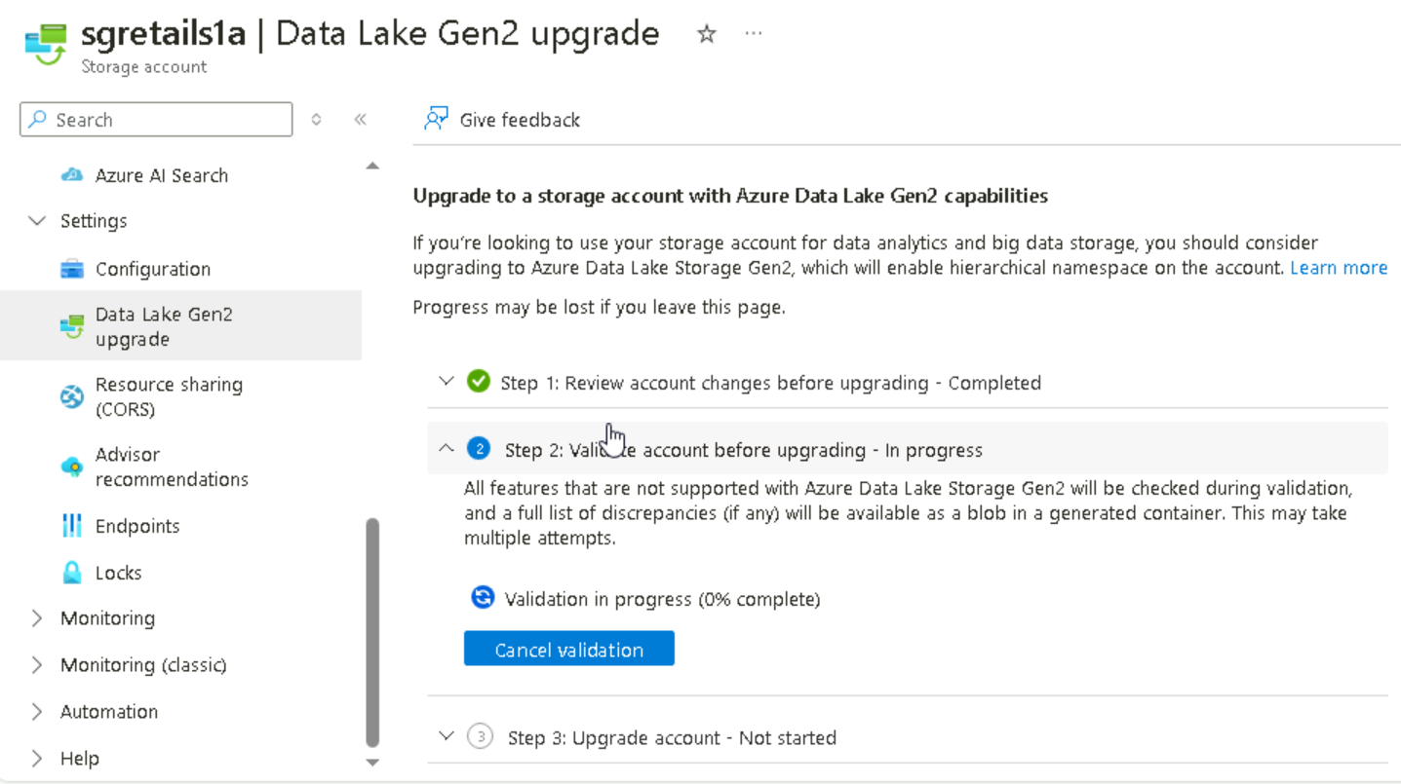

**Azure data factory(ADF)**

It accept one format and convert to other format which is acceptable from azure data factory(ADF)

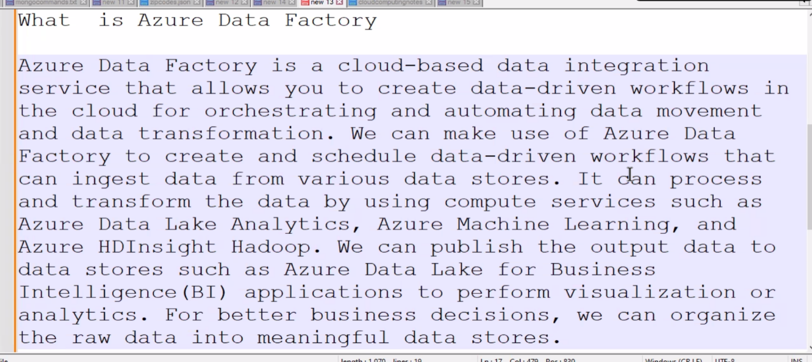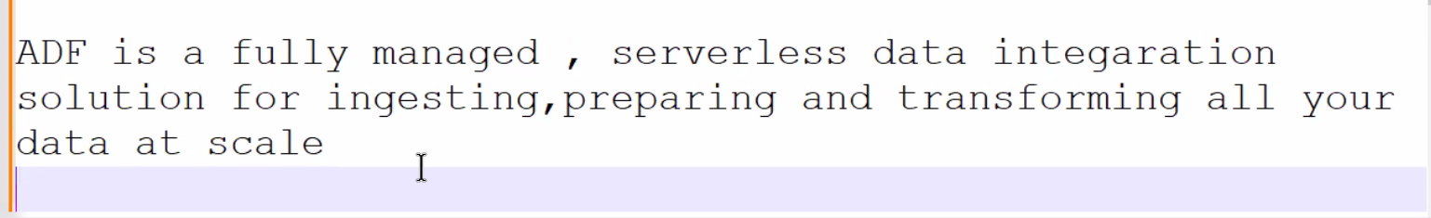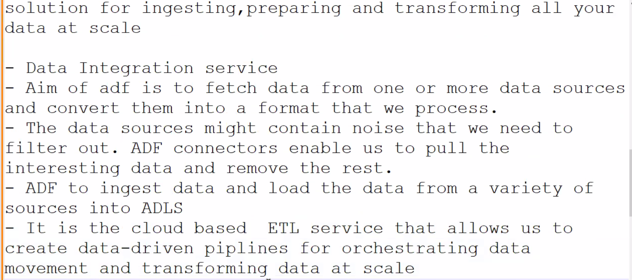

Data from cloud,apps,twitters,FB,On-premises DB’s all these are going to azure data factory and from here it will go to DB’s

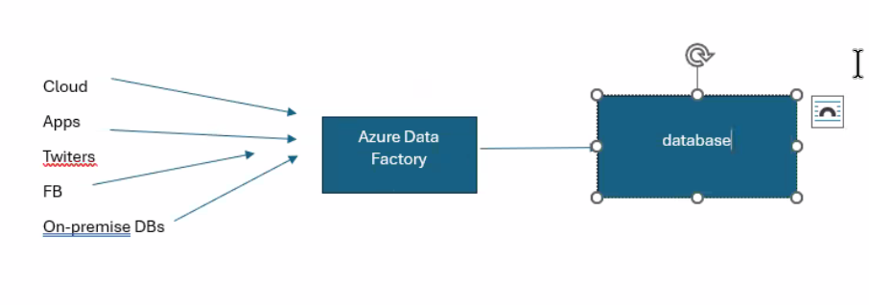

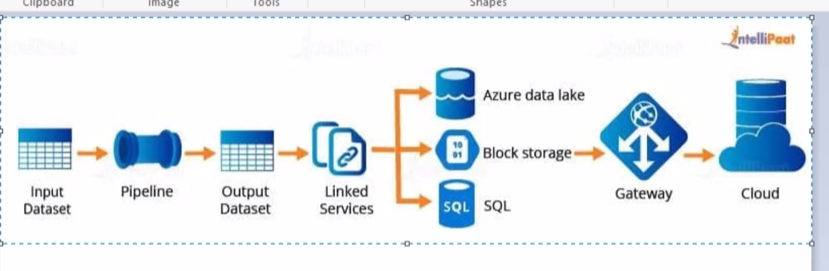

Creating of data factory and create it.  
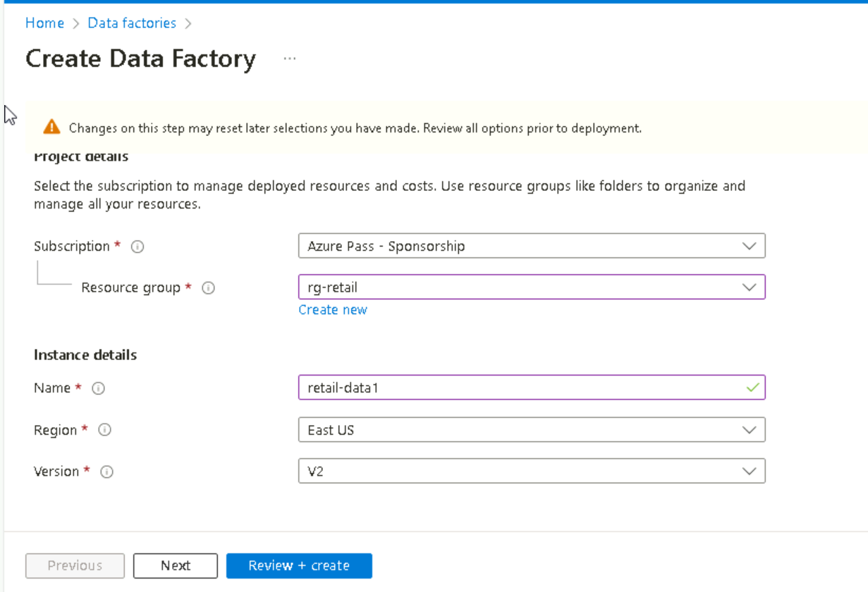

Click on Launch studio  
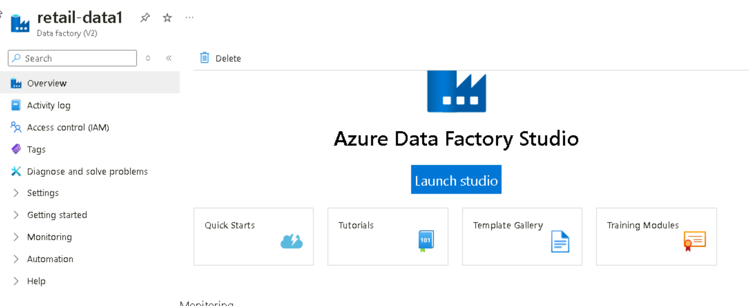

Create link service azure blob storage  
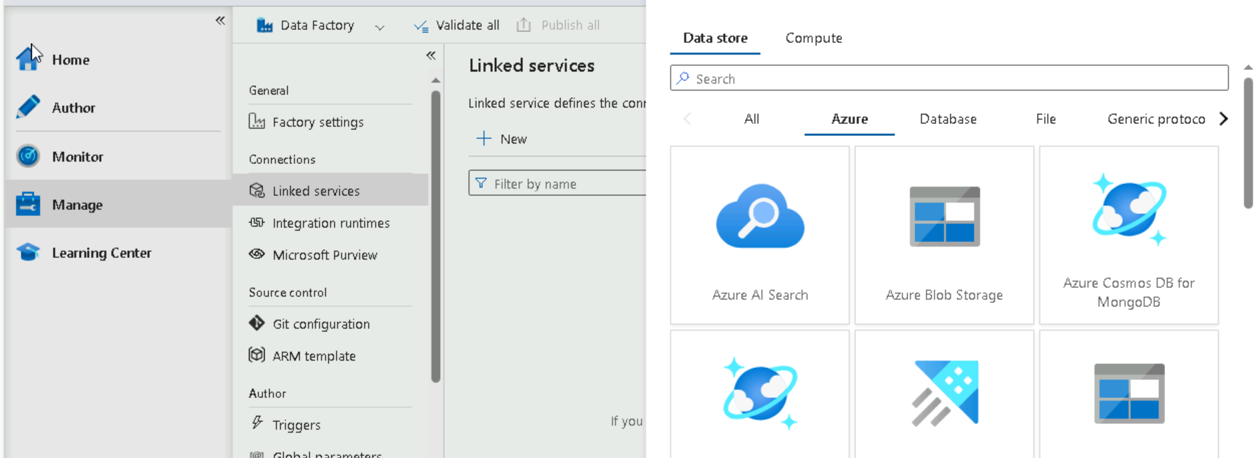  
give name and select the storage account which we want to link

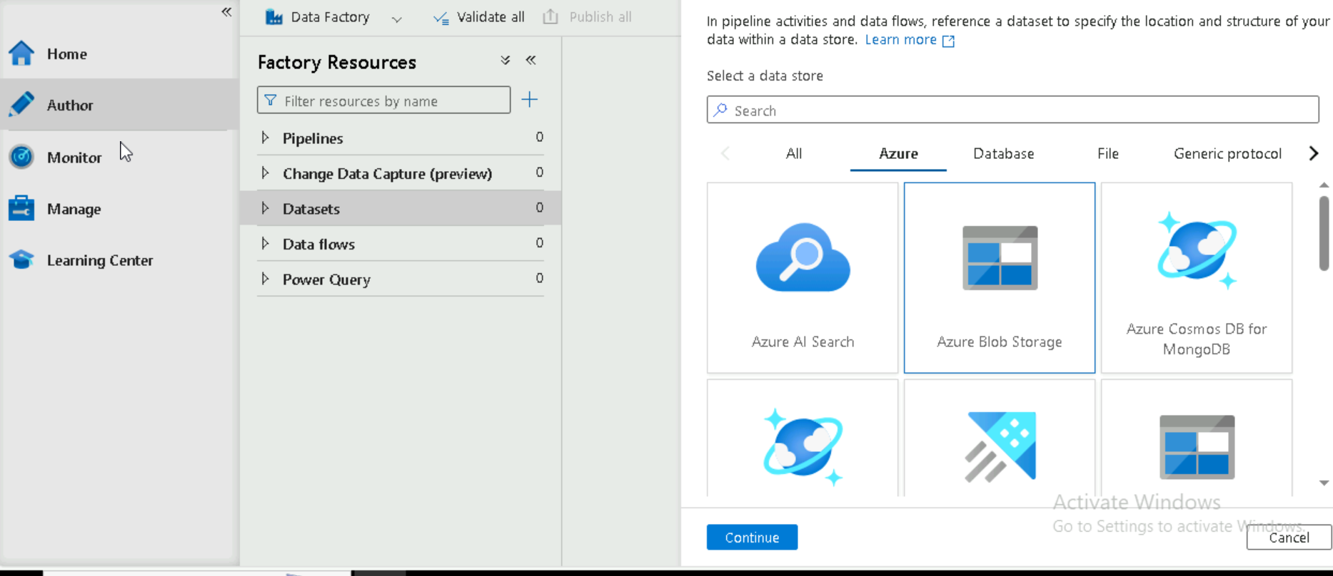  
acuzre blob storage 🡪 delimited text 🡪 uncheck the mark and select link we created 🡪select the path  
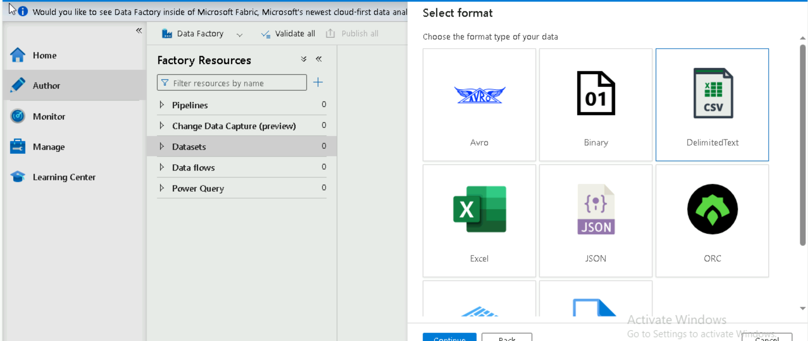

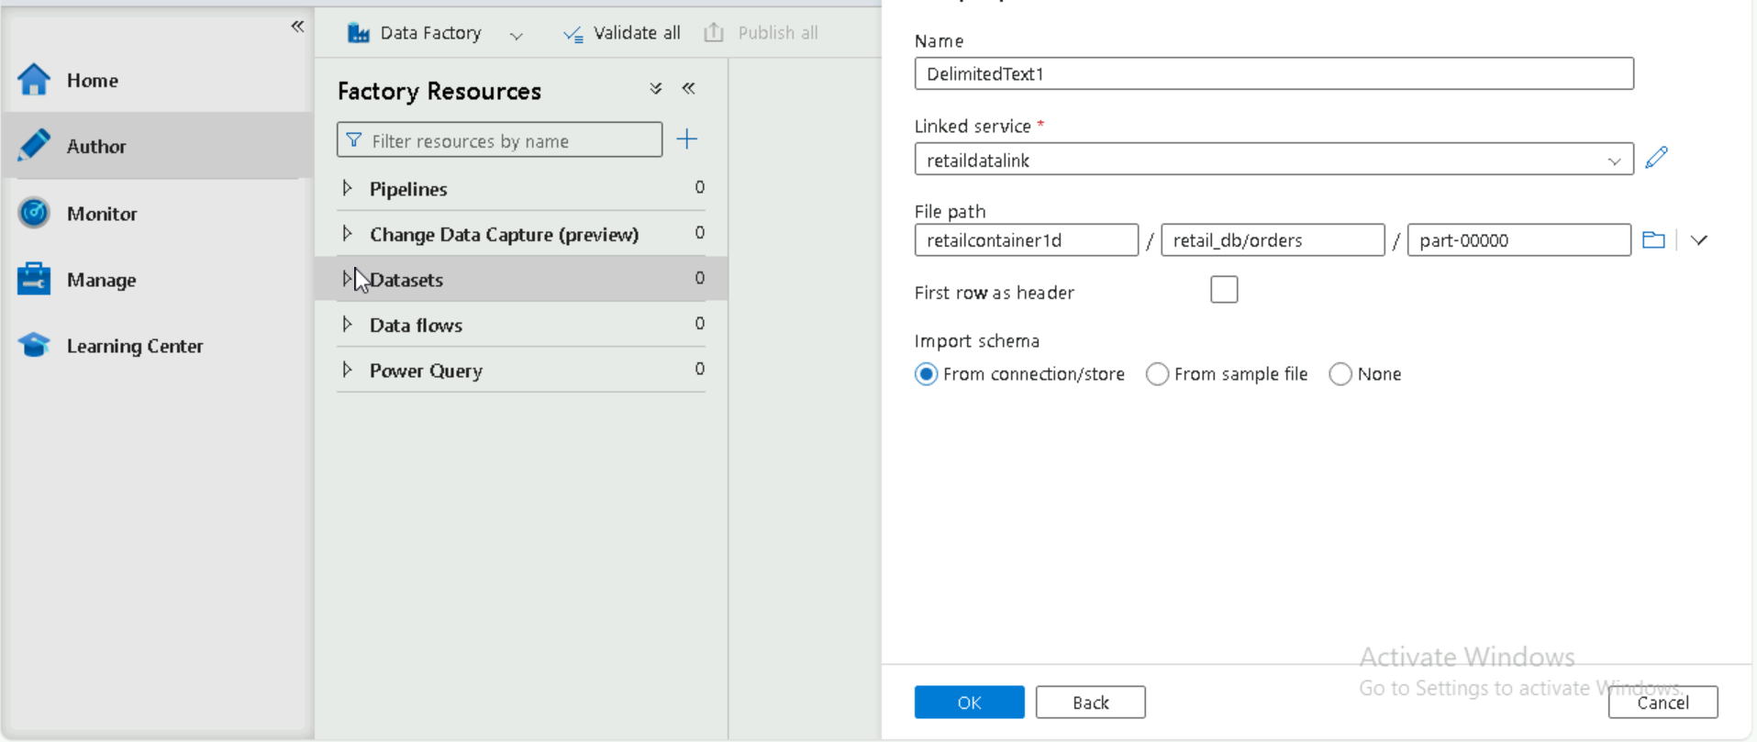

Select publish all and rename the dataset as ordersCSV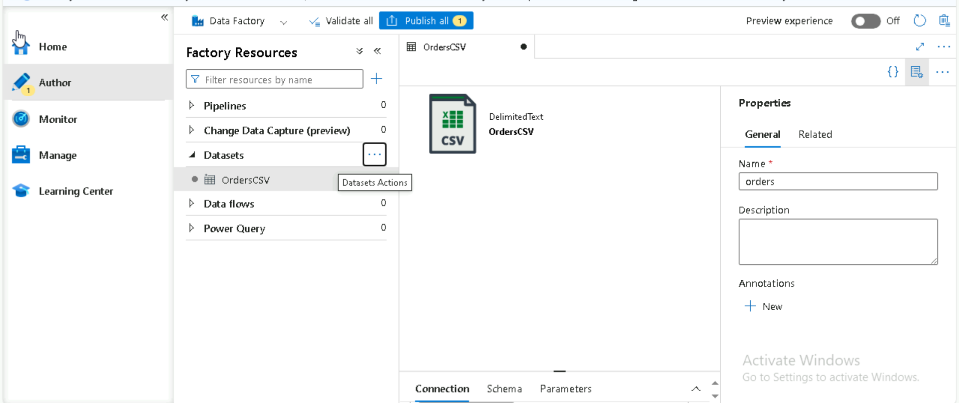  
in connection we can drag right to see the data preview.  
  
Create 2nd data set this is a empty parquet file, while creating give none option

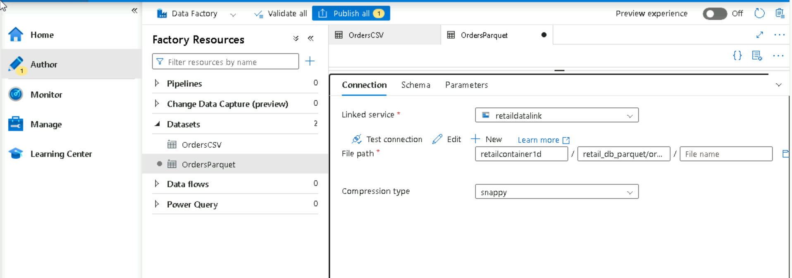

Create data flow 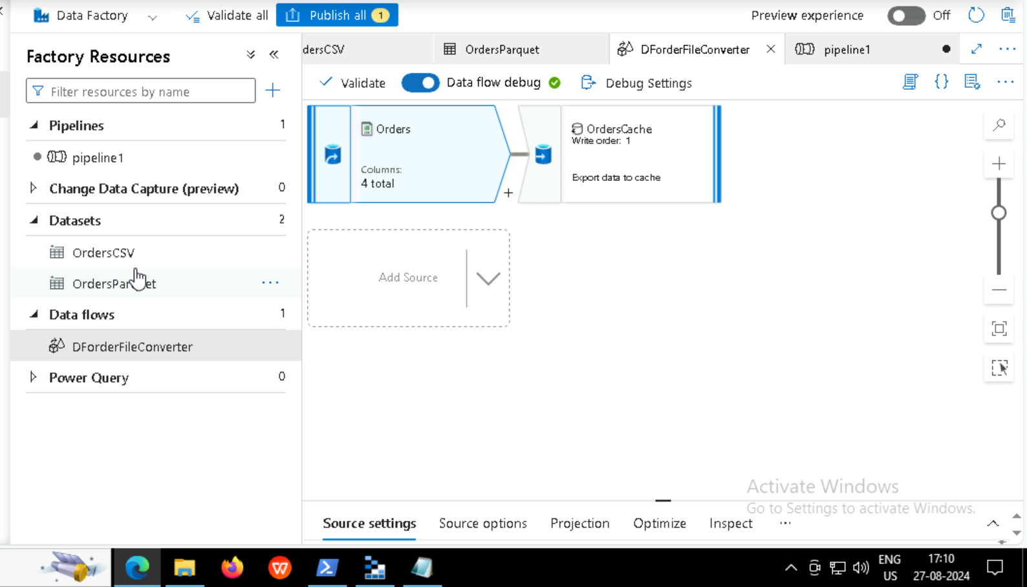  
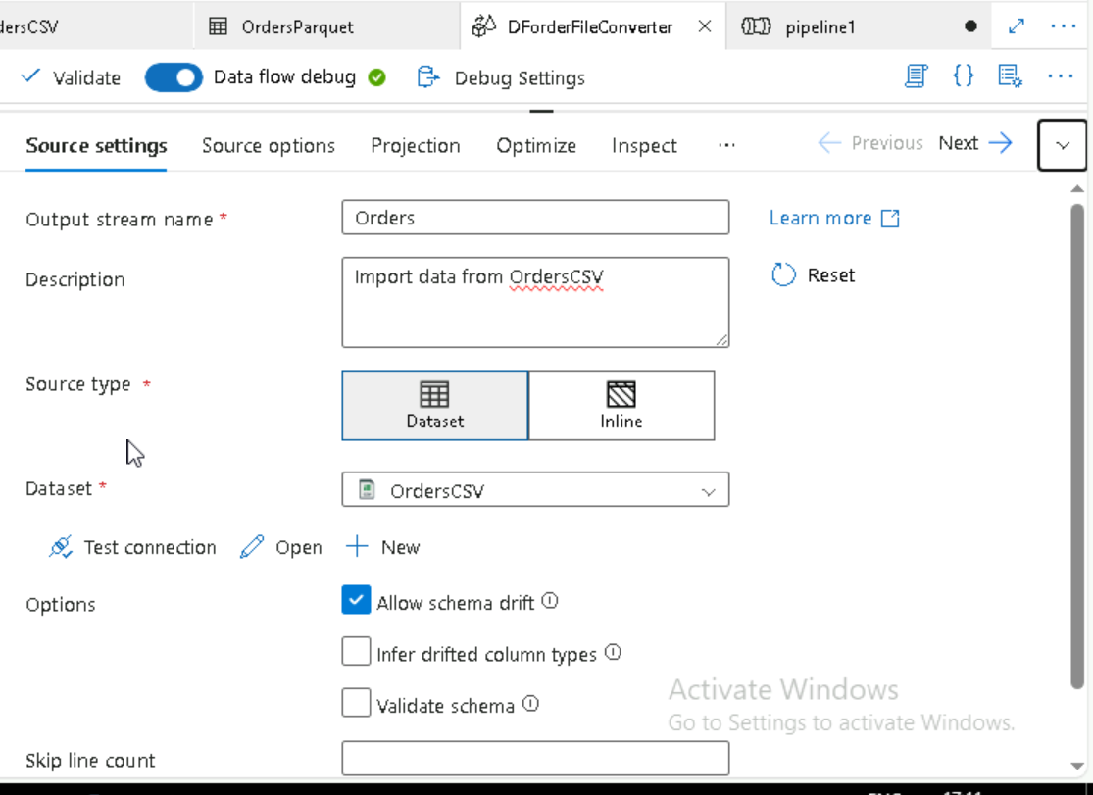

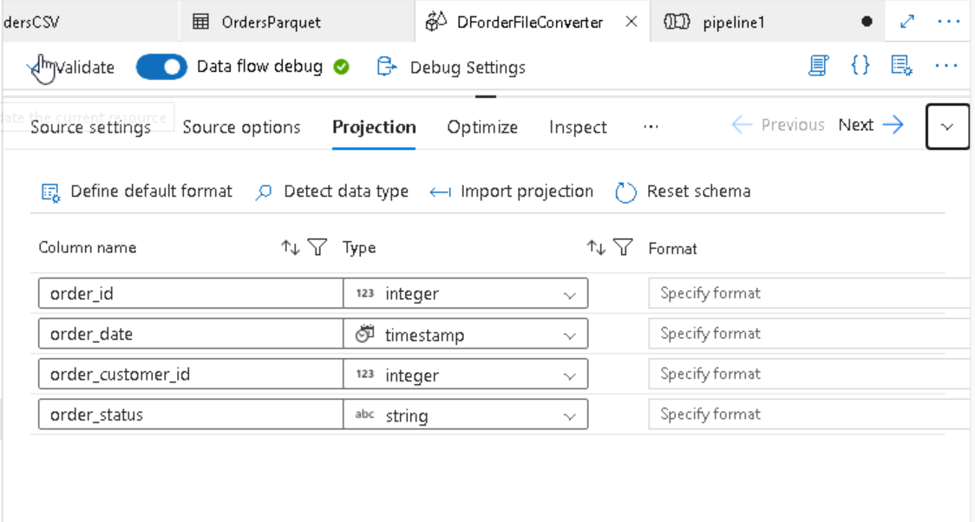  
and later give data preview.  
  
whether the data flow is correct or not will create the SINK for orders   
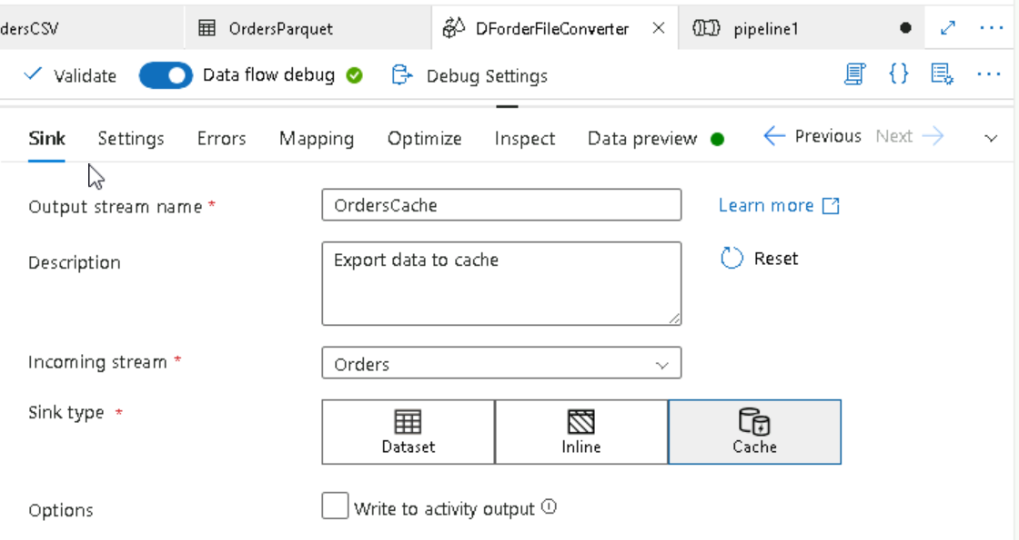  
later give validate all , if no error found publish it.  
  
next create a pipeline, add **data flow** from the activities  
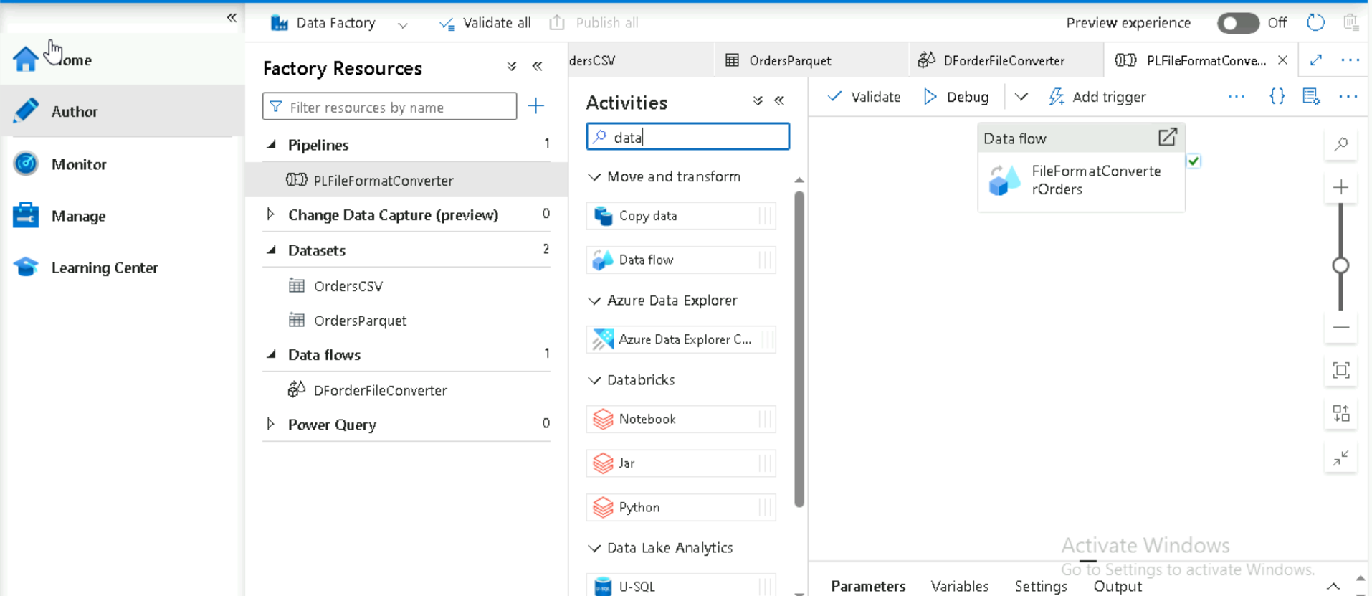 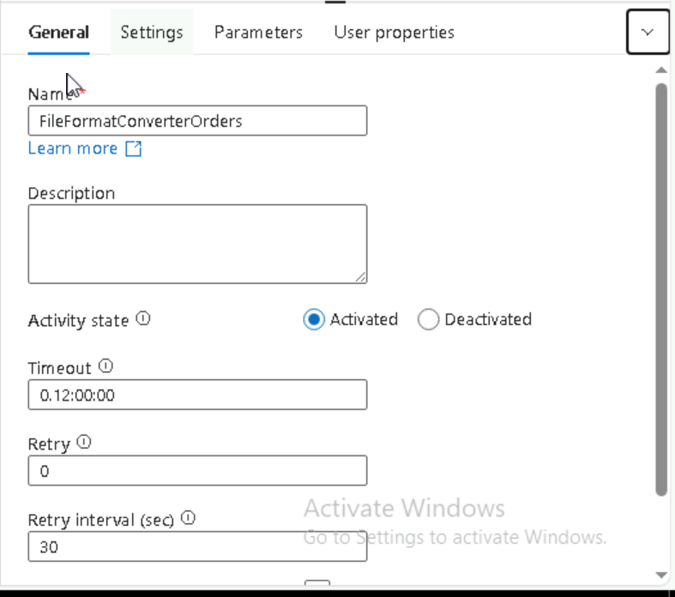  
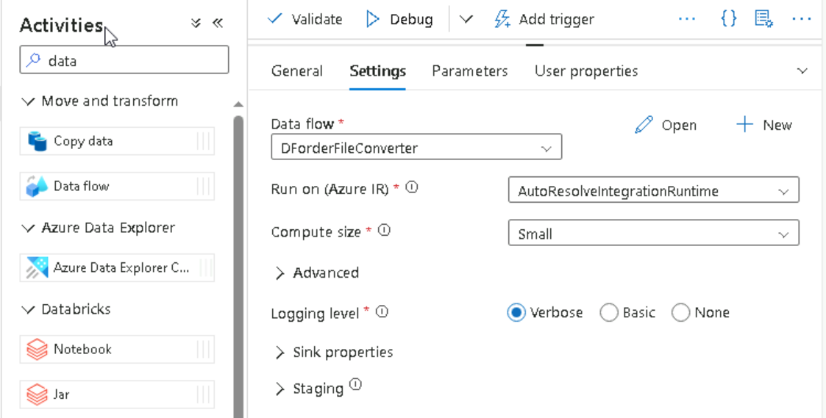  
  
Then click on add triggers and click on Okay ,, in monitor we can see the pipeline running.  
  
Convert from CSV to parquet   
Create sink  
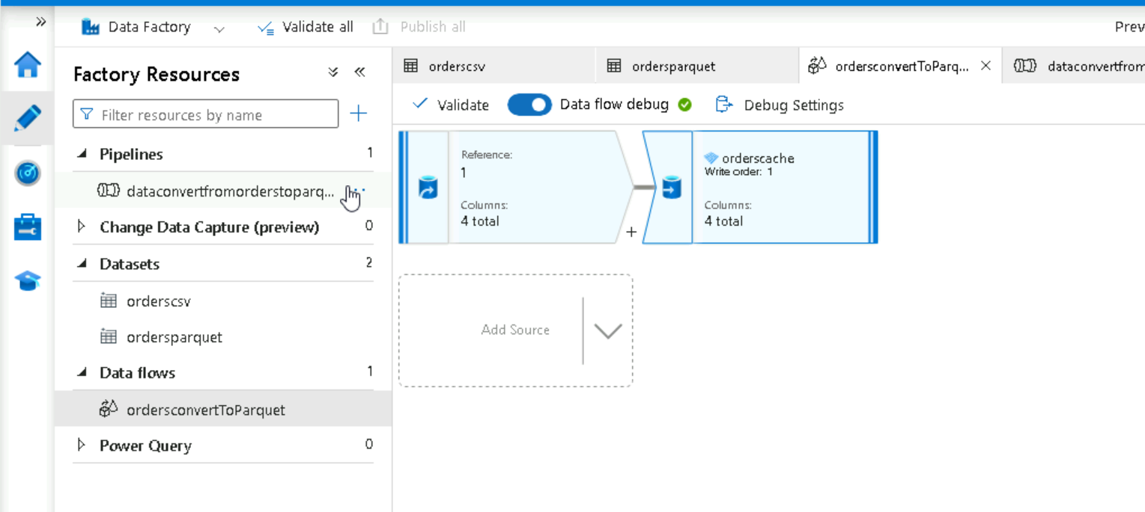

Select the destination parquet path   
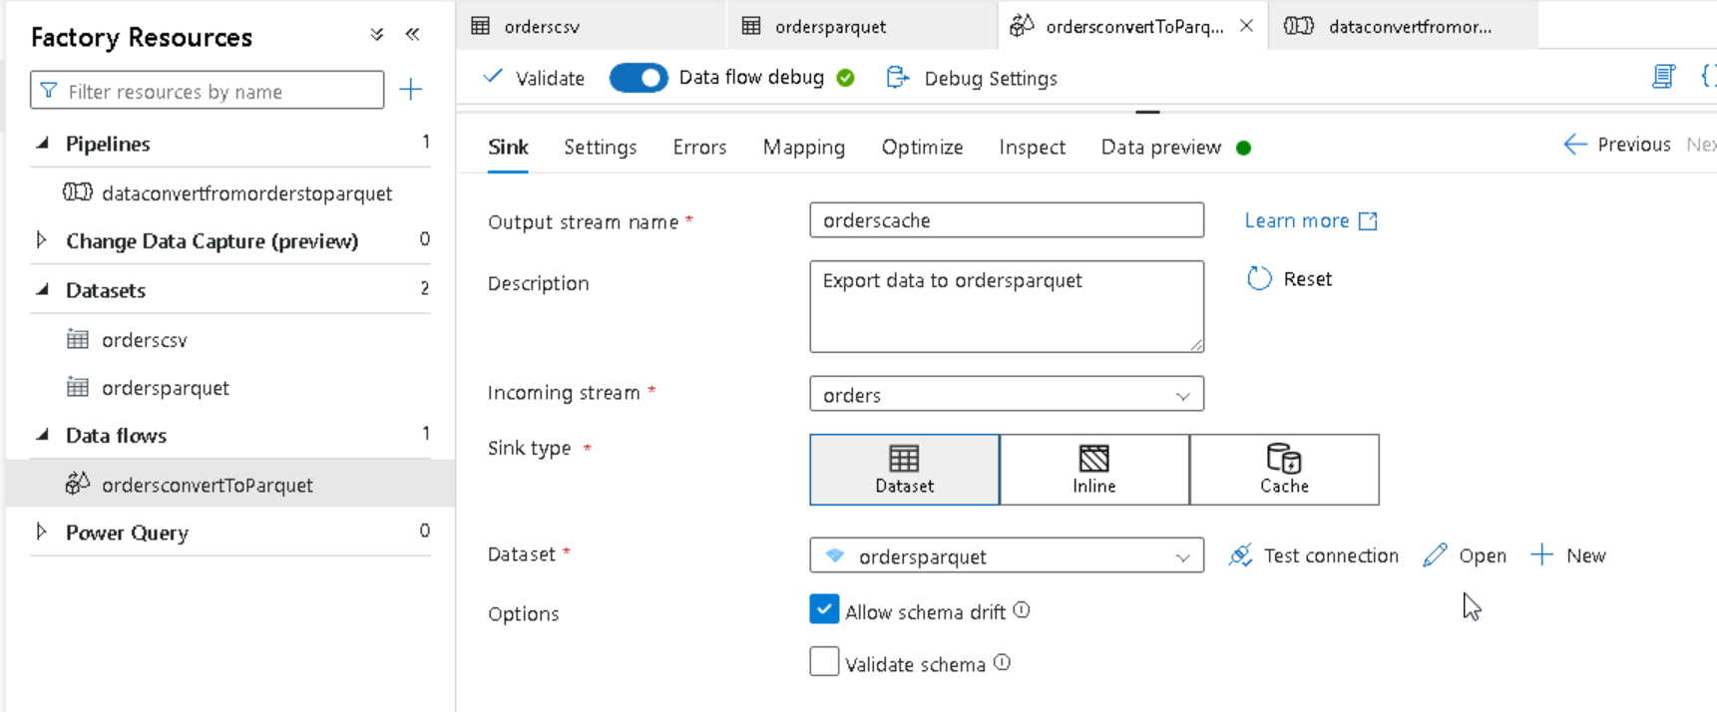  
  
  
**Task 1**

[Use the Azure portal to create a data factory pipeline - Azure Data Factory | Microsoft Learn](https://learn.microsoft.com/en-us/azure/data-factory/tutorial-copy-data-portal)

**ETL**

Create one more data set under azure blob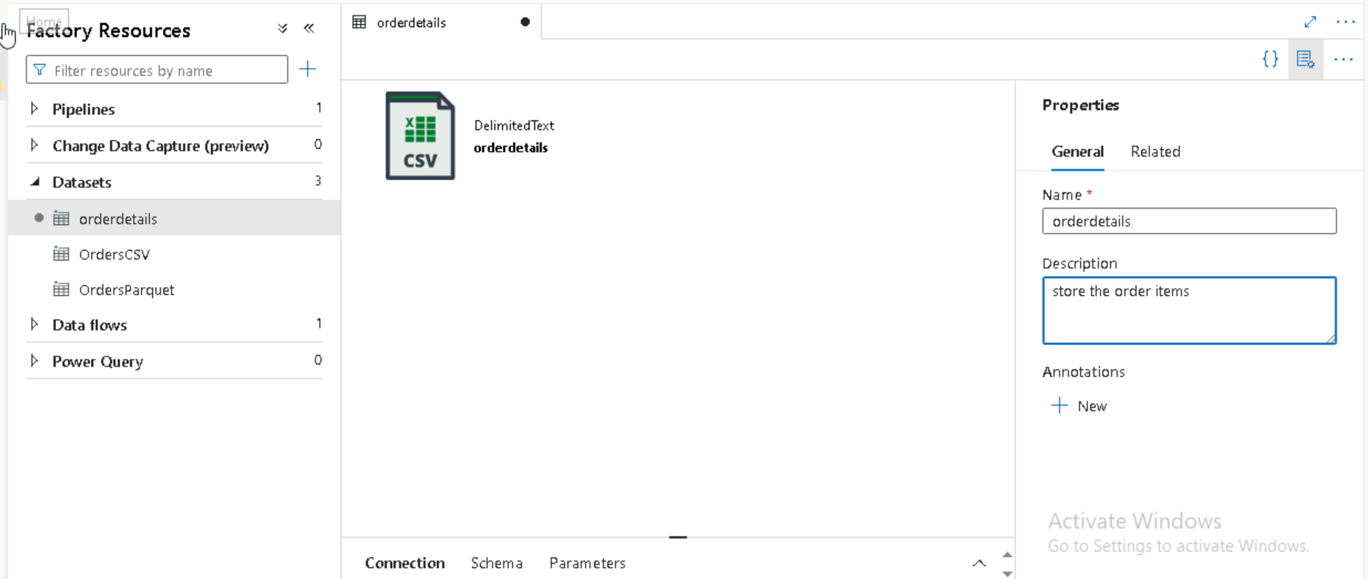

Rename orderCSV as order  
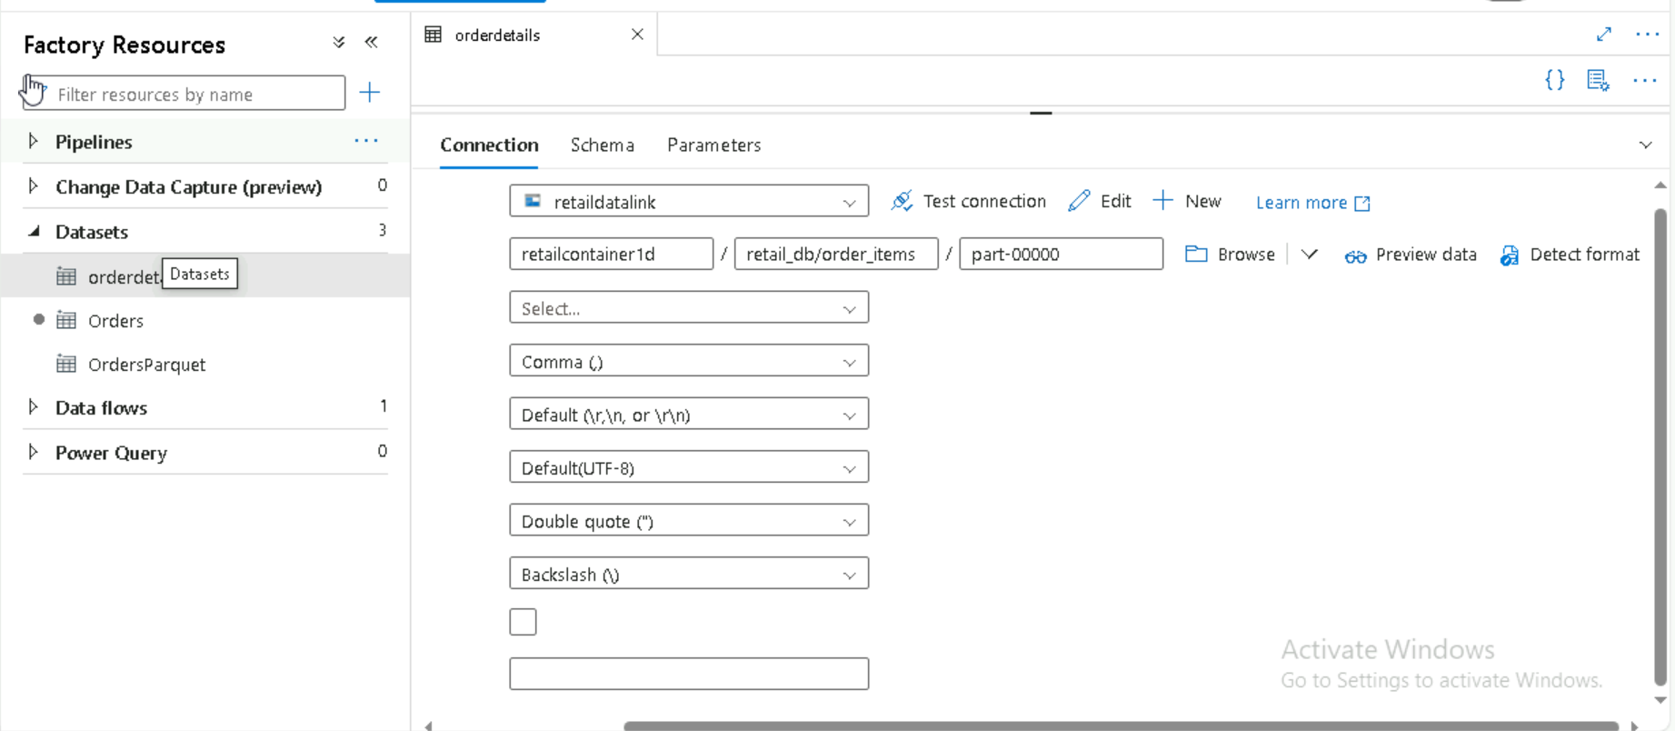

Cretae data flow   
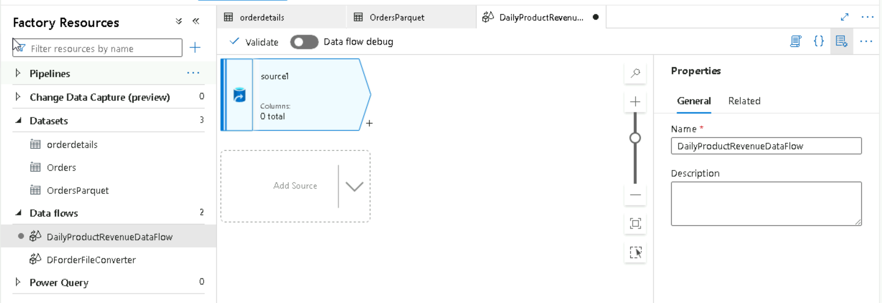

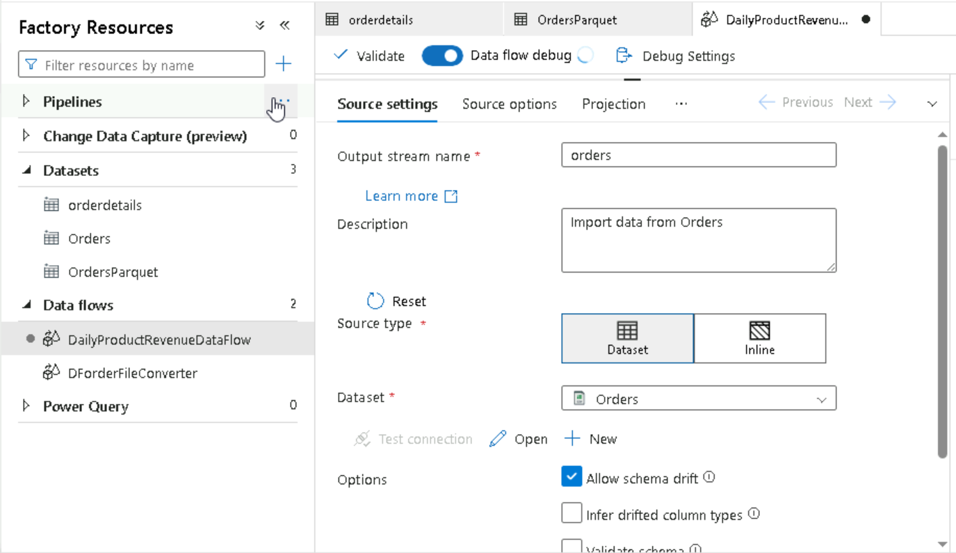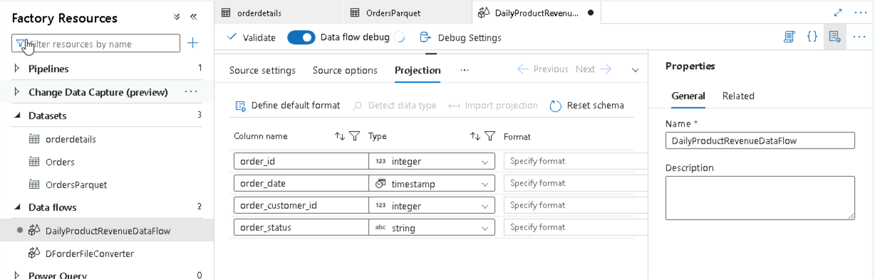  
  
Create Filter method by giving condition  
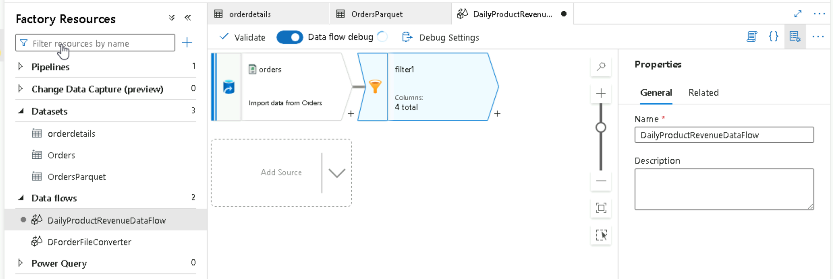

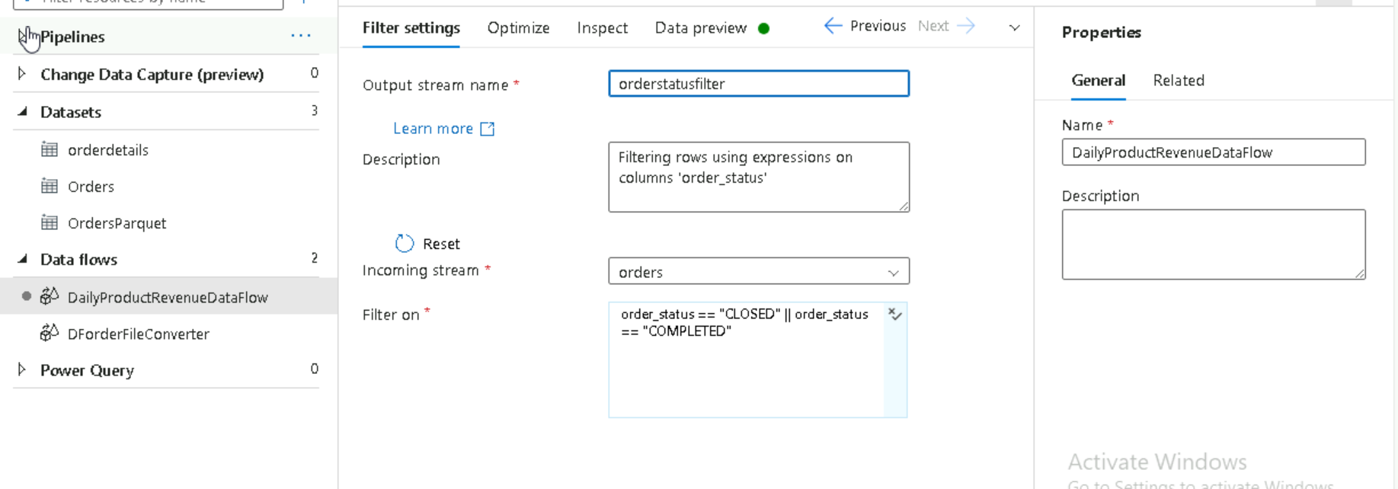  
once after publishing create a data flow pipeline and run the pipeline  
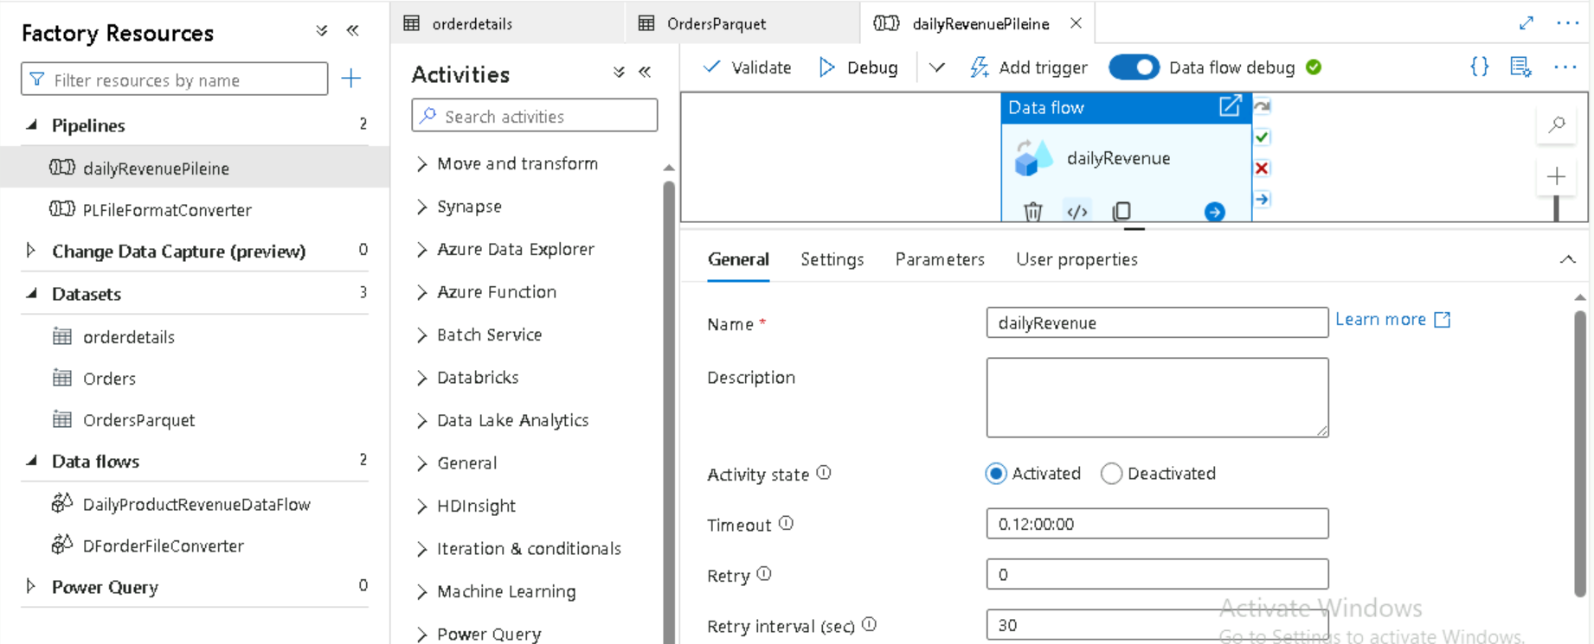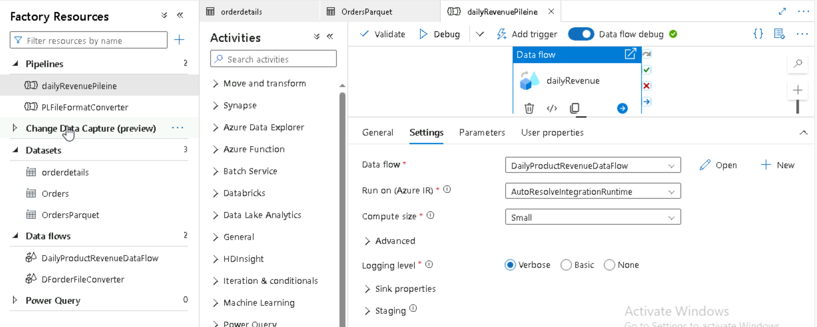

**JOINS**  
Create data flow for order details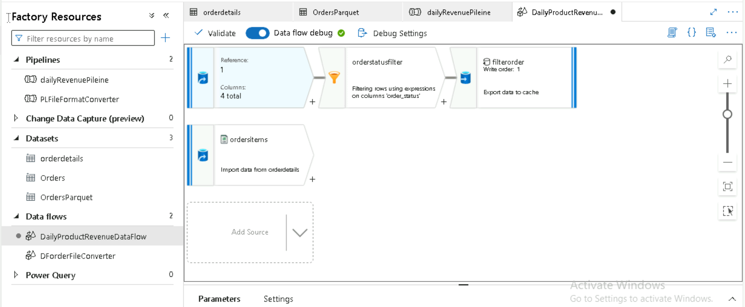

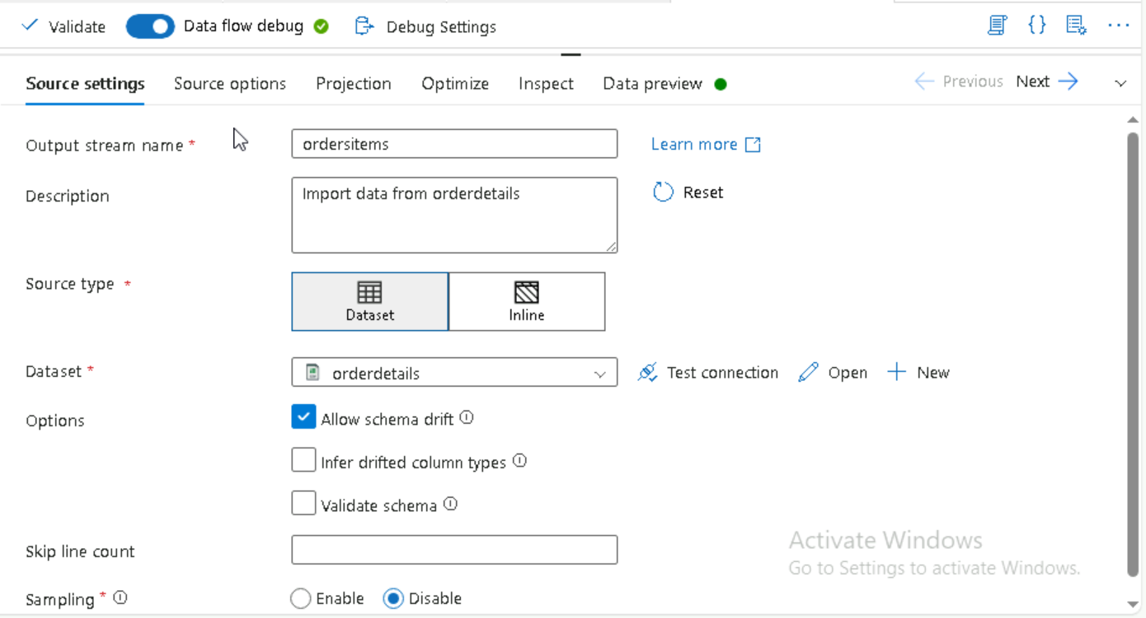

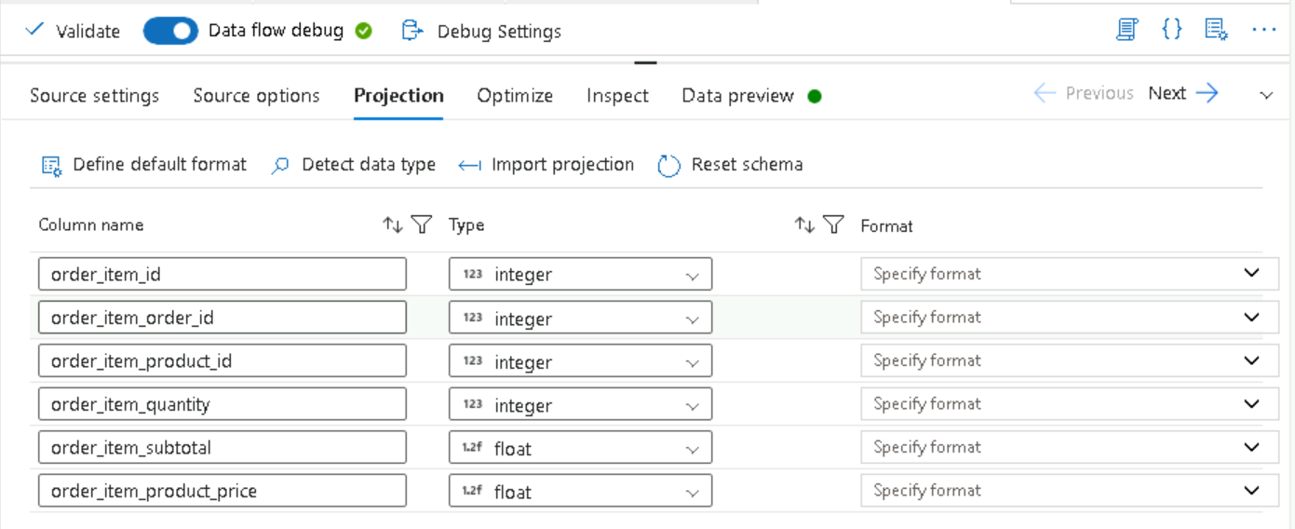

Now create join  
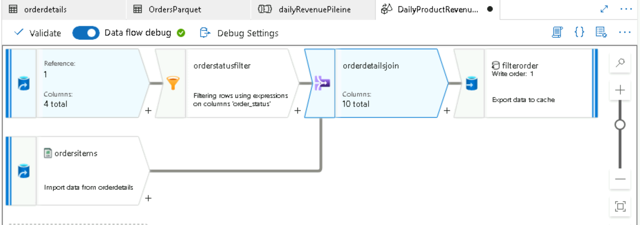  
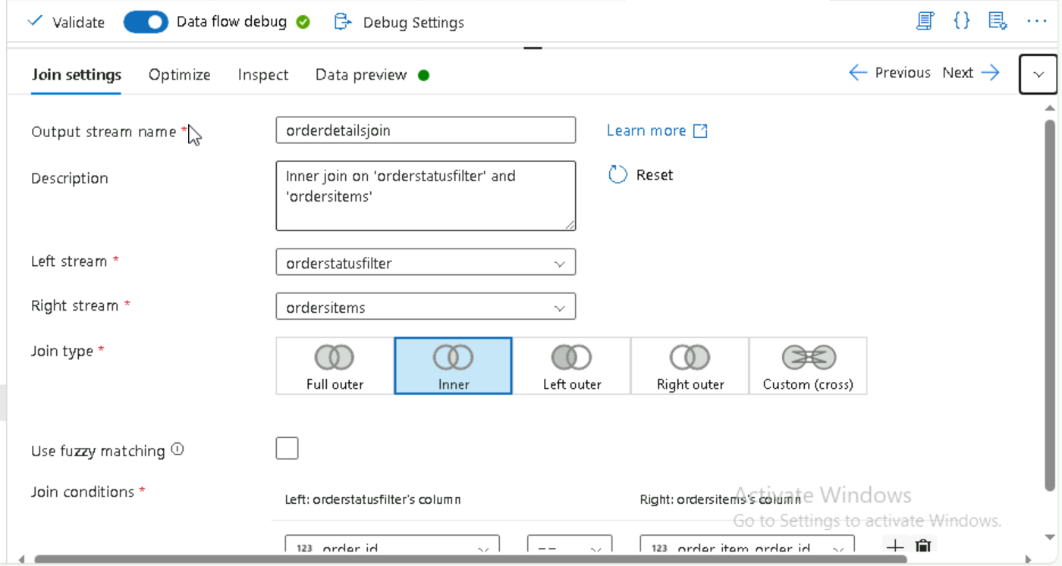  
  
run the pipeline  
  
now create aggregate function  
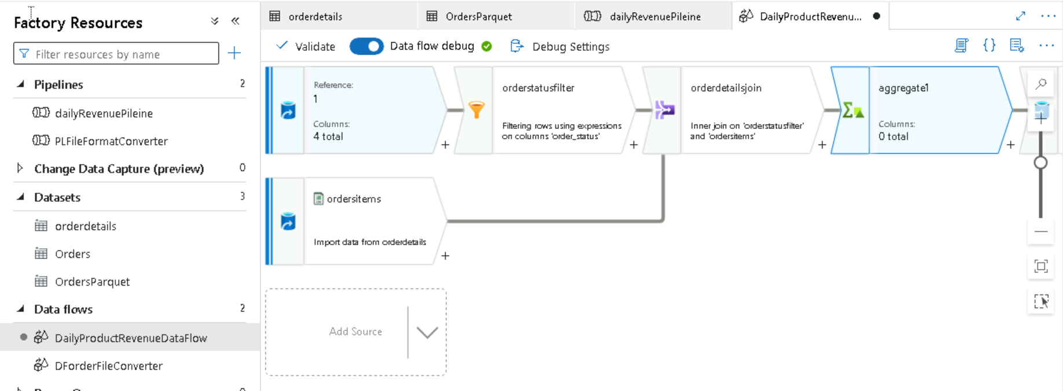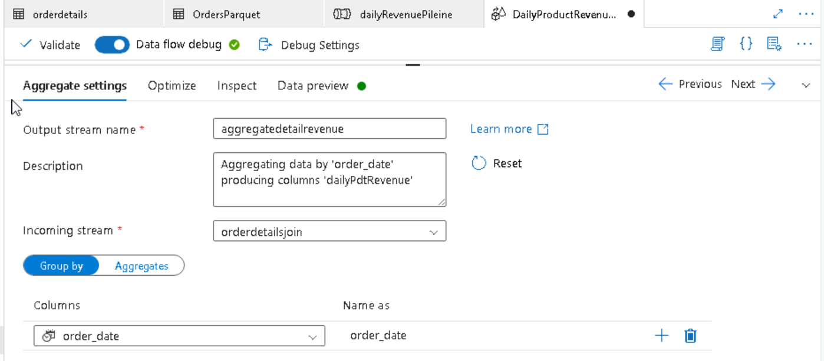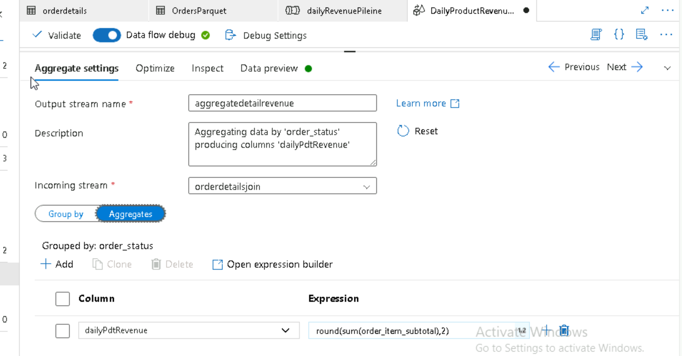  
  
**Creating parameter**

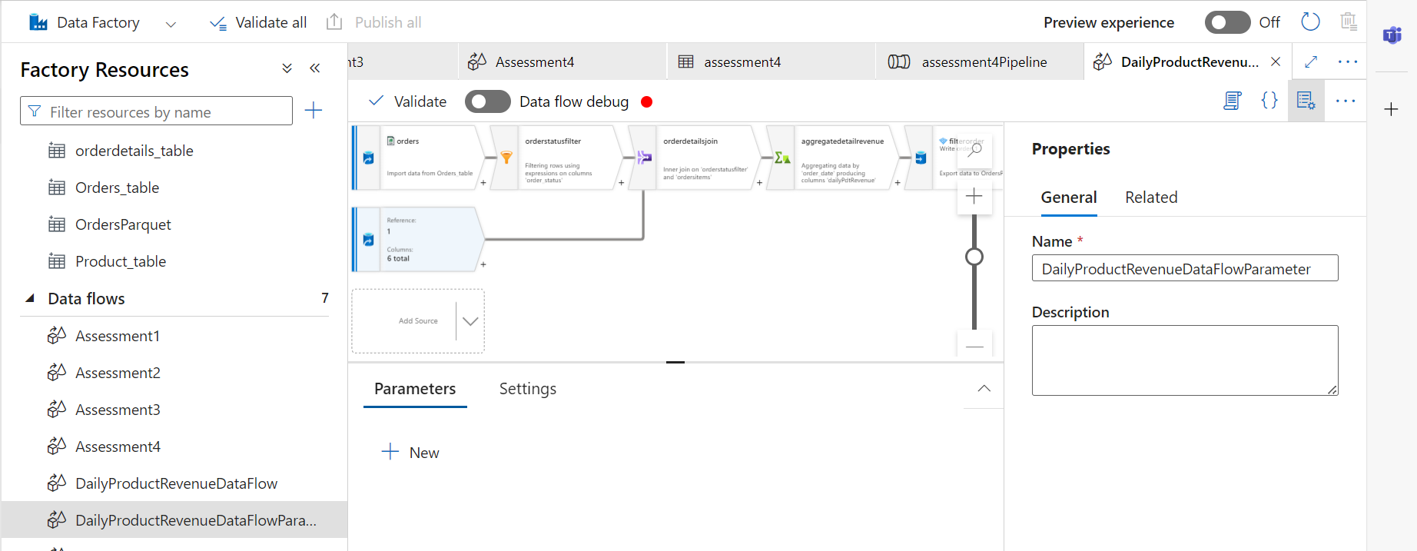

Create Dataset and create parameter  
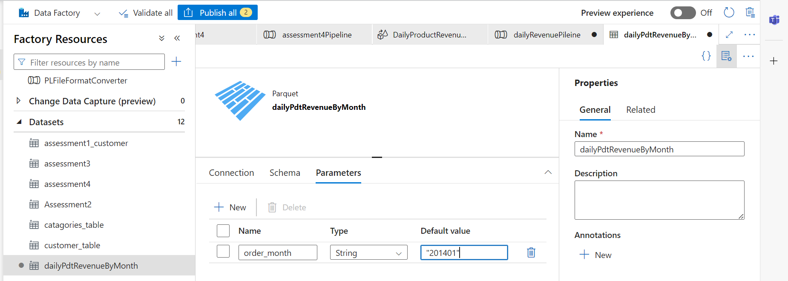

Click on add dynamic contnent  
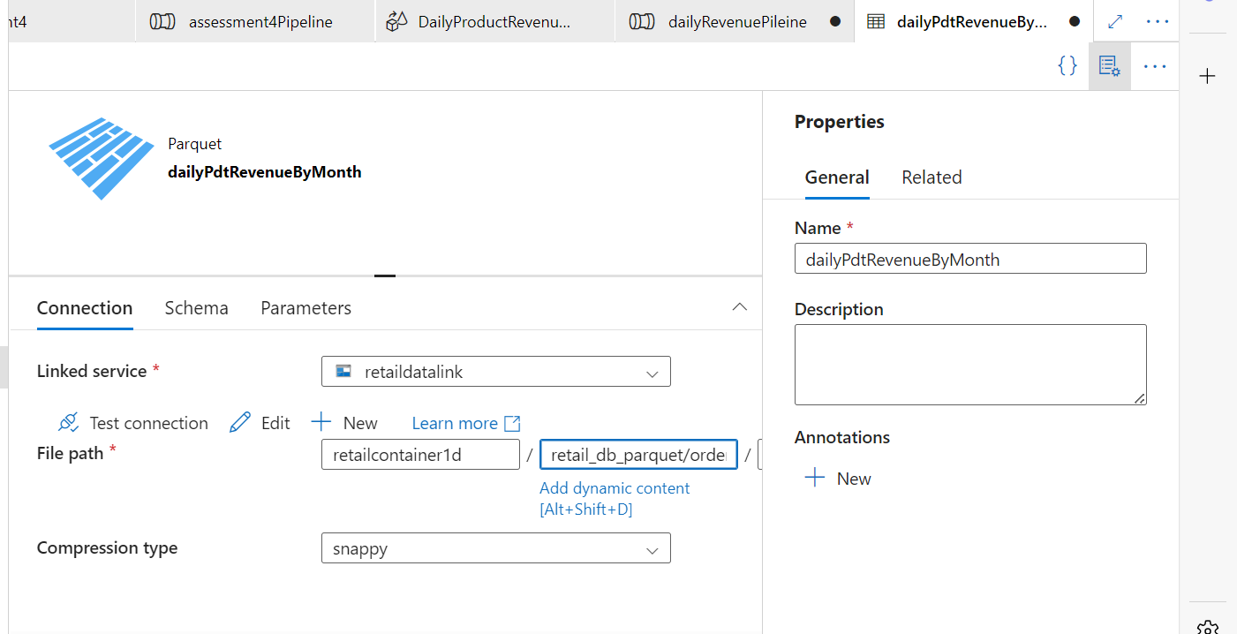

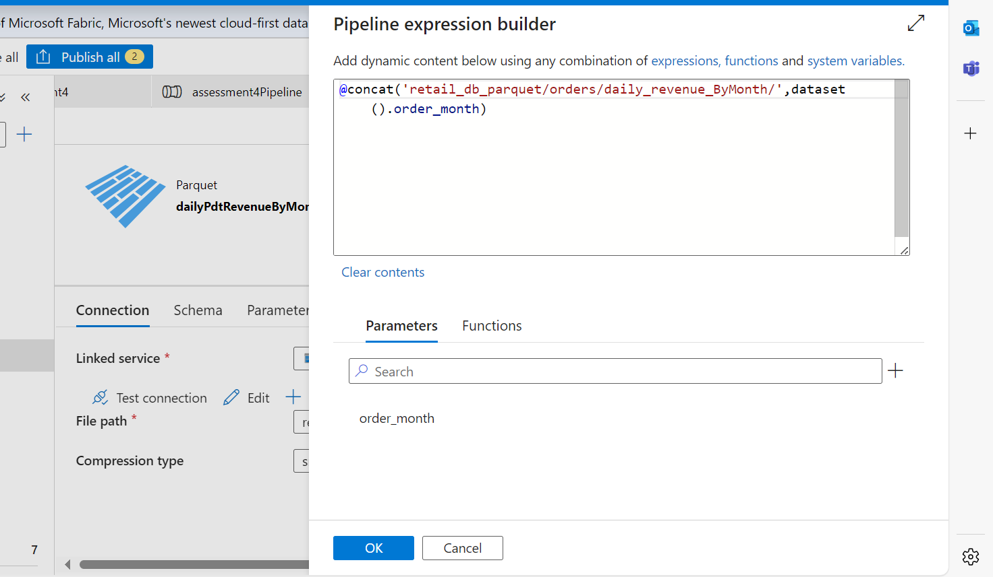

Now In data flow create parameter  
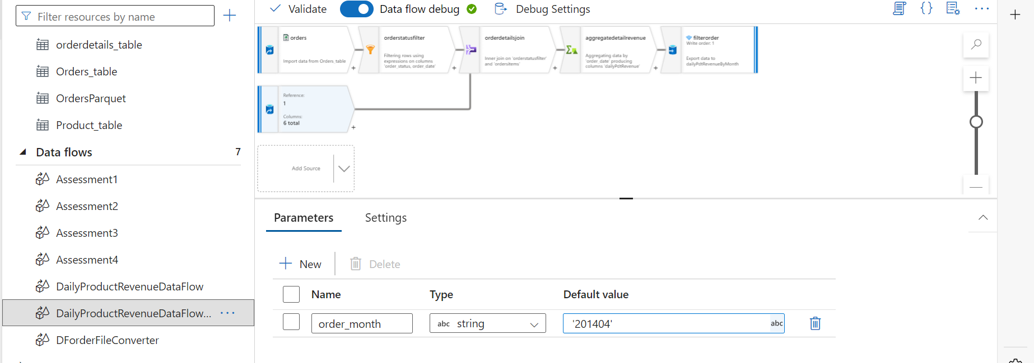

In filter write like below aggregation  
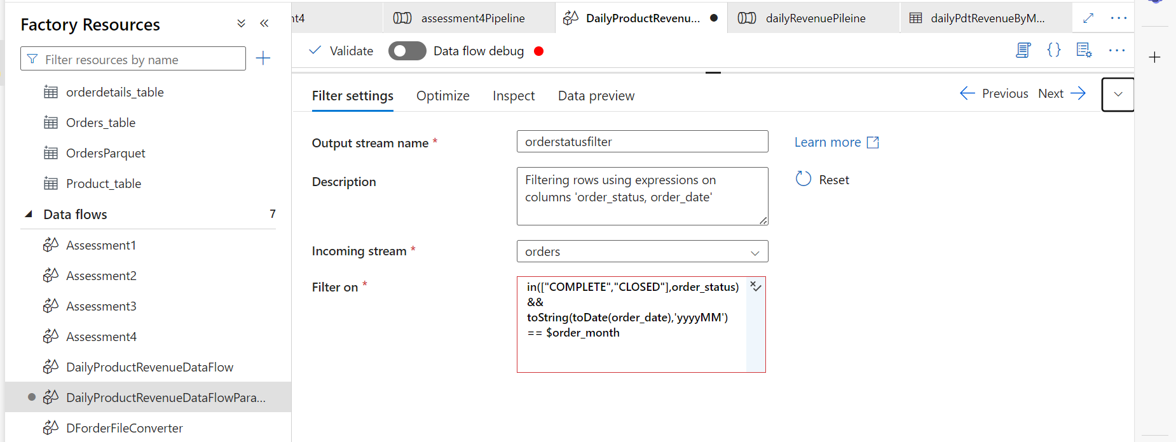

Now create pipeline and create parameter  
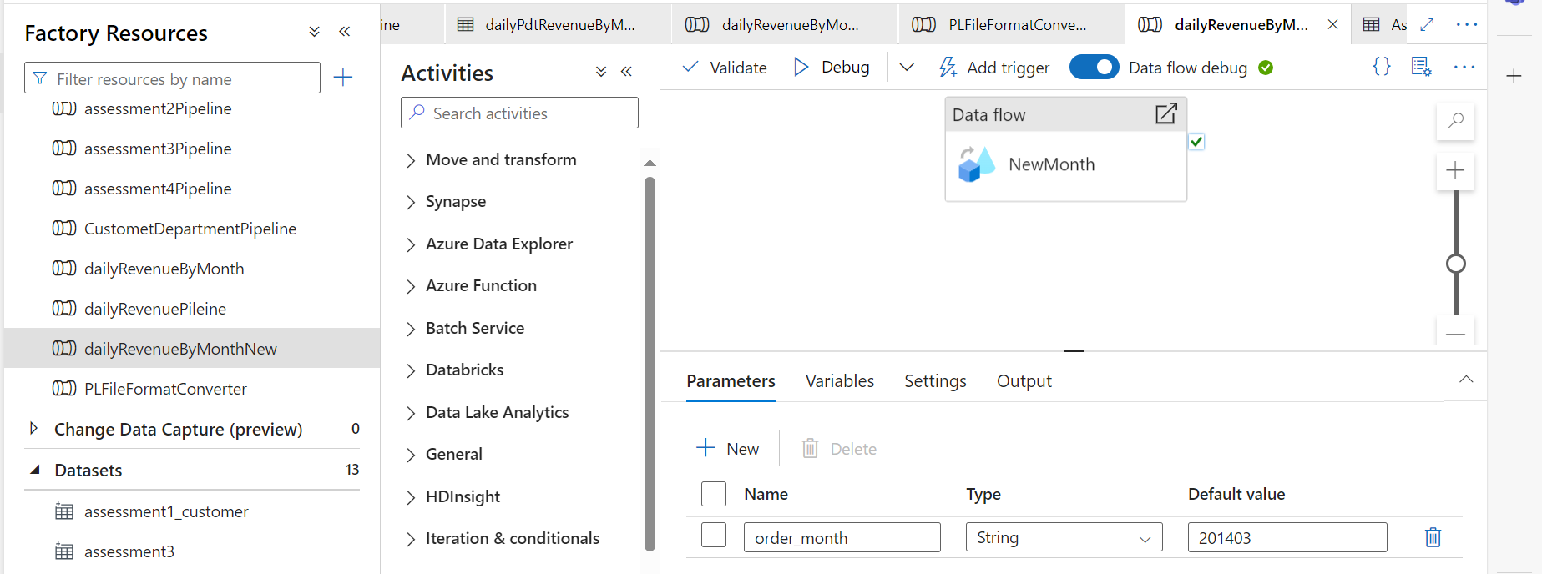

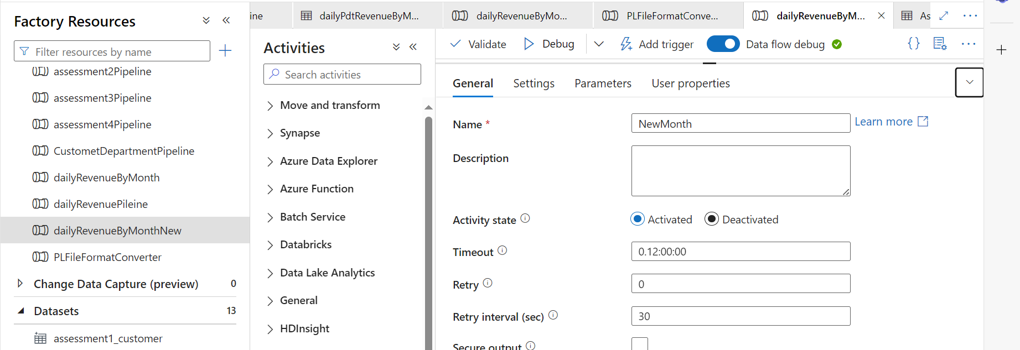

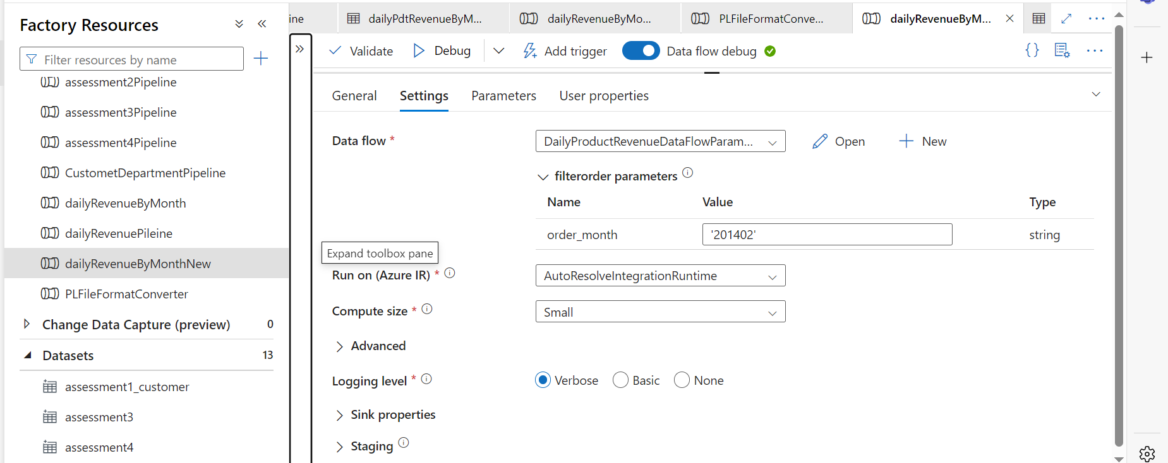

Create pipeline expression  
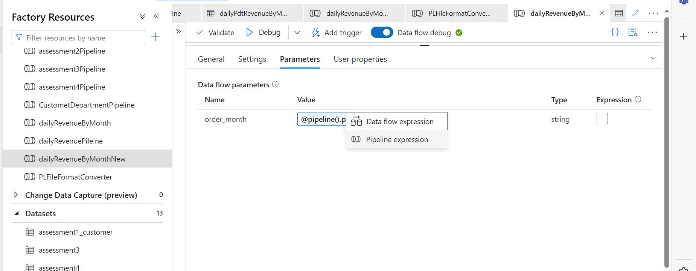

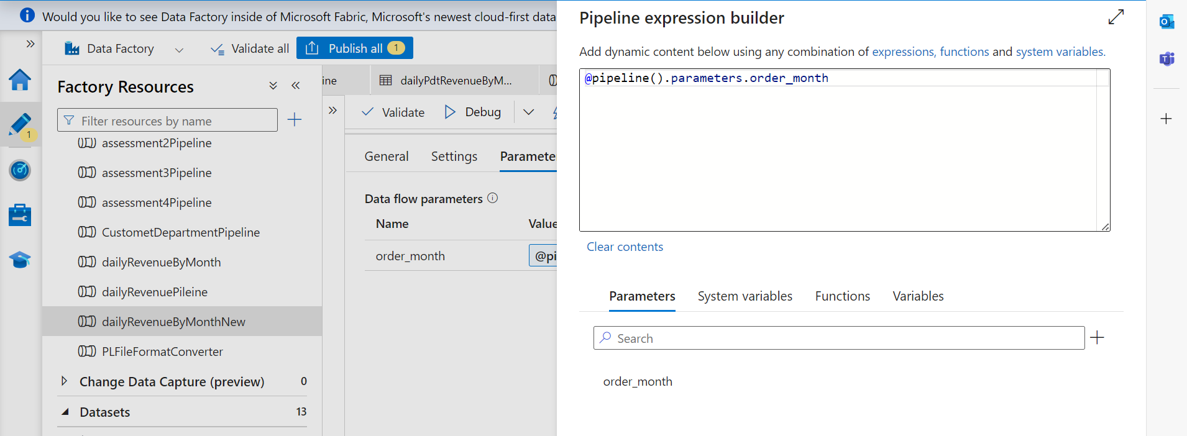

Now trigger the pipeline

**Assignments**

1. Get all the customers who has ordered from the department fitness and Apparel

2. Get all the order items for the customer who lives in the city Caguas and having customer fname starting with 'Mary' or customer lname contains 'Smith'

3. Generate the report of total sales customerwise for the customers whose orders are not closed or completed.

4. Generate the report of total sales order\_date wise, customerwise and orderstatus wise.

Creation of For Each Pipeline “activity demoPepline”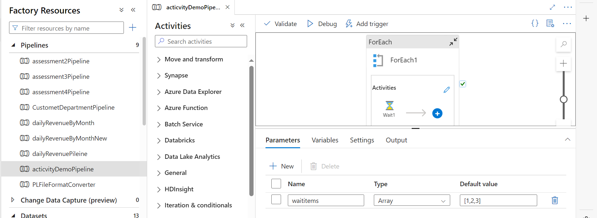

Create parameters  
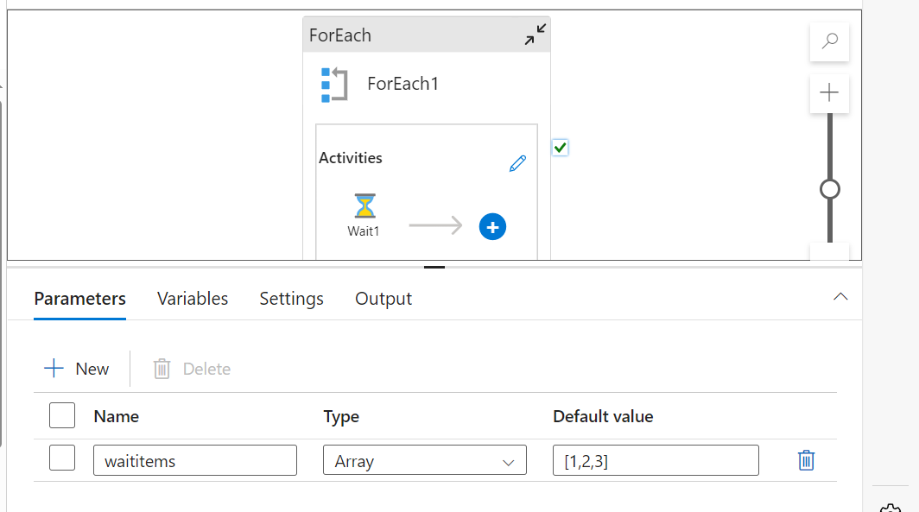

Edit and add wait activity and in setting write @item()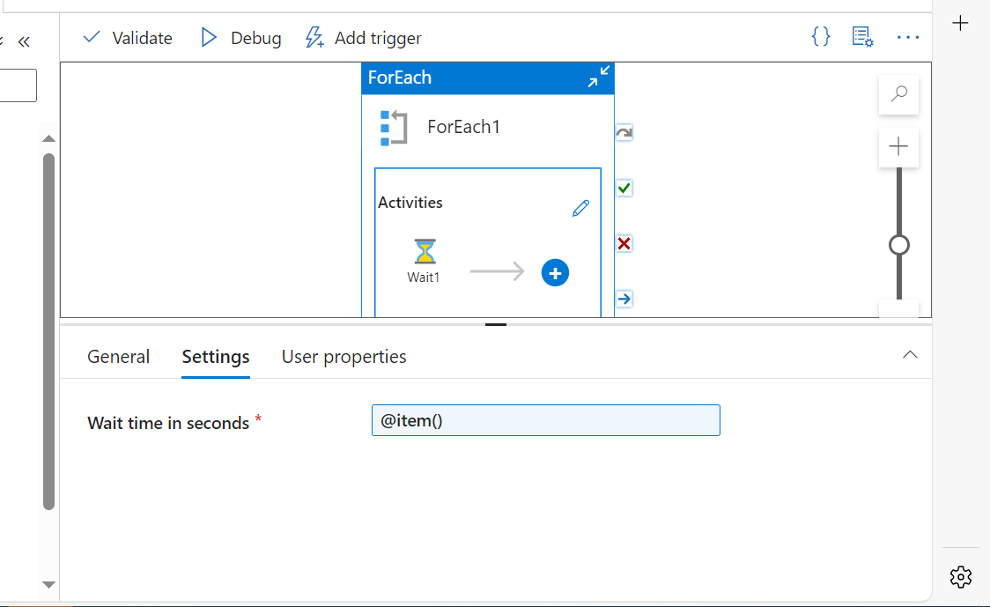

For each parameter in setting select the parameter which we created  
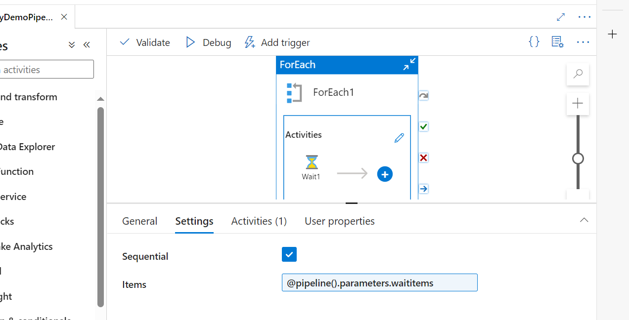

🡪publish and trigger the pipeline

---------------------------------------------------------------------------------------

Create SQL SERVER

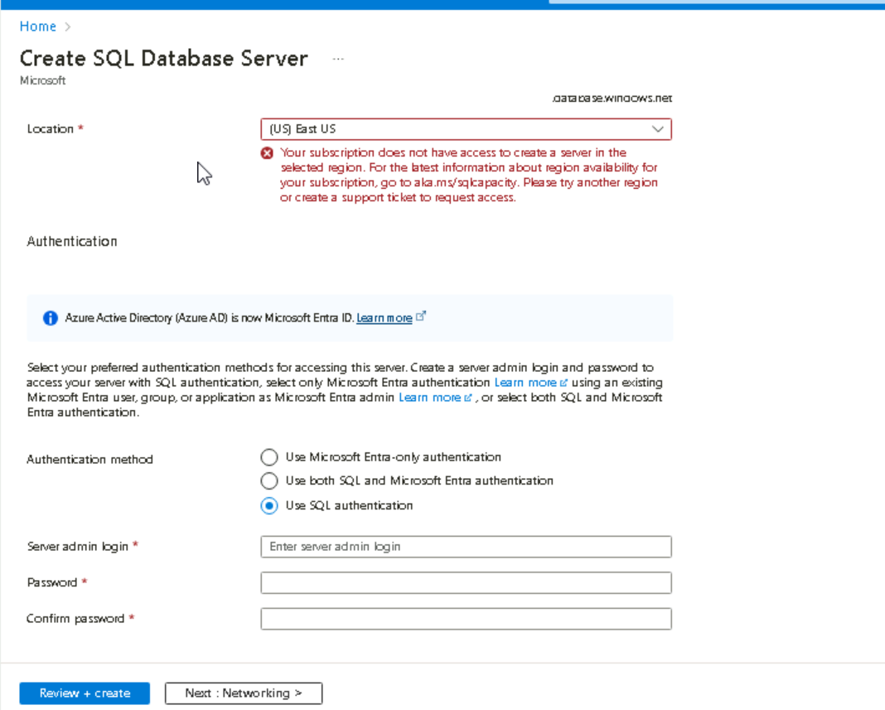

Create databse 🡪give database name and keep local resudent(LRS)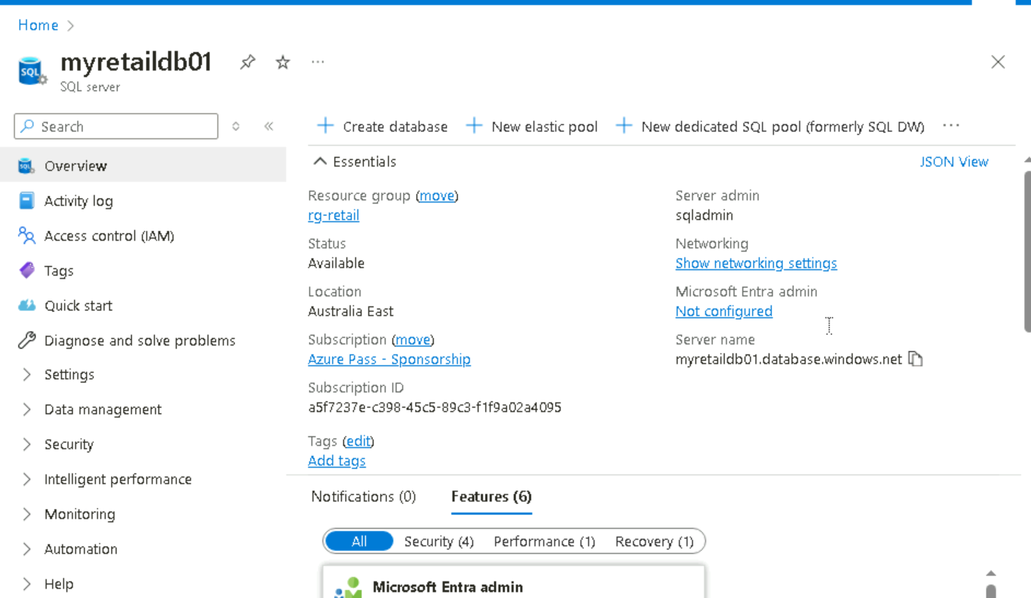

Connect with azure studio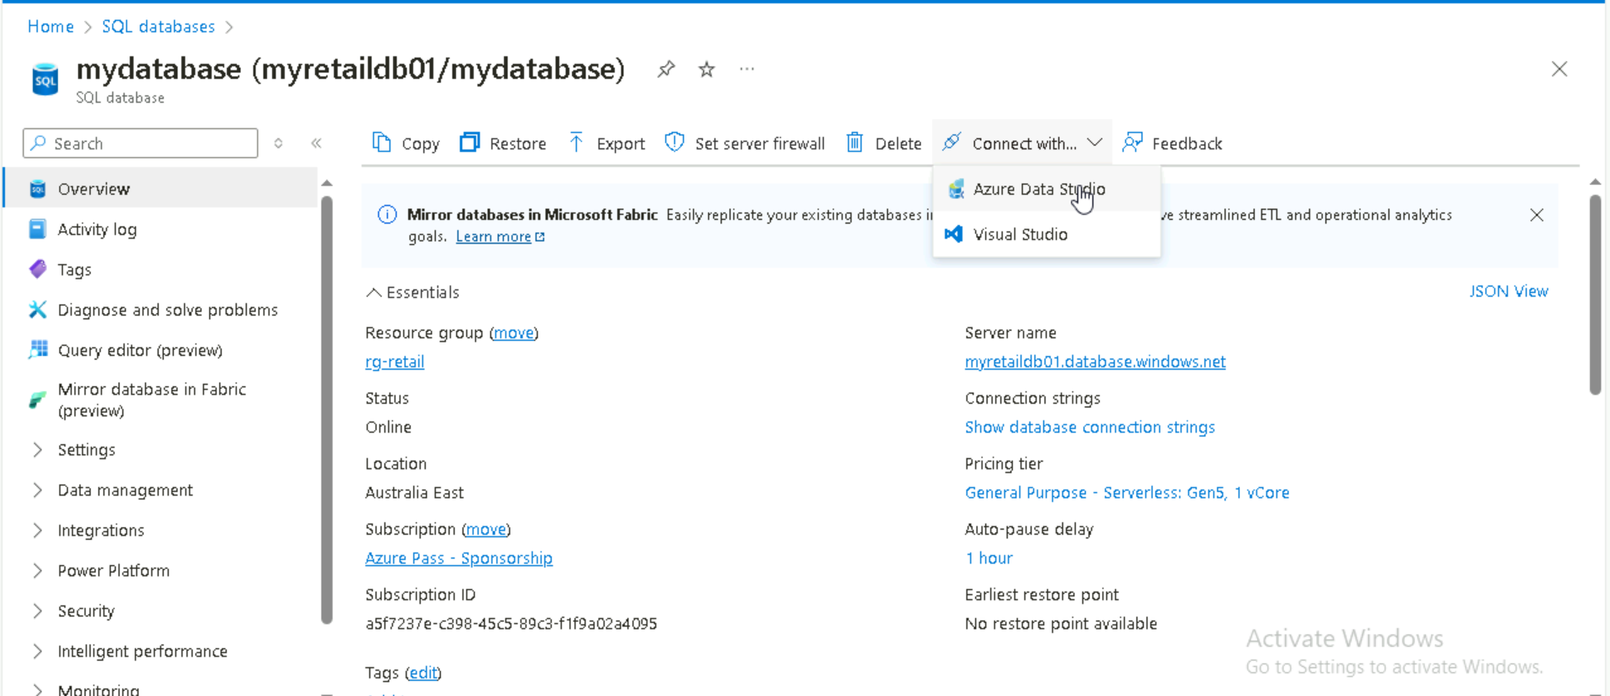

Change the security setting  
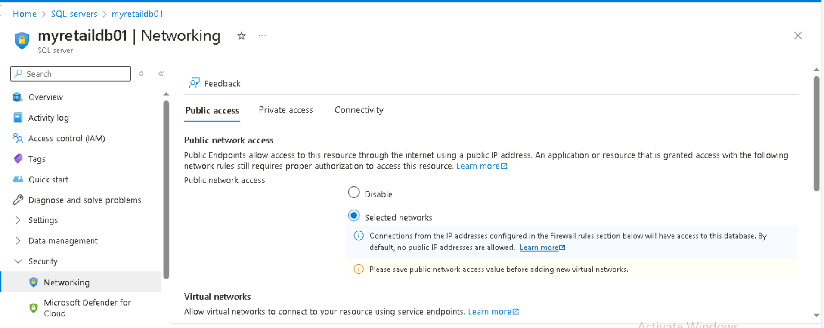  
allow and save it  
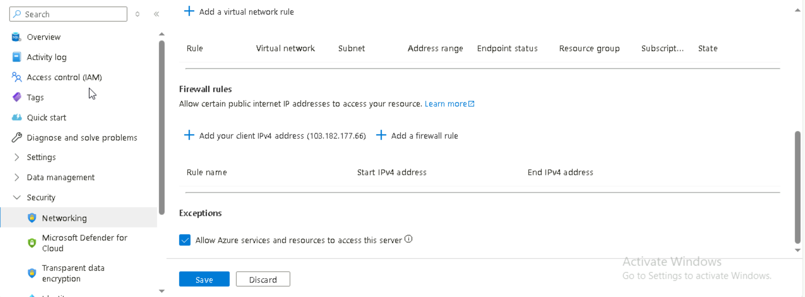

Install azure data studio and click on create connection 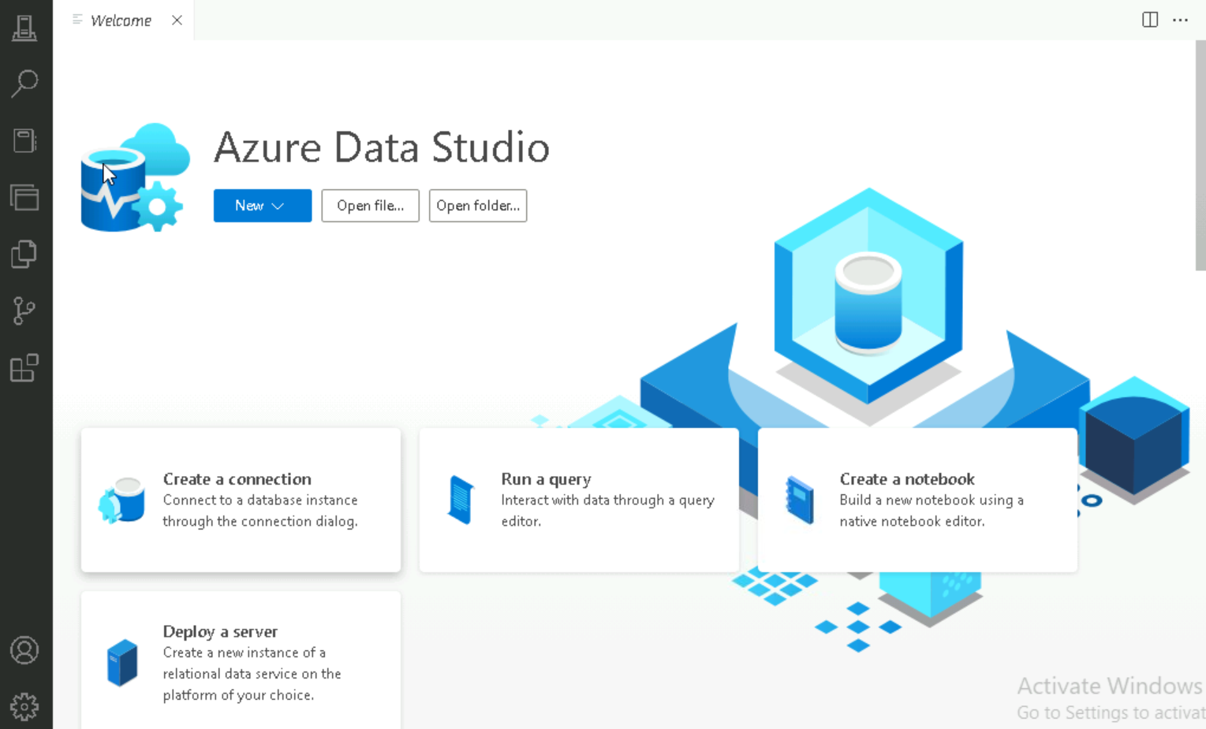

Then give connect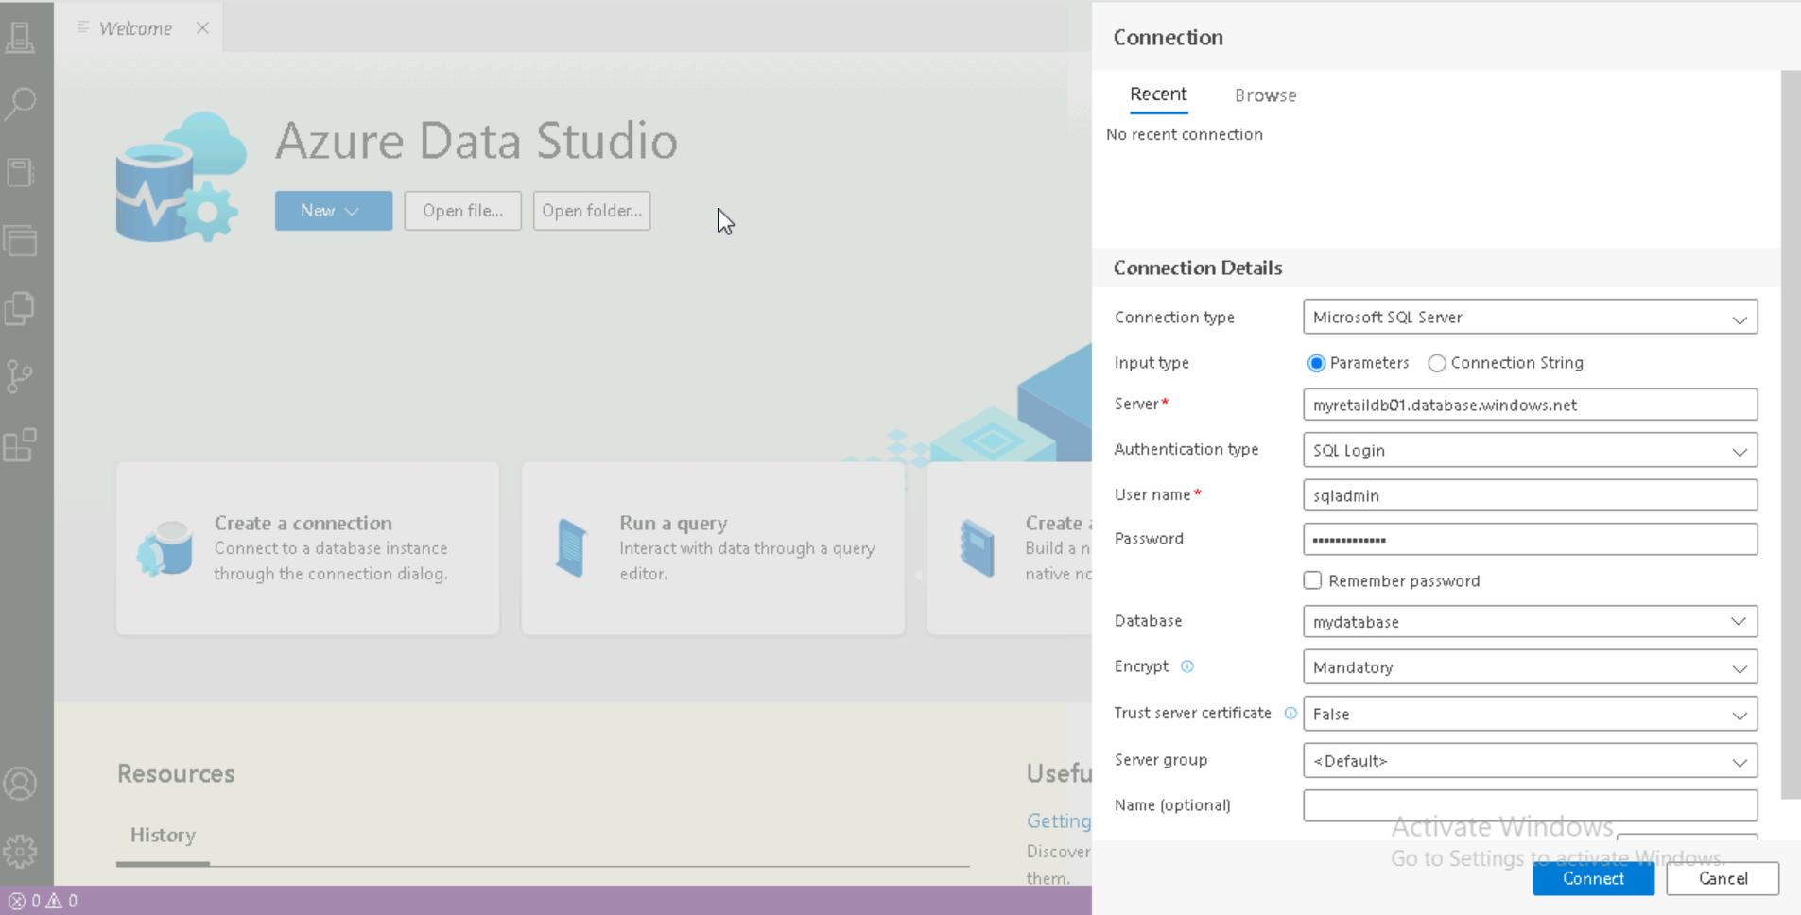

Click on okay

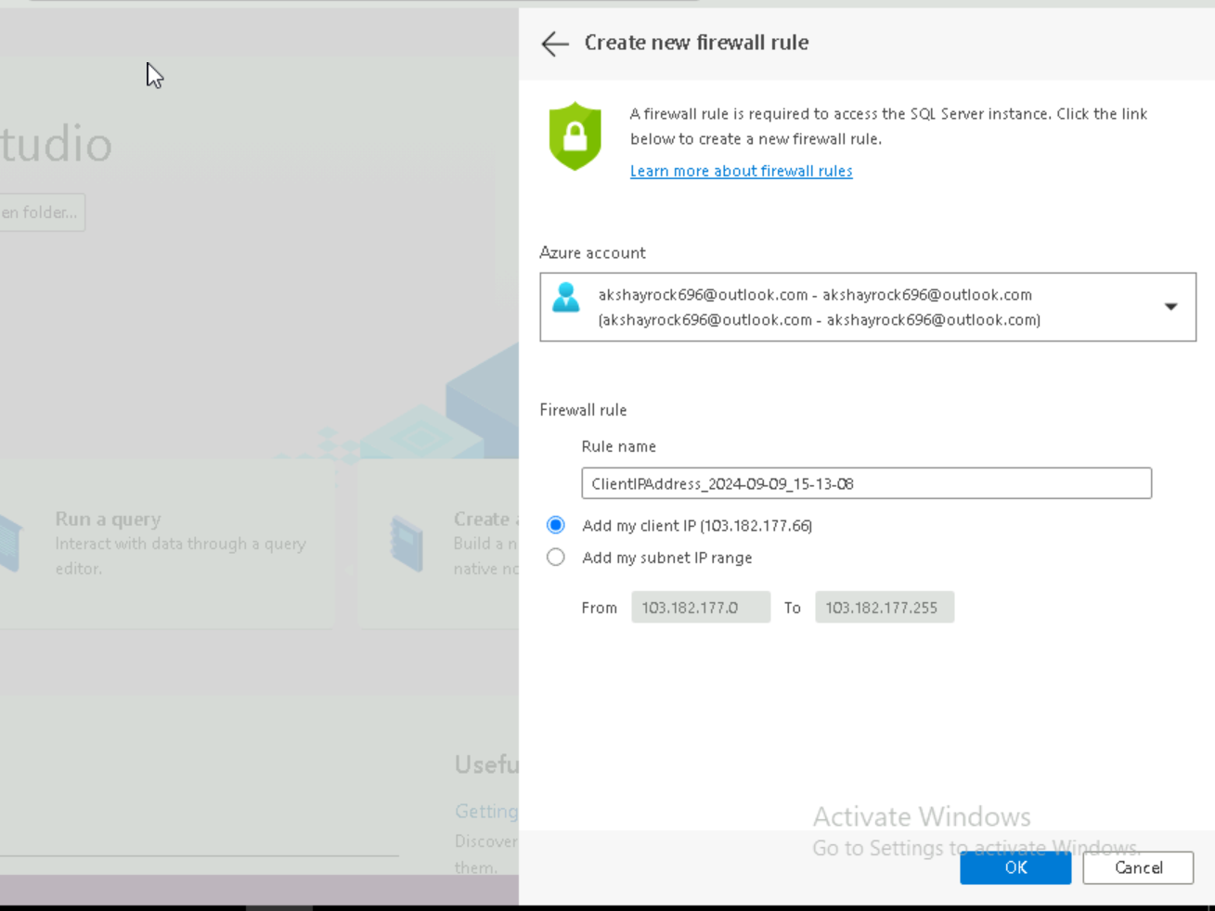

Click on new query 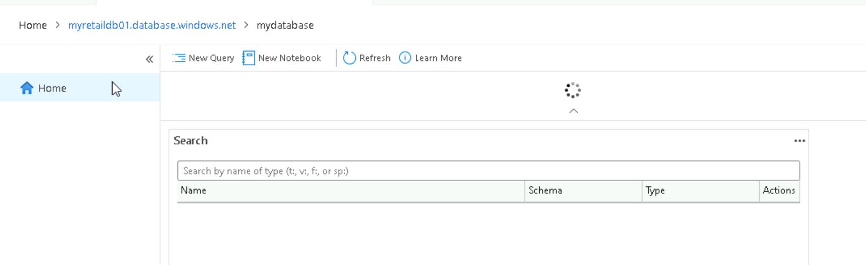

Run query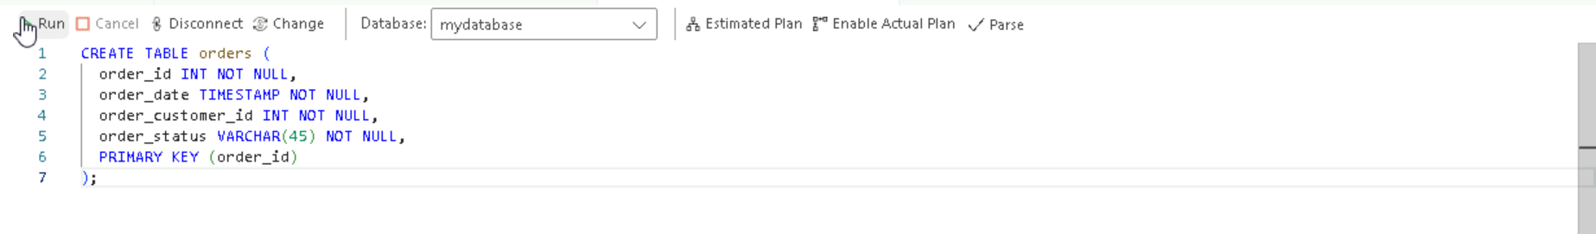

Create aures ql database  
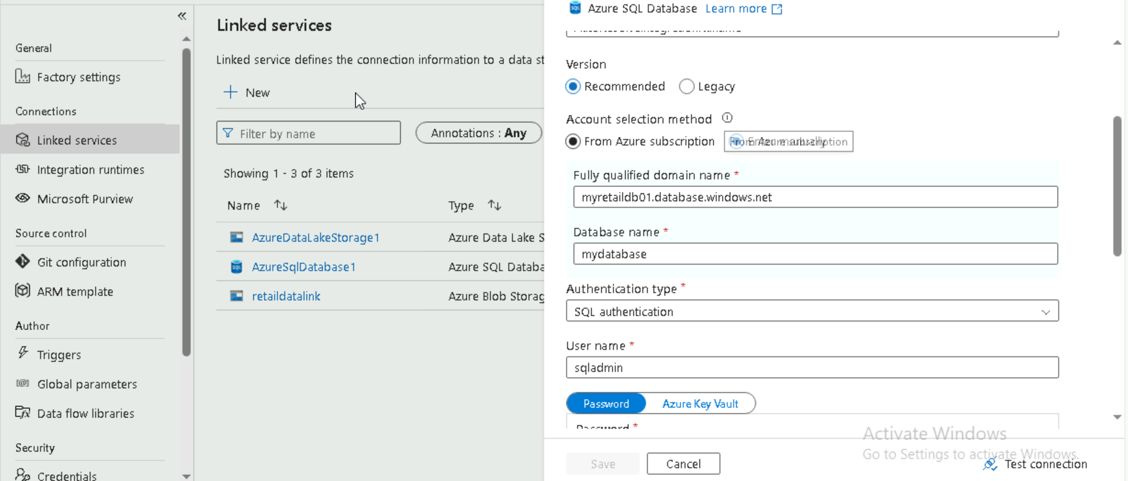

Create azure datalake give name and select subscription and select storage account

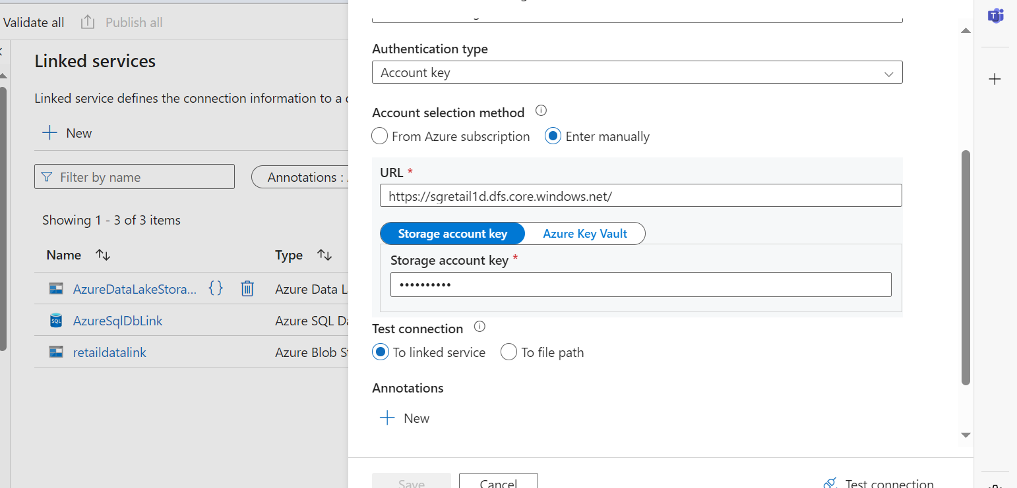

Create azure database for MYSQL  
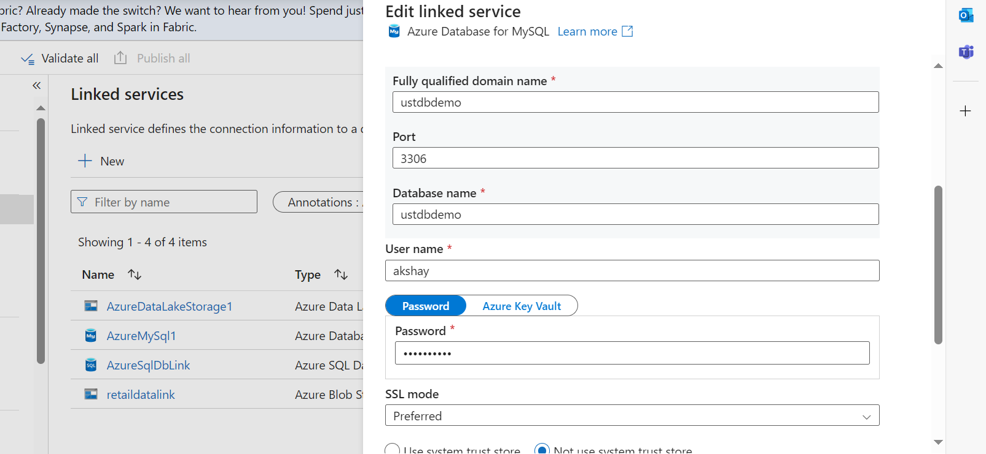

Test connection 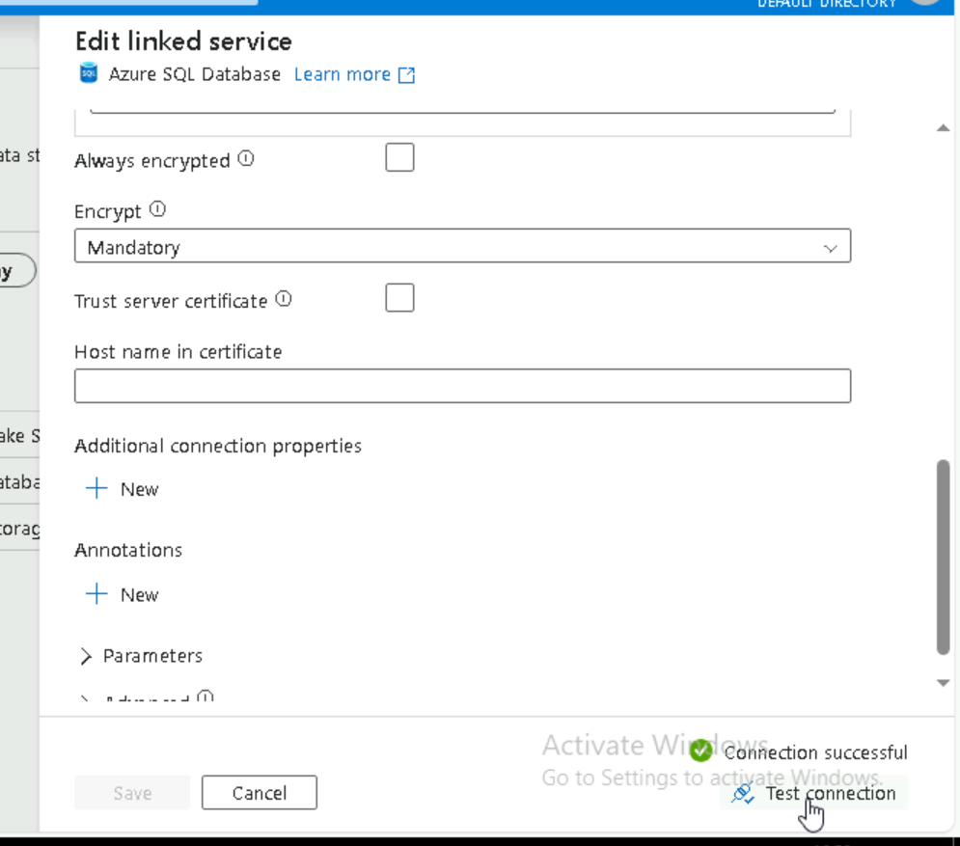

 Create azure sql data base and select table which we created and test the connection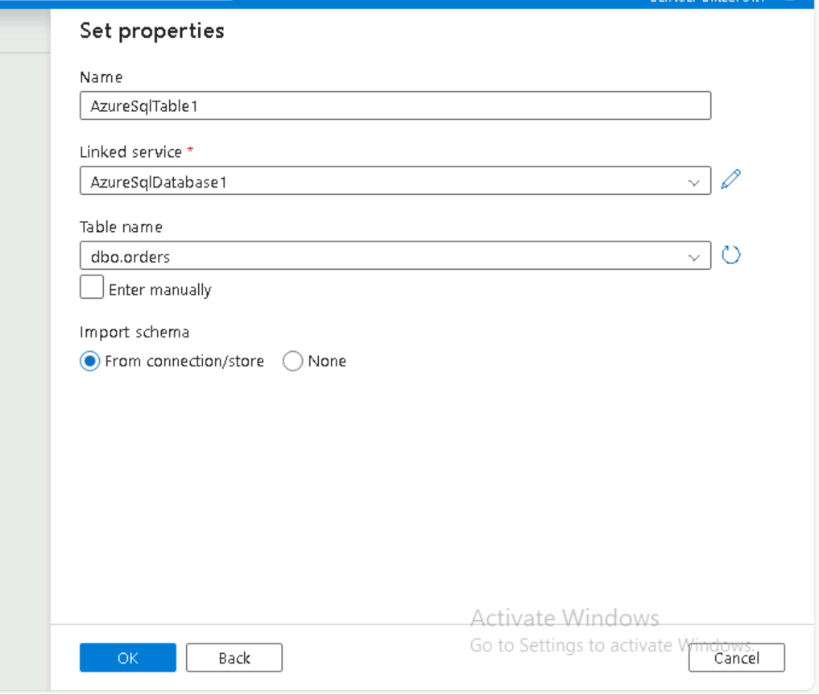

Create pipeline for copy data and select source file  
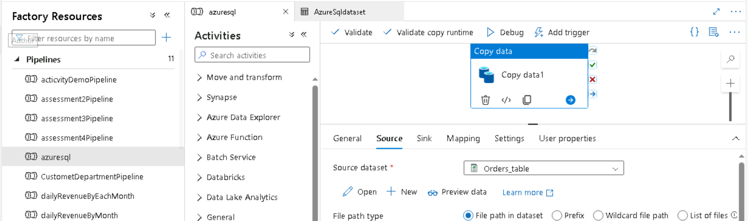

Select sink file which is sql database  
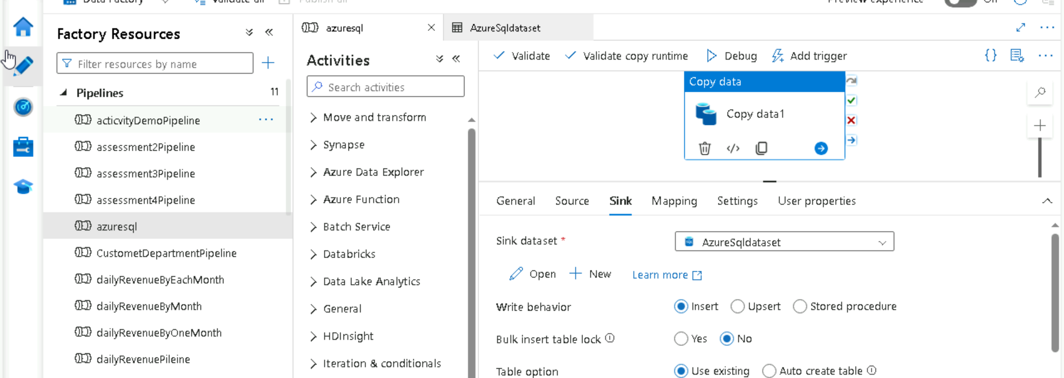

🡪trigger the pipeline and we can see the data in azure studio  
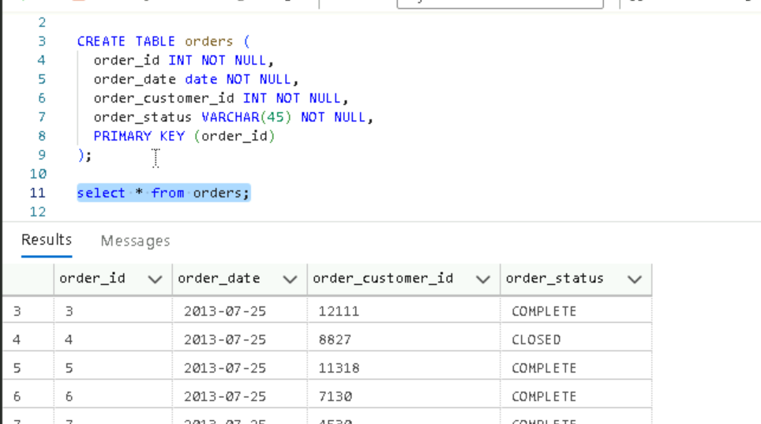

**Copying data from blob to SQL db using parameter**

Create a blob file of department table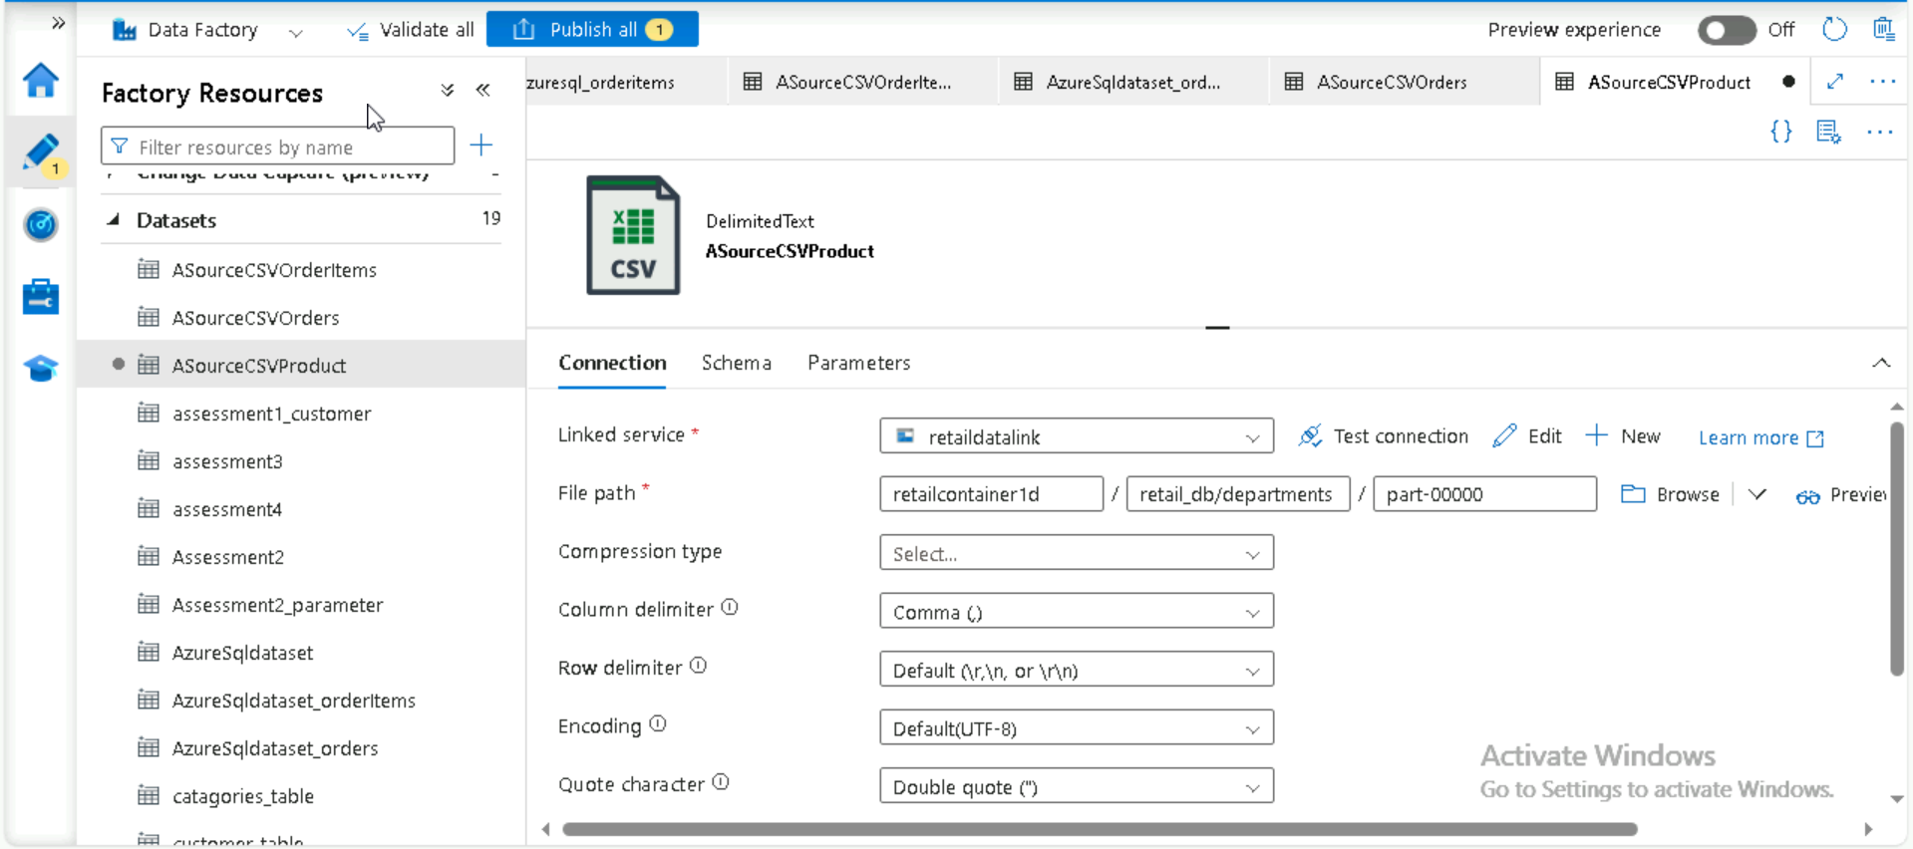

Create department schema in DB

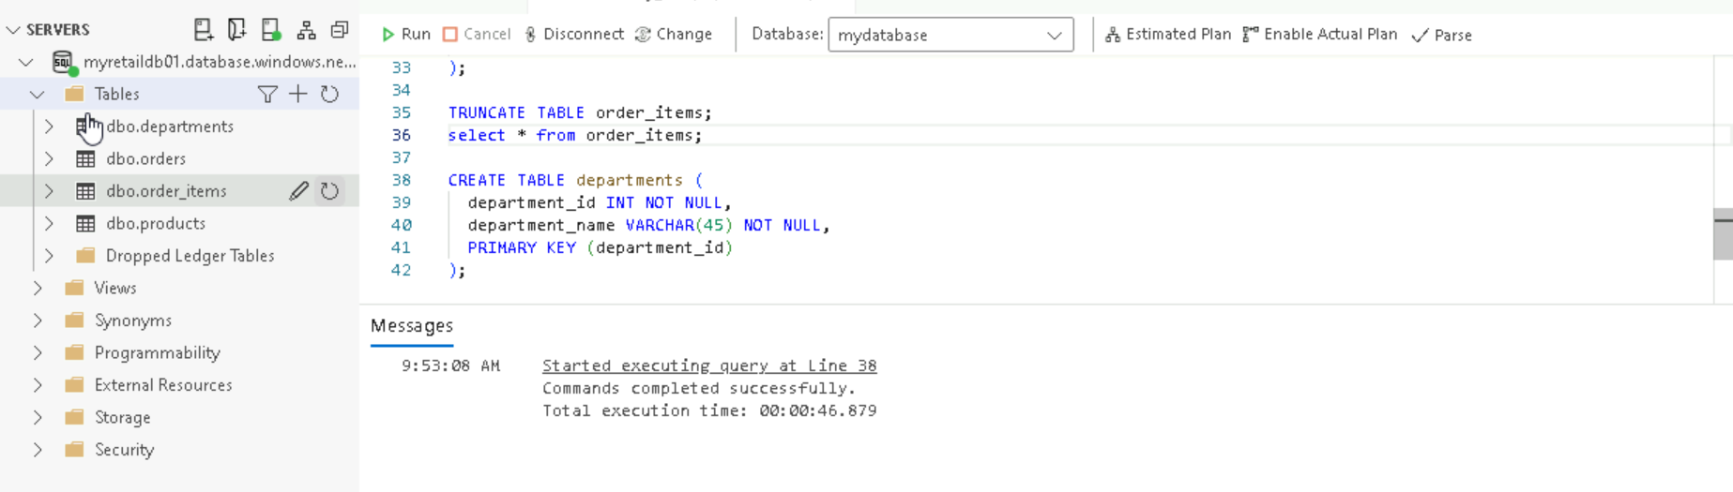

Create destination data set of department using SQL database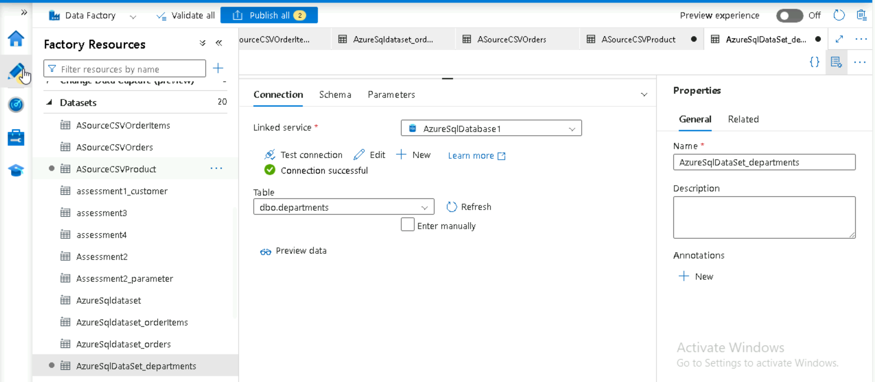

Create pipeline with copy data activity and select the source file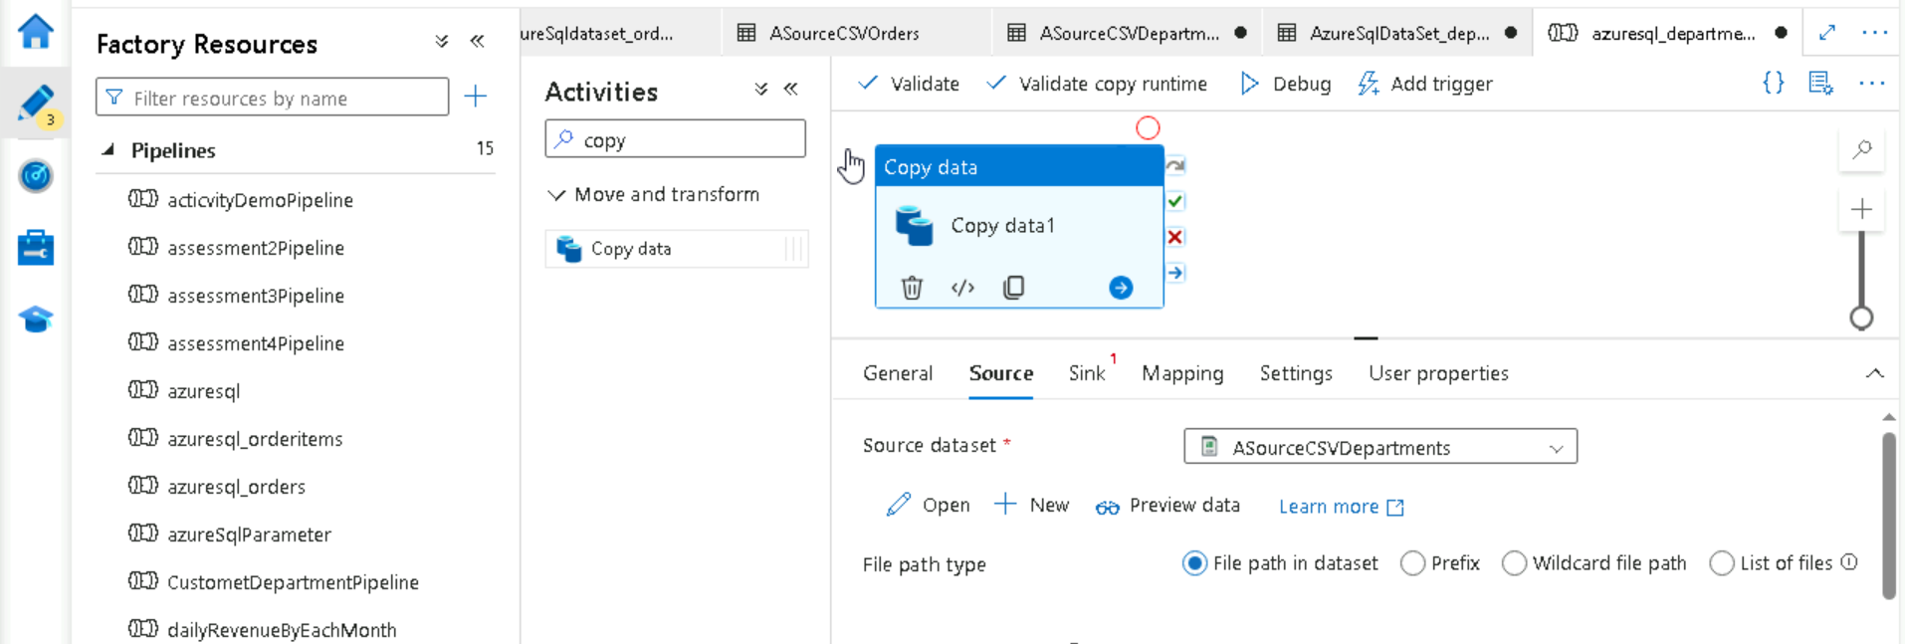

Select sink file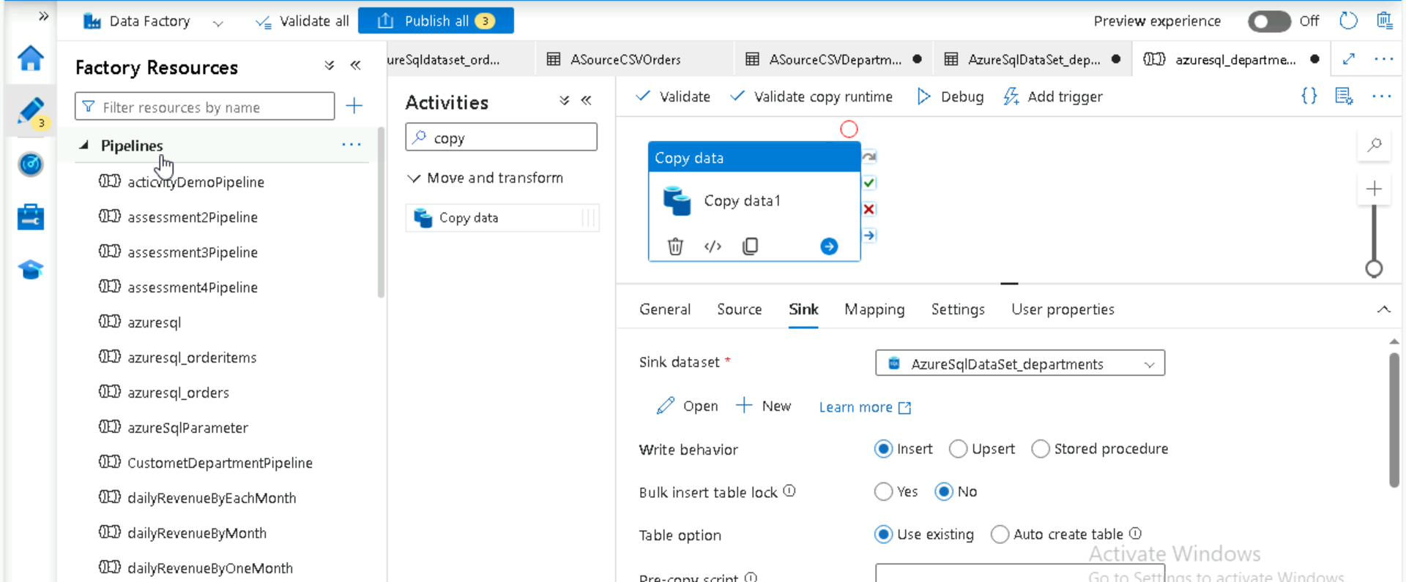

Import schema in mapping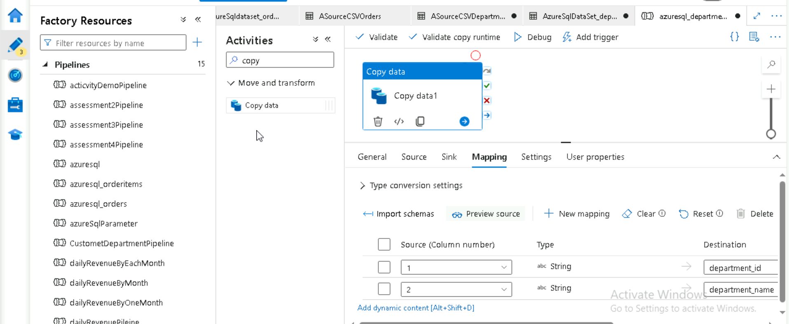

Now create parameter in source file as source as parameter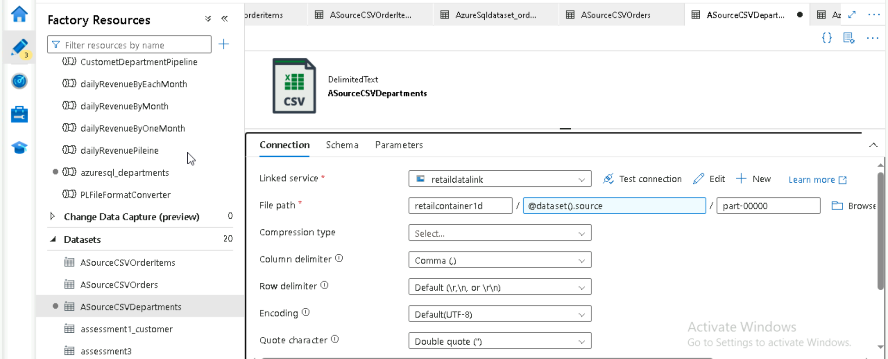

Create parameter in destination file as tablename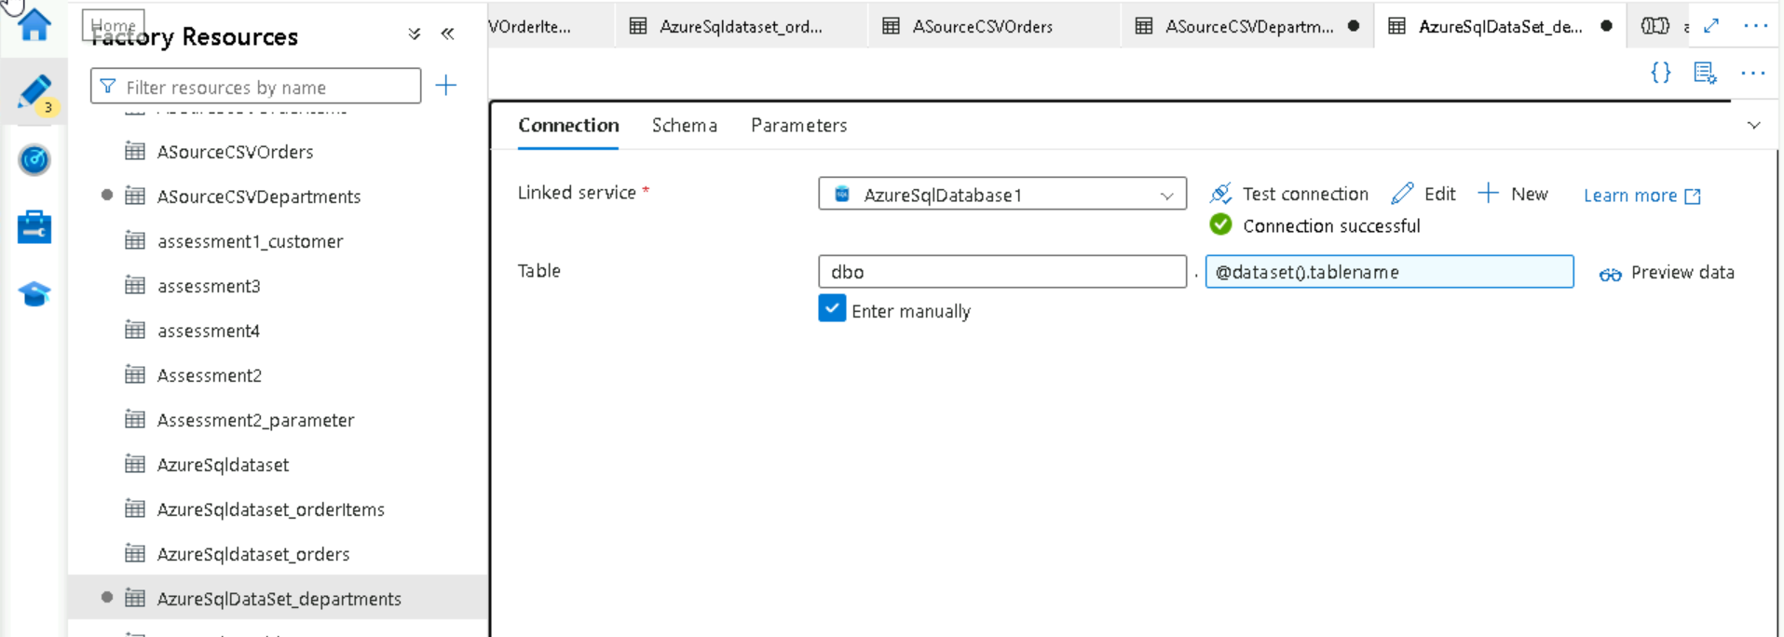

Create 3 parameter in pipeline and give json value in mapping parameter

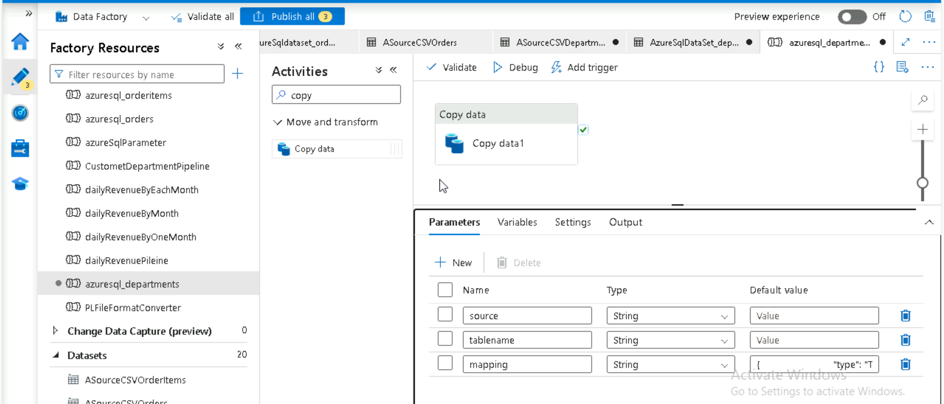

Select parameter in source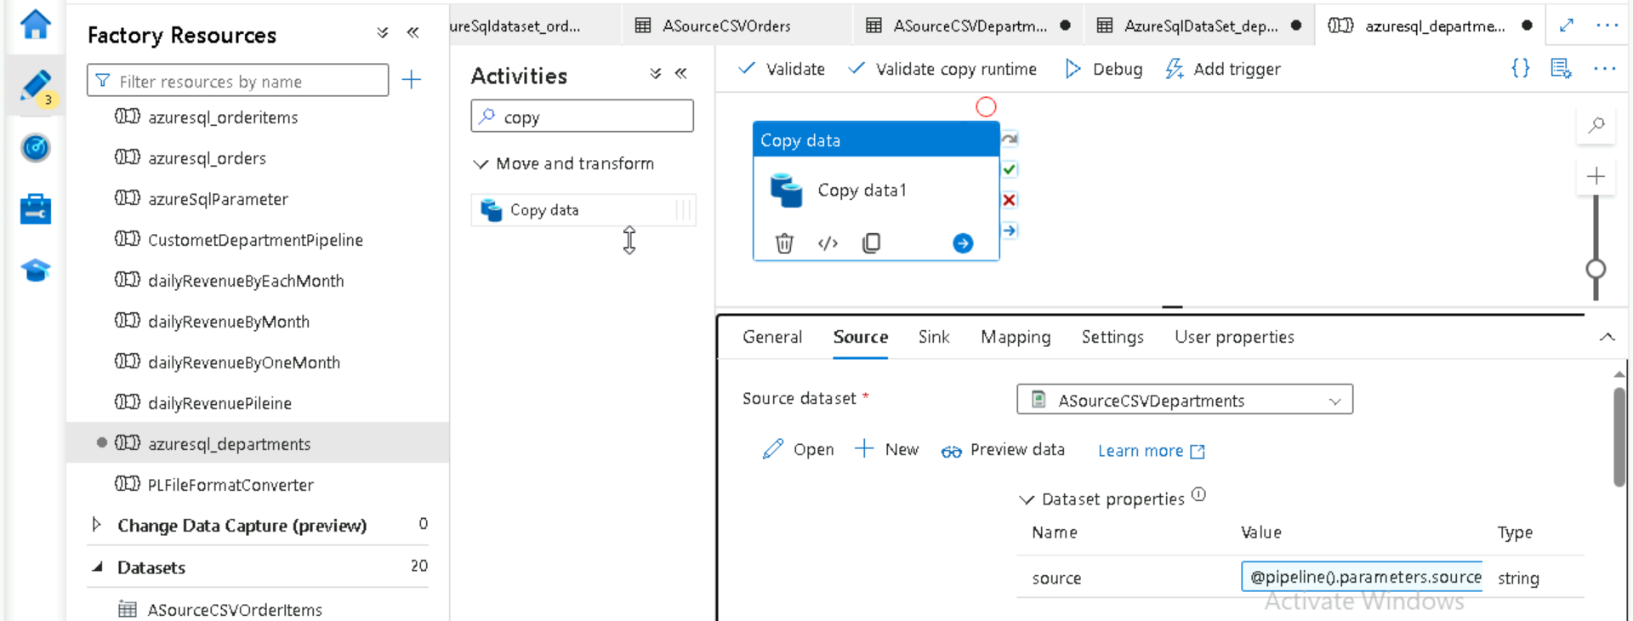

Select parameter in sink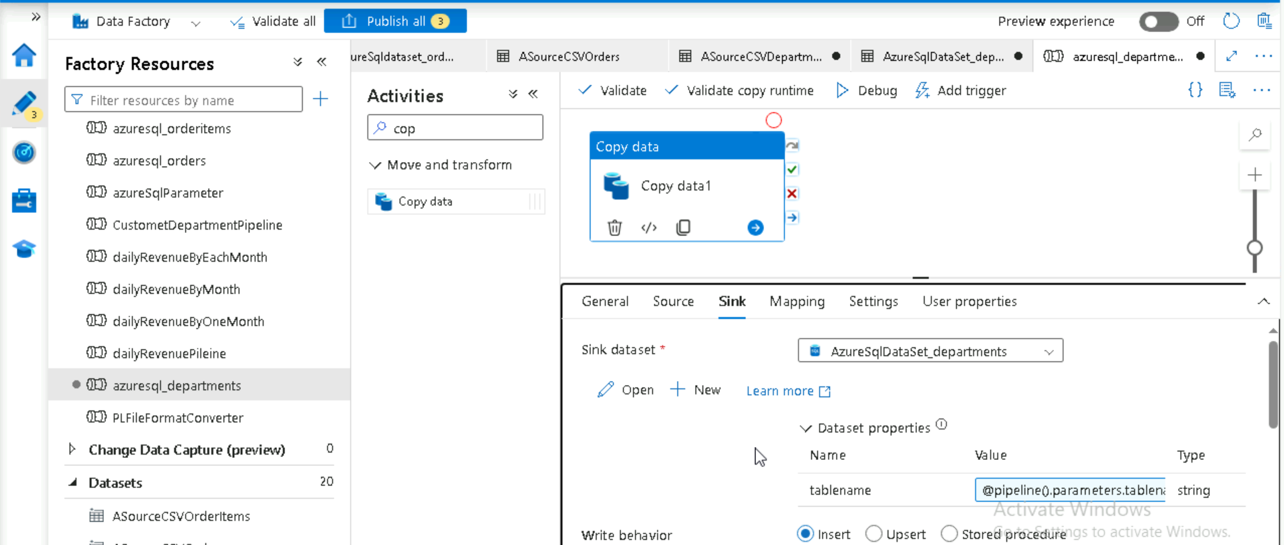

Json from her to   
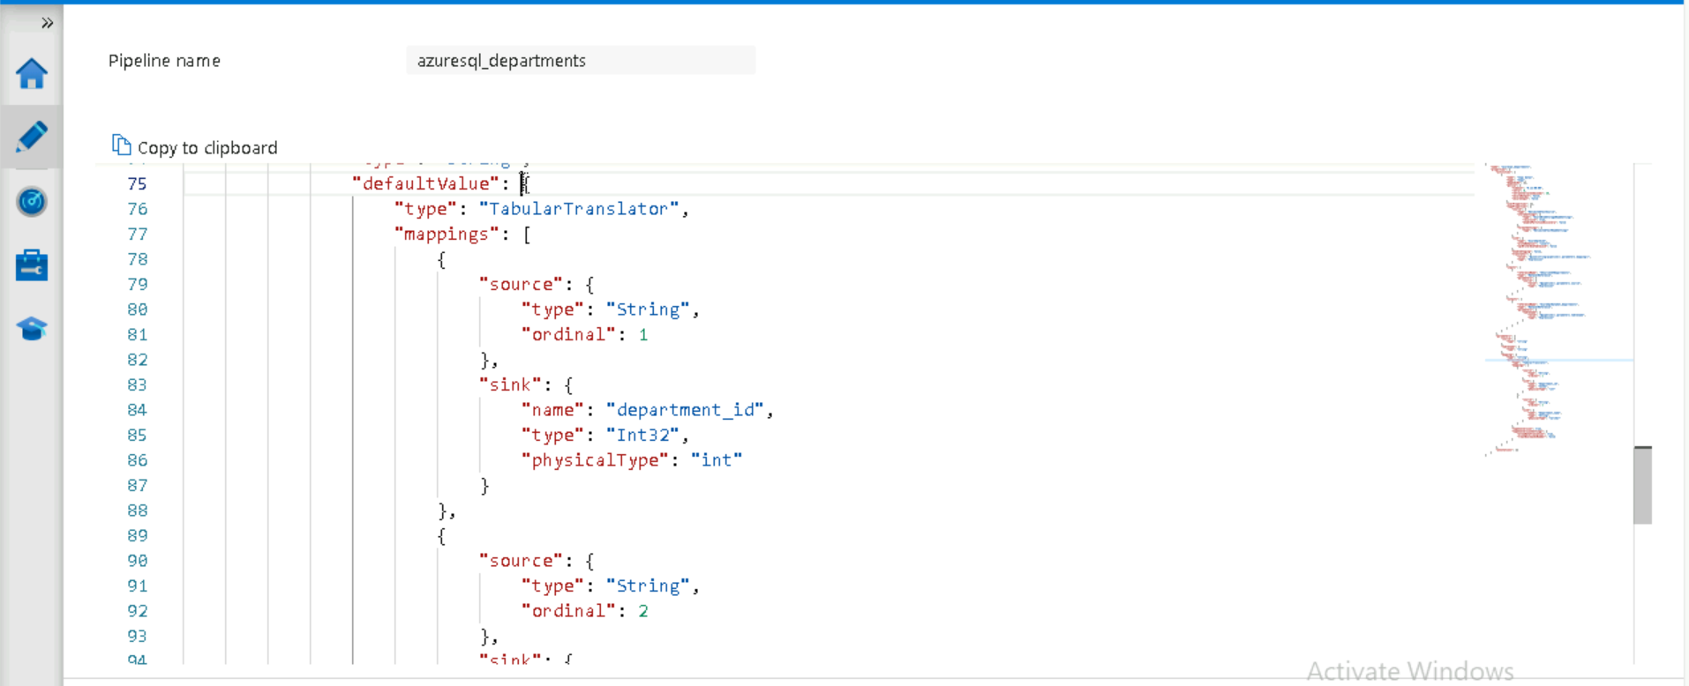

To hear  
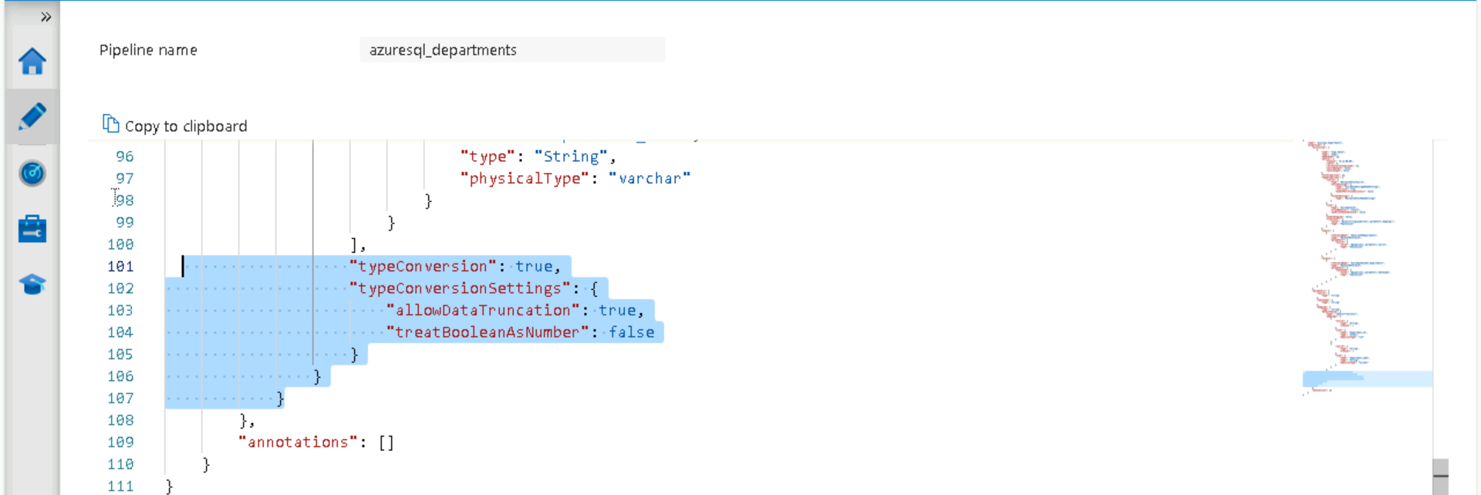

Select parameter in mapping and give json(string

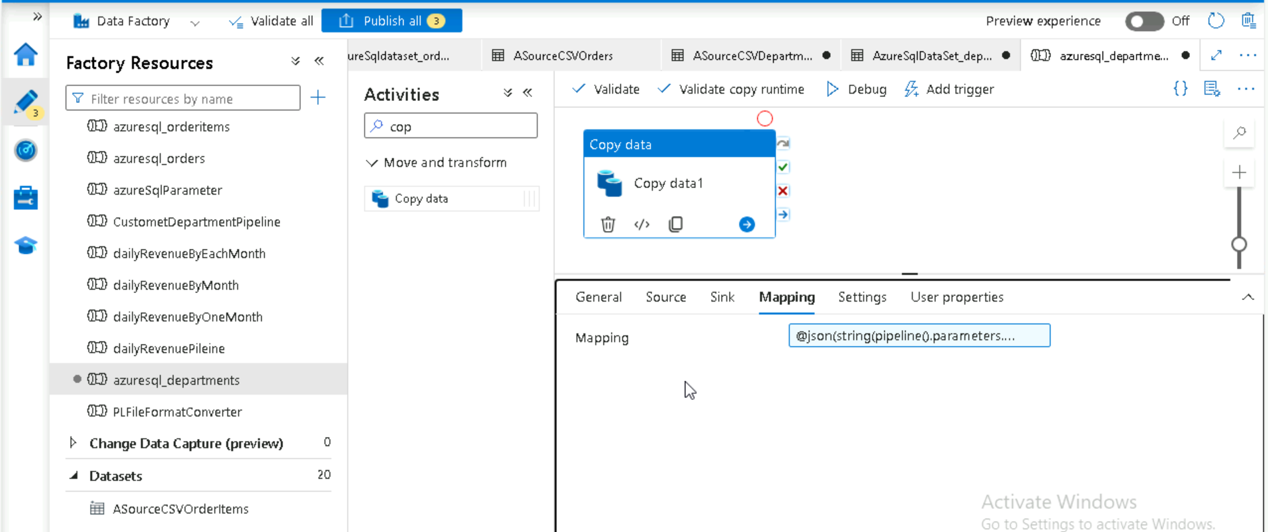

Publish and trigger the pipeline  
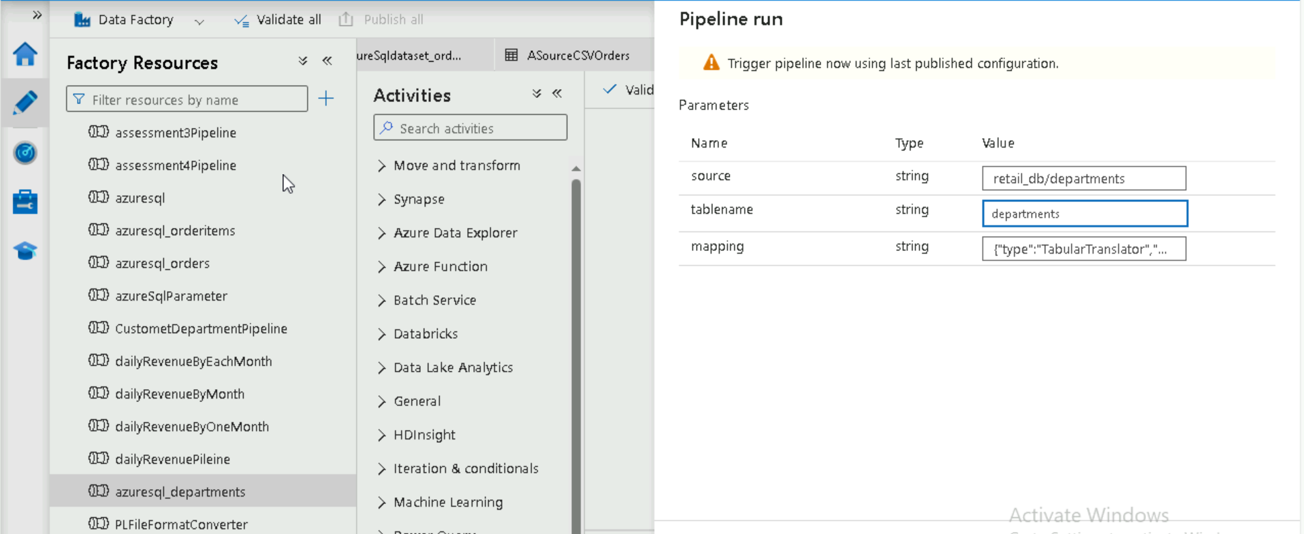

Azure data factories interview question

<https://www.projectpro.io/article/azure-data-factory-interview-questions-and-answers/601#mcetoc_1gvel94m82d>

**Azure Synapsis**

What is azure synapse and features of synapse**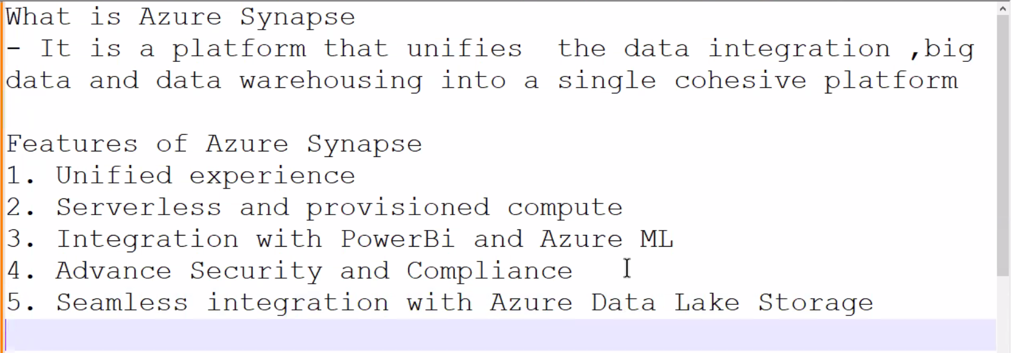**

Benefit of azure synapse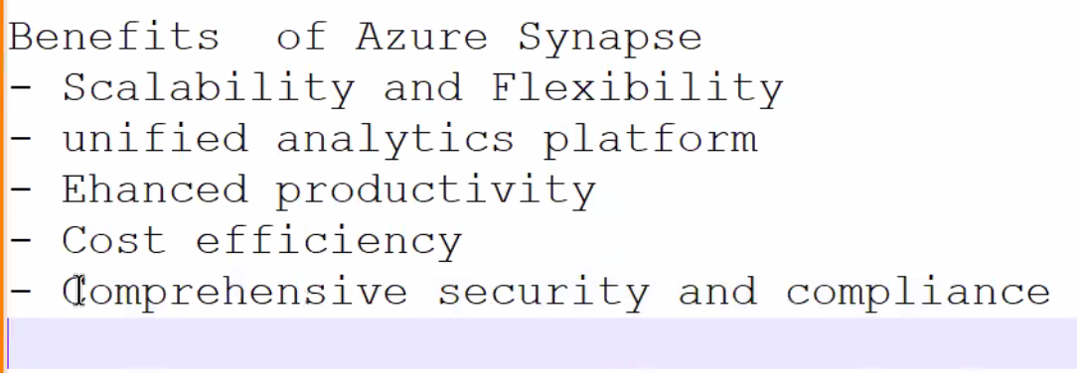

Azure synapse analytics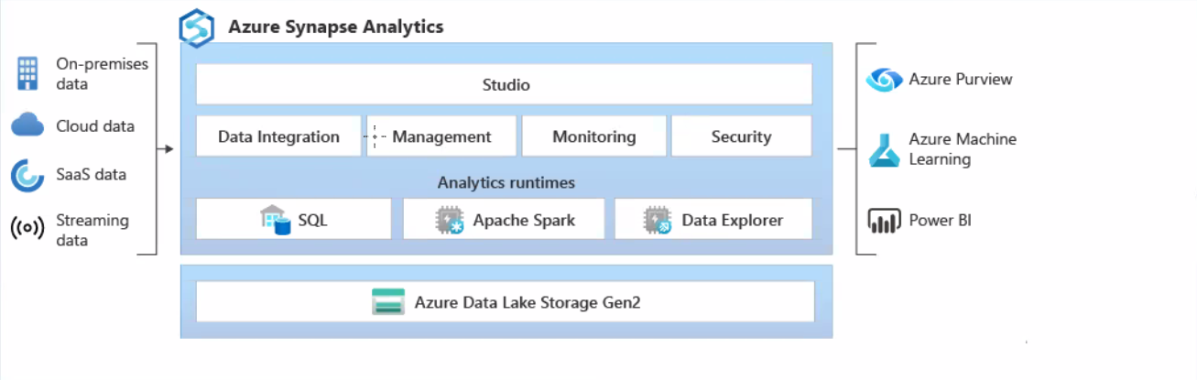

Create storage account with data lake storage gen2 for azure synapse

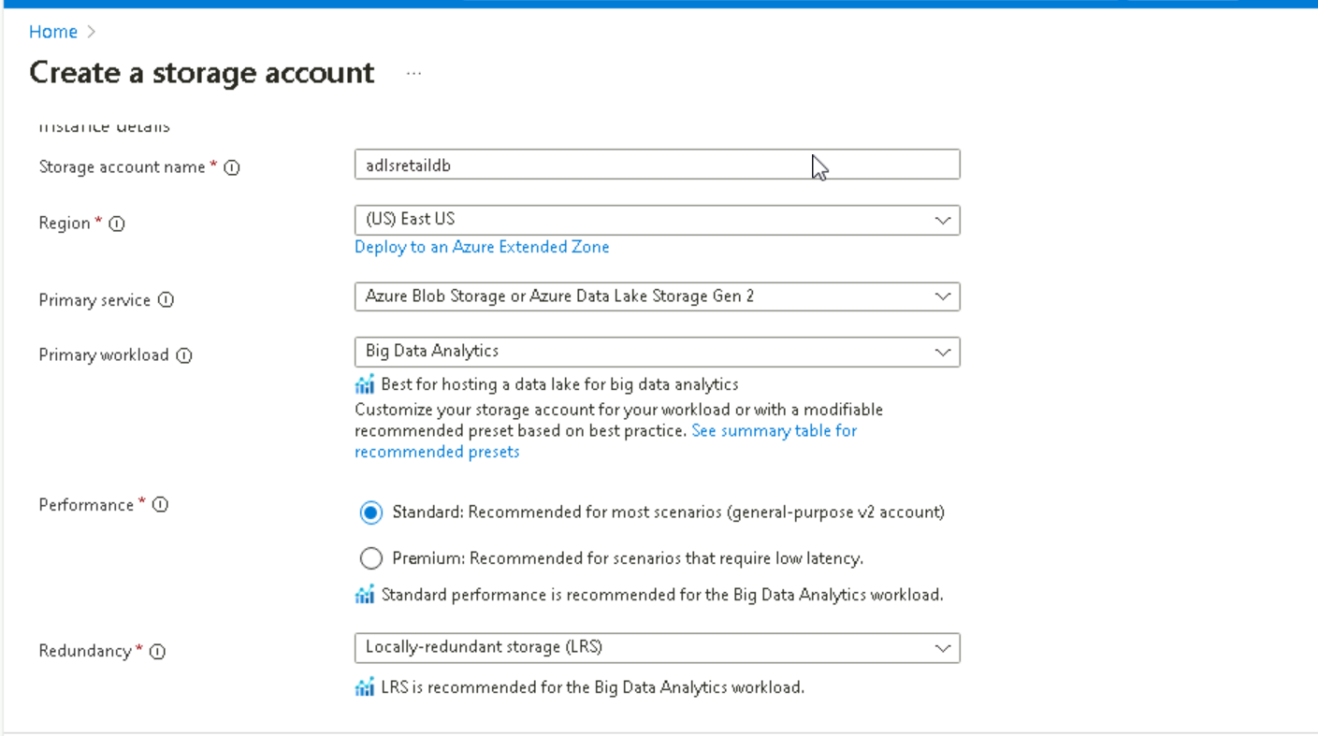

Change encryption as 🡪all service type 🡪review and create storage account

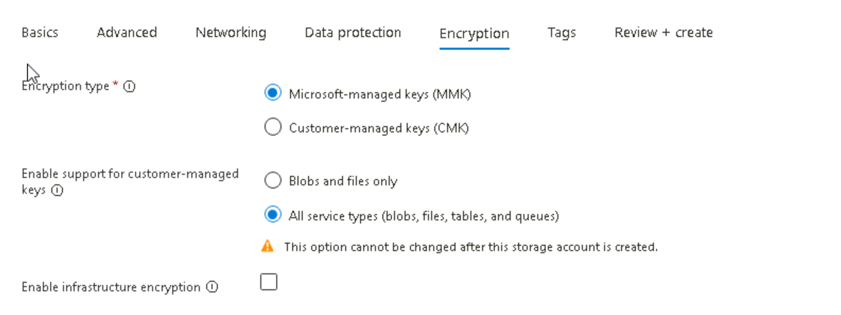

Create synapse workspace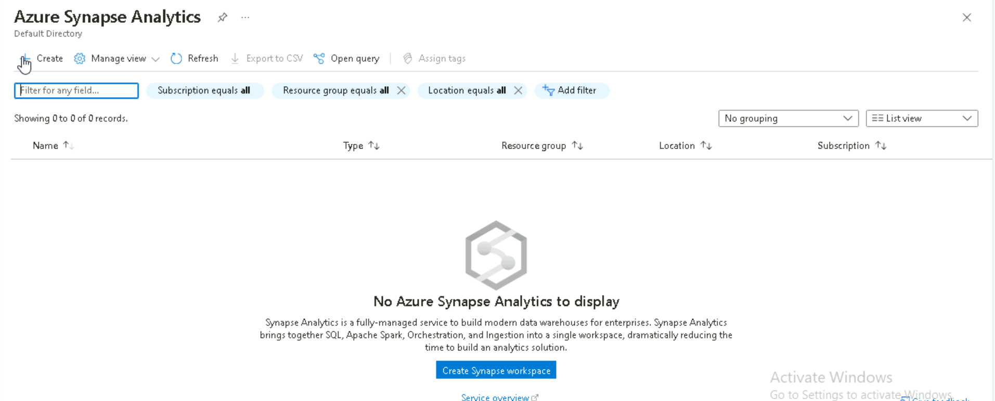

Select central US region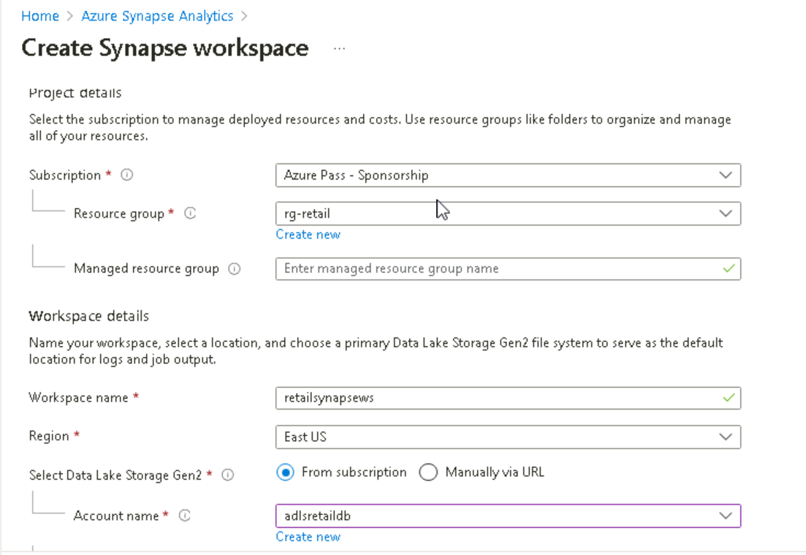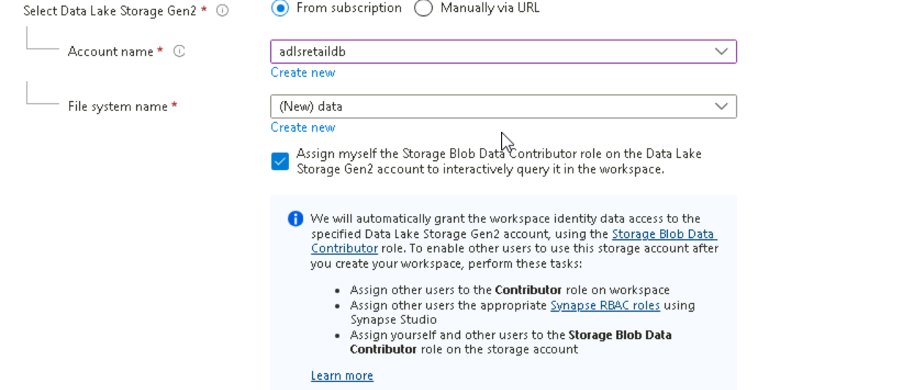

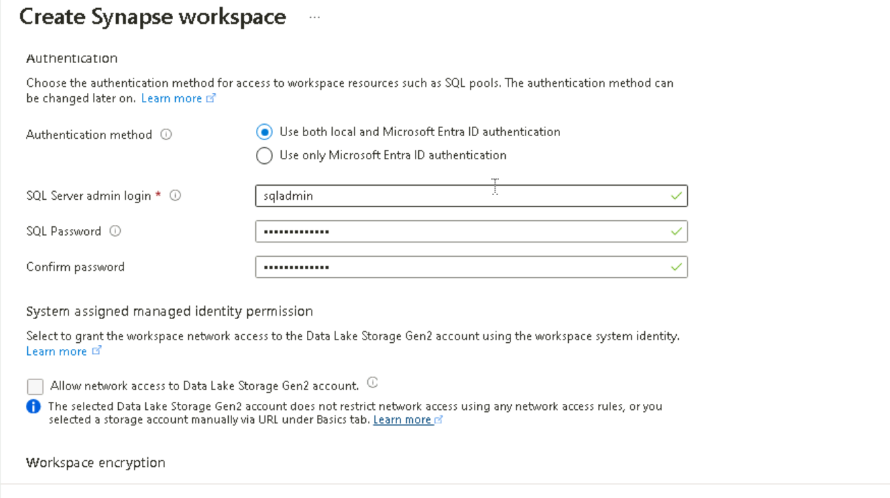

Goto overview and click on open synapse studio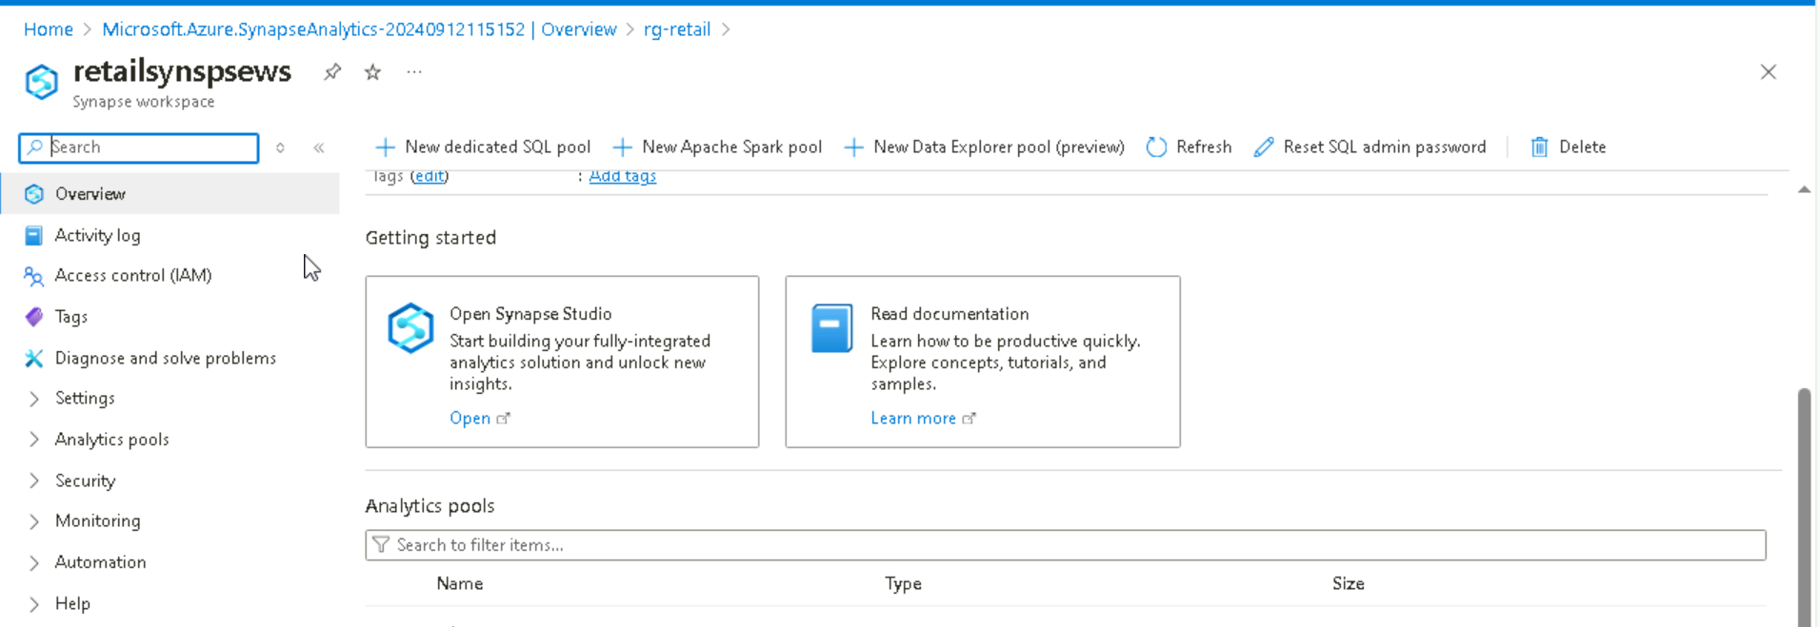

In storage account where container is available assign the role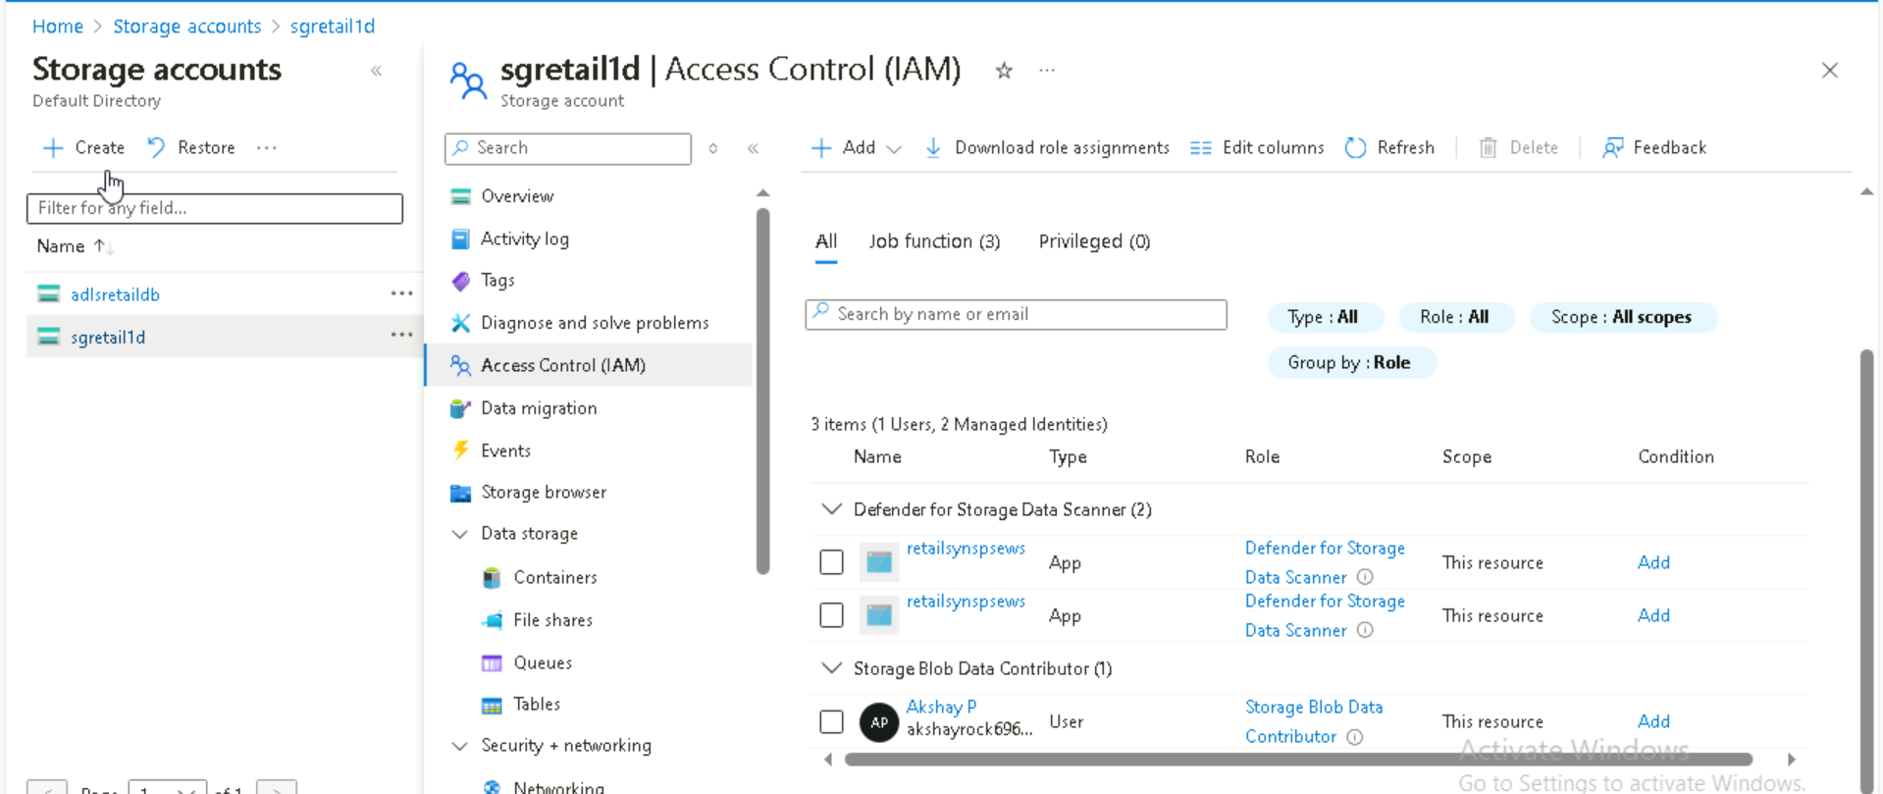

Create link storage for blob storage and create it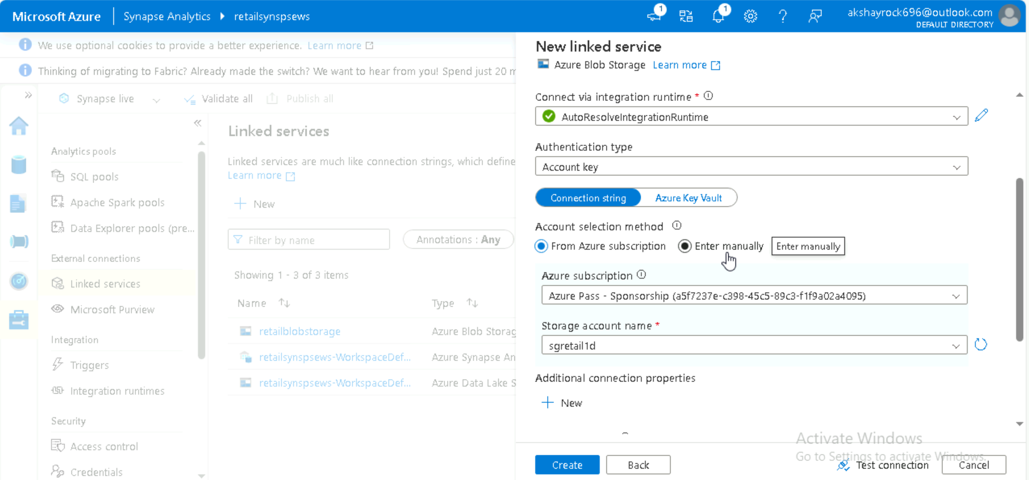

Now we saw data   
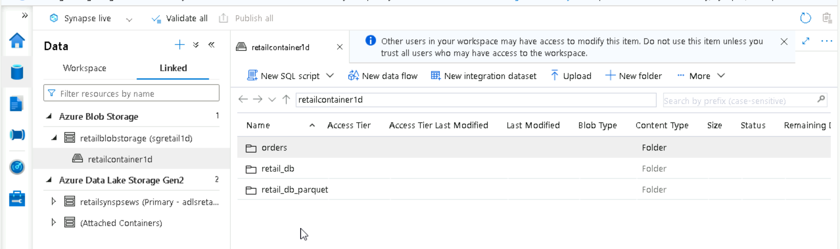

Select file and click on new SQL script  
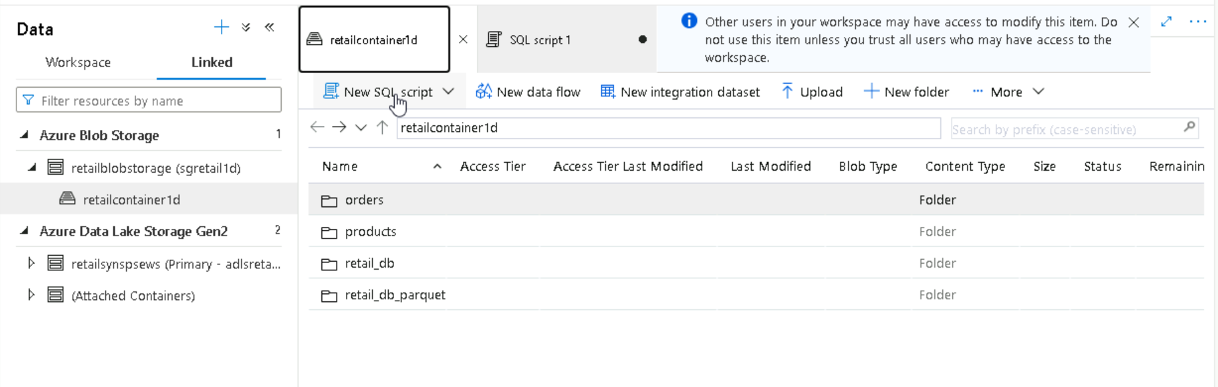

Run the query

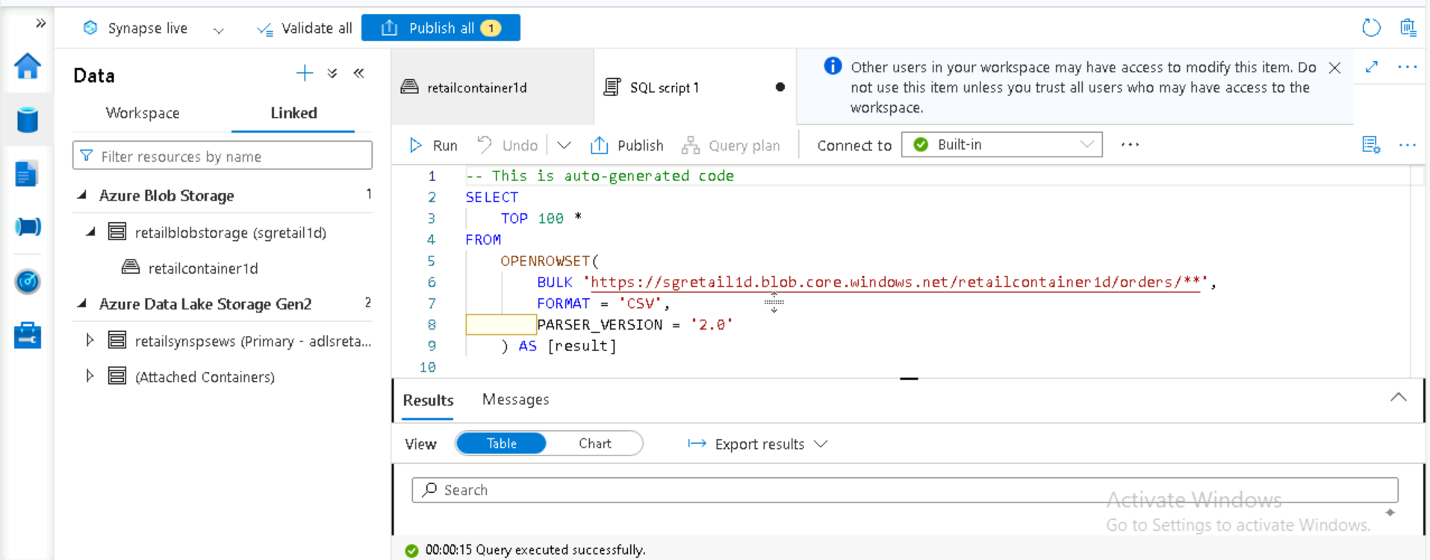

We got system define column name  
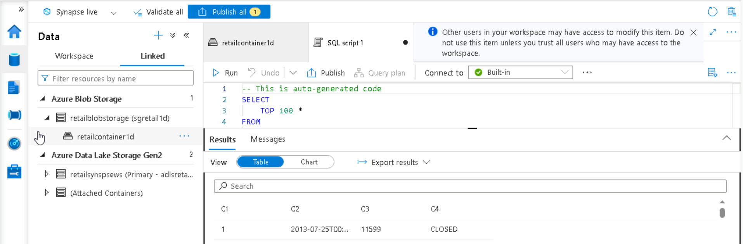

To get the column name change the code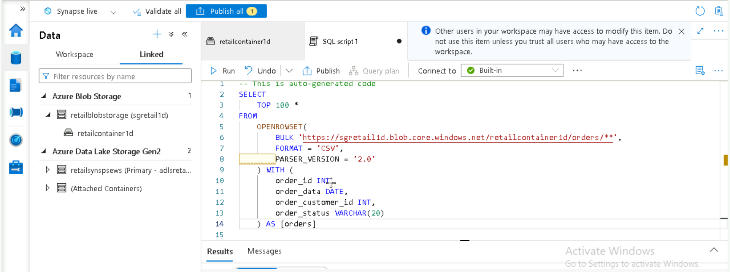

Now we can see the column name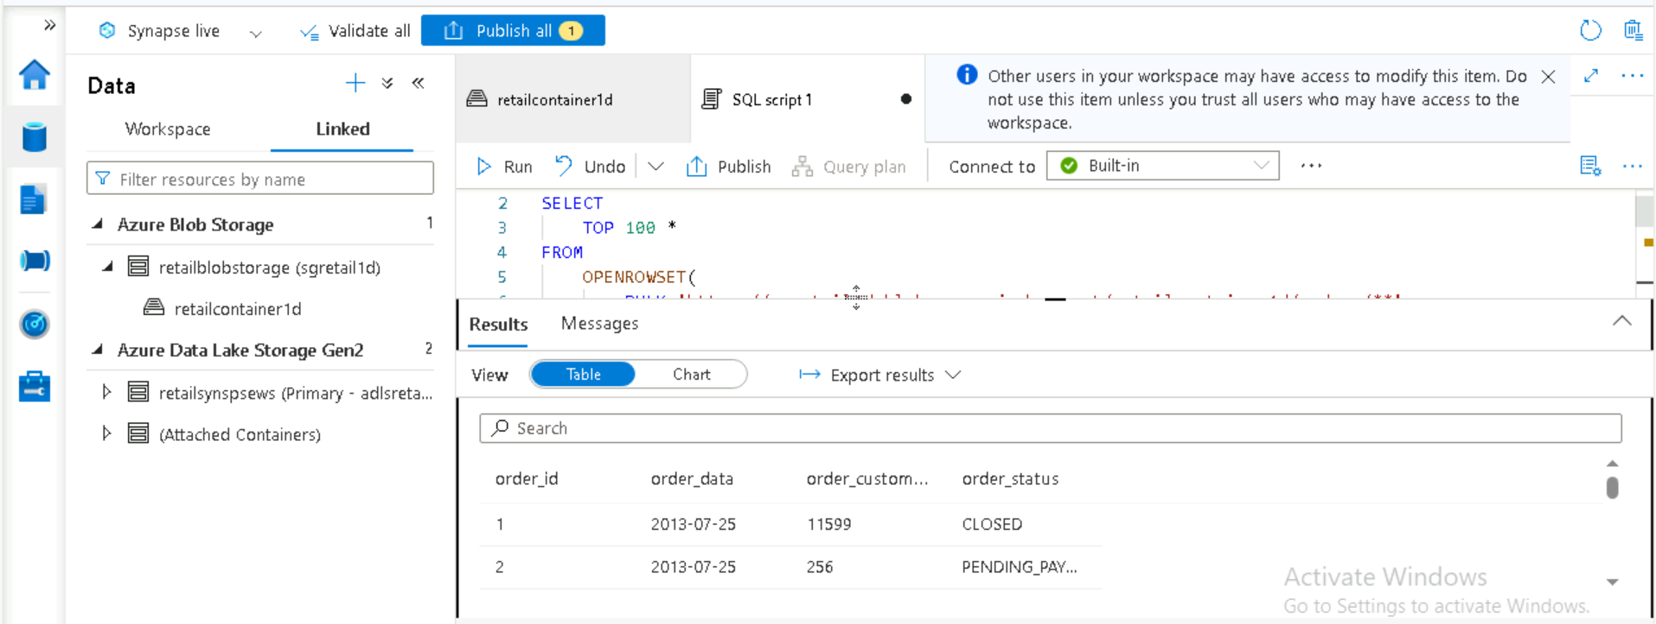

Different table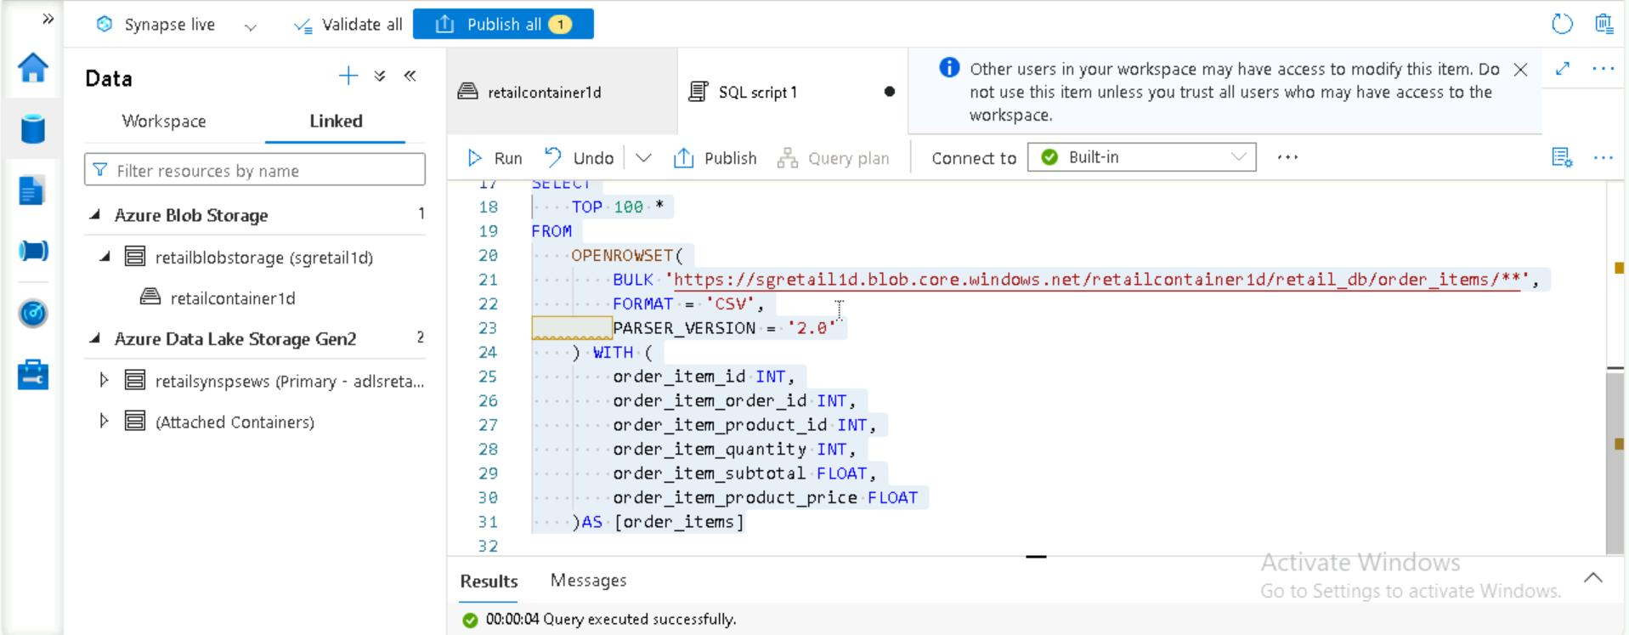

Practice synapse

[Azure Synapse Analytics - Azure Synapse Analytics | Microsoft Learn](https://learn.microsoft.com/en-us/azure/synapse-analytics/)

**Synapse Analytics questions:**

<https://www.projectpro.io/article/azure-synapse-analytics-interview-questions-and-answers/743>

**1. How does Azure Synapse differ from Azure Databricks?**

Azure Synapse is a [data integration](https://www.projectpro.io/article/data-integration-projects/955) service with some amazing transformation capabilities while Azure Databricks is data analytics focussed platform build on top of Spark. Azure Synapse integrates [big data](https://www.projectpro.io/article/big-data-interview-questions-/773) analytics and enterprise [data warehouse](https://www.projectpro.io/article/data-warehouse-project-ideas-for-practice/572) into a single platform. While Databricks allows customers to develop complex machine learning algorithms and perform big data analytics. However, both both Synapse Analytics and [Azure Databricks](https://www.projectpro.io/article/azure-databricks/865) can be used together when building a [data pipeline](https://www.projectpro.io/article/data-pipeline-definition-architecture-examples/528). **(Data synapse will be used for data analysis along with data transformation capabilities and it integrates data analytics and data warehouse in a single platform where as in data bricks it is build up on top of spark and it allow customer to build up based on machine learning alghartihems to perform data analytics.)**

**2. Define the linked service in Azure synapse Analytics.**

The external sources outside the Azure Synapse Analytics workspace are connected via Linked Services. A linked service is required in a data pipeline to read or write data to source or destination. For instance, you can use it to establish a connection to the [Azure Data Lake](https://www.projectpro.io/article/azure-data-lake/705) storage account to execute [SQL](https://www.projectpro.io/article/sql-database-projects-for-data-analysis-to-practice/565) queries on the files. Suppose you want to pull data from an on-premises server into the cloud or connect to the Azure data lake storage account to perform SQL queries on the files. In these cases, you must build a linked service by providing data such as a username, password, and server address to establish a connection**.(The external data/source connected to synapse using linked service, where using this data we can perform read and write activity and for building this we can connect storage account to the linked serive and we can test the connection)**

**3. What do you understand by the default SQL pool in Azure Synapse Analytics?**

Anytime you build an Azure synapse analytics workspace, a serverless SQL pool is already set up. It is referred to as the built-in serverless SQL pool and is a default SQL pool that is accessible for use. The default SQL pool in Azure Synapse Analytics helps with query optimization, data distribution, and data compression. **(when ever we build one default sql pool is created with the name called built-in and with this we can use it for query optimization, data distribution and data compression)**

**4. What does the Azure Synapse Analytics OPENROWSET function do?**

The OPENROWSET function lets data engineers read data from diverse data sources including flat files, RDBM’s, and other OLE DB sources. In [Azure](https://www.projectpro.io/article/azure-data-engineering-tools/669) Synapse, one uses the OPENROWSET function to read the file as a table. For instance, you want to perform the queries on a file saved in the ADLS account. Using the rowset function, which converts each row of a file into a row of a table, you can read this file as a table**.(Using ROWSET function we can read the data of different files like flat file or rdbms file etc, ROWSET will convert each column as row and read the data in table format)**

**5. What makes Azure Synapse Analytics different from Azure Blob storage?**

Large volumes of unstructured data, such as video, audio, and images, can be stored in the cloud using Azure Blob storage. You can gather, store, and analyze huge amounts of data with the help of Azure Synapse Analytics, a cloud-based data warehouse service.In a nutshell, Azure Blob Storage majorly focusses on storing and retrieving data while Azure Synapse Analytics focusses on preparing, managing, and analyzing data.  **(In Azure blob storage we can store the huge amount of unstructured data and main focus on stroring the data where as synapse will analyze the huge amount of data and focus on preparing managing and analysing the data)**

**6. Assume you are the lead data engineer at your company, and a few spark notebooks have been run in the past few hours. You want to examine each notebook execution. Where will you find the past hour few hours' histories and retrieve the event log for them in Azure Synapse Analytics?**

You must access the monitor tab in Azure Synapse Analytics. You can find the activities area in the monitor tab on the left. The Apache Spark application has a separate tab below it. The Spark history server will appear on the following page when you click on it. Simply click on that to view the whole history and to download the event log for a particular application run. **(In Monitor Tab on we can find the activities area and we can see apache spark application separate tab and spark history will be appeared here and history server will be available for download , just download and view it)**

**7. Suppose you are a data engineer for the XYZ company. The company wants to transfer its data from an on-site server to the Azure cloud. How will you achieve this using Azure synapse Analytics?**

You must develop an integration runtime to transfer data from an on-premises server to a cloud server. This integration runtime will act as the self-hosted IR since the on-premise servers cannot be connected using the auto-resolve integration runtime, After creating the self-hosted IR, you can use the copy function to build a pipeline that will transfer data from the on-premise server to the cloud server**. (Build integration runtime which is a self hosted IR and create a pipeline , attach Intigration runtime to the pipeline and attach copy function to trigger the pipeline to copy data from on-premises to cloud)**

**8. Suppose you are the lead data engineer at XYZ company, which is transitioning from on-premise to cloud. On one of their on-site servers, your organization holds some mission-critical data. As a result, you must ensure that the team's self-hosted IR is only accessible to specified team members. What is the best way to meet this requirement using Azure Synapse Analytics?**

Open the Azure synapse analytics workspace studio. Navigate to the access control section under the monitor tab. You can grant access at the workspace item level there. Choose the IR item and the IR's name, role, and member data. **( In Monitor tab go to access control option select the integration runtime item and give the name , role and member details who needs to get accessed)**

**9. Assume that a different application will access the data created by your stored procedure in the SQL pool database. Daily updates of this data are necessary. What approach would you apply to address this issue?**

To begin, open the Azure Synapse Analytics workspace and create the pipeline in the integration tab of the resource. The activity for the SQL pool stored procedure must be added to this pipeline. Choose the specified stored procedure from the SQL pool stored procedure activity. Schedule this pipeline by including the trigger that will run it daily**. ( Create the pipeline and attach the SQL stored procedure to the pipeline and later trigger the pipeline based on the daily basis)**

**10. Let's say you want to know how many SQL requests your team has already executed in the SQL pool. Where can you see a list of every historical query run in the Azure Synapse Analytics workspace?**

Any time you perform a query in Azure Synapse Analytics, a history log is generated. You must select the manage tab to see the SQL request. You can sort by time to see the executions and their respective results. **( Anytime we perform any query a history log will be generated and in manage tab we can see all the details )**

**11. What does the Azure Synapse Analytics control node do?**

The primary component of a Synapse SQL architecture is the control node. A distributed query engine is executed on the Control node to optimize and coordinate parallel queries. The Control node converts a T-SQL query into parallel queries executed against each distribution when submitted to a specific SQL pool. The DQP engine, used in serverless SQL pools, runs on the Control node and divides user queries into smaller ones that Compute nodes will process to optimize and coordinate distributed execution. **( Control node is a primary component and DQE distributed query engine will be executed in this name node and it integrate the data into small part and execute parallelly )**

**12. What is the method to create a pipeline in the Azure synapse analytics?**

You can create a pipeline in Azure Synapse with the following steps:

* Open the Integrate hub in Synapse Studio.
* Click on 'Pipeline' to build a new pipeline. Open the Pipeline designer by clicking on the newly created pipeline object.
* You can start dragging the activities from the ‘Activities’ panel on the left into the blank space in the middle.
* You must publish your pipeline once it has been created. After that, you can test it to ensure there are no errors and verify that it works.

**13. In Azure Synapse Analytics, how much data can you keep in a single column simultaneously?**

The maximum size of a single column in Azure Synapse Analytics depends on the storage technology used and also on the datatype of the column**. You can store up to 1 billion 2-byte Unicode characters using nvarchar [(n | max)].**

**14. Briefly discuss the method for setting up a spark job in Azure Synapse Analytics.**

The Apache Spark job must first be created under the Develop tab. You must now go to the integrate tab and build the pipeline there. Select the spark job activity and include it in the pipeline. Configure the spark job activity by choosing the exact spark job you intend to schedule. Lastly, you must schedule this pipeline, and your Spark task will be scheduled automatically. You can summarize the answer in following steps -

i) Create a Spark Pool

ii) Prepare the Data

iii) Write the Spark Job

iv) Submit the Spark Job

v) Monitor the Spark Job using Synapse Analytics Studio

vi) Schedule the Job

**15. Mention some of the data security features offered by Synapse Analytics.**

Synapse Analytics provides certain data security features for dedicated SQL pools, including Data Discovery & Classification, Dynamic Data Masking, Vulnerability Assessment, Advanced Threat Protection, and Transparent Data Encryption.Synapse Analytics supports encryption of data both in transit and at rest. Data can be encrypted using Azure Key Vault, which provides a secure way to store and manage encryption keys.

Along with preparing these interview questions, you should explore some real-world [Azure projects](https://www.projectpro.io/projects/big-data-projects/microsoft-azure-projects) to showcase your [data engineering skills](https://www.projectpro.io/article/data-engineering-skills/804) on your resume. Get your hands on some Big Data and Data Science projects from the [ProjectPro](https://www.projectpro.io/?utm_source=Blog743&utm_medium=HomePage" \o "ProjectPro" \t "_blank) repository to help you improve your skills.

* **Data Discovery & Classification,**
* **Dynamic Data Masking,**
* **Vulnerability Assessment,**
* **Advanced Threat Protection,**
* **Transparent Data Encryption,**
* **Azure Key Vault**

**Data Bricks**

[**Tutorial - Perform ETL operations using Azure Databricks | Microsoft Learn**](https://learn.microsoft.com/en-us/azure/databricks/scenarios/databricks-extract-load-sql-data-warehouse)